CIRRASPEC Administrator  
User’s Manual

System Version: 3.0

Revision History

|  |  |  |  |
| --- | --- | --- | --- |
| **Document Version** | **Date** | **Name** | **Description** |
| 1.0 | 19/02/2018 | Sayali Dev | Created for Administrator User |

**Table of Contents**

Revision History 2

Accessing the Application 6

Login Guidelines 6

Logging into the Application 6

Logging off the Application 7

Accessing the Home Page 8

Accessing the My Account Page 9

To set user profiles on My Account page : 10

Site Settings 10

Changing Your Password 10

Navigating through the application 11

Workflow for an Administrator 13

System Administration Tasks on page 14 to 46 13

Project Management Tasks on page 147 to 199 13

System Administrator Tasks 14

Create and Manage Kits 14

Viewing a List of Kit Templates 14

Searching for a Kit Template 16

Viewing the Kit Template Details 18

Creating a Kit Template 20

Copying a Kit Template 24

Deleting a Kit Template 27

Modifying a Kit Template 29

Activating a Kit Template 33

Deactivating a Kit Template 34

Generating a Kit Template Manifest Report 35

View and Create Questions to be used in Forms 36

Viewing a List of Questions 36

Performing a Search on the Questions Search Page 38

Viewing the Question Details 40

Creating a Question 42

Modifying a Question 45

Deleting a Question 49

Activating a Question 50

Deactivating a Question 51

Deprecating a Question 52

Reinstating a Question 53

Using the Search Questions Window 54

Using the Search Question Values Window 56

Create and Manage Forms 58

Viewing a List of Forms 58

Searching for a Form 59

Viewing the Form Details 61

Previewing a Form 63

Creating a Form 64

Copying a Form 68

Creating a New Section for a Form 69

Modifying a Form 73

Deleting a Form 77

Activating a Form 78

Deactivating a Form 79

Deprecating a Form 80

Reinstating a Form 81

Import various Workflow Process Types using standardized Templates 82

Uploading a Process Template 82

Create and Manage Storage Devices 88

Viewing a List of Storage Devices 88

Searching for a Storage Device 90

Viewing the Storage Device Details 92

Creating a Storage Device 94

Adding a New Identifier 99

Generating a Storage Map Report 100

Printing a Barcode Label 103

Modifying a Storage Device 104

Modifying a Storage Division 107

Adding a Storage Division 112

Moving a Storage Division 117

Create and Manage Sites, Users, Couriers 121

Viewing a List of Address Book Entries 121

Searching for an Entry 122

Viewing Details for an Entry 124

Creating an Entry 126

Copying an Entry 130

Modifying an Entry 134

Deleting an Entry 139

Activating an Entry 140

Deactivating an Entry 141

Site Administration 143

Clear Application Cache 143

Manage User Session 143

Project Management 144

Overview 144

Definitions 144

Viewing a List Projects and Collections 145

Searching for a Project or a Collection 147

Viewing the Project Hierarchy Details 149

Creating a Project Hierarchy 151

Adding a Collection to an Existing Project 165

Adding a Collection Event to an Existing Collection 177

Modifying the Project Details 182

Modifying the Collection Details 184

Deleting a Collection 192

Modifying the Collection Event Details 193

Deleting a Collection Event 196

Search by Date Ranges, Change Search Results display, Manage Events and Upload Files 197

Understanding the Date Range Search Options 197

Changing the Search Results Display 200

Changing the Number of Records Per Page 200

Changing the Display Columns 201

Sorting Search Results 202

Managing Events 204

Viewing an Event 204

Creating an Event 206

Changing the Status of an Event 208

Viewing or Adding Comments to an Event 209

Adding an Action for an Event 210

Viewing the Actions Associated with an Event 211

Common File Upload 212

Uploading a File 212

Downloading a File 215

Deleting a File 216

# 

# Accessing the Application

To access the CIRRASPEC application, you must have a valid user name and password.

### Login Guidelines

* The password must contain a minimum of six characters and is case sensitive.
* The password must contain at least one alphabet, one number and one special character such as !, @, #, &, etc.
* The application prompts you to change your password after you login for the first time. For more information about how to change your password, see **Changing Your Password**.
* This application supports the following browsers:
  + Firefox 3.5 and above
  + IE 8.0 and above
* You must not run IE 8.0 in the Compatibility mode. You can check the IE compatibility view by clicking **Tools** > **Compatibility View settings**.
* You must ensure that any pop-up blocker software is turned off.

## Logging into the Application

To log in:

1. Enter CIRRASPEC web site URL In the address bar of a Web browser.

The **Login** page appears.

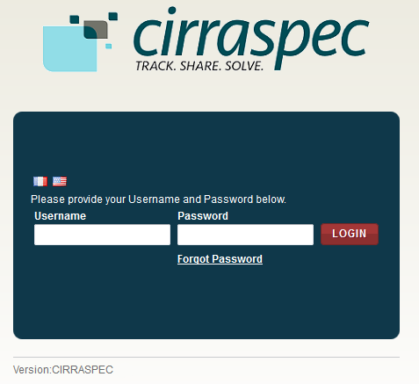

1. In the **Username** box, type your username and in the **Password** box, type your password.

**Note:**

If you have forgotten your login credentials or need login assistance, send an e-mail to [cirraspec@tgen.org](mailto:Bio4Dhelp@tgen.org).

1. Click **Login**.

The CIRRASPEC **home page** appears.

On top right, below the My Account link, Home page displays Welcome note:“Welcome User Sitename”

**Note:**

* If you have more than one assigned collection site locations, you are prompted to select the appropriate location for this Web session.
* Click on **SAVE,** the home page displays the location selected on top right Welcome note.

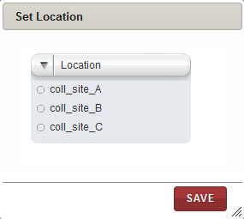

## Logging off the Application

To log off from the application, in the upper-right corner of any page, click the **Logout** link.

On successful logout, The **Login** page appears.

## Accessing the Home Page

You can access the CIRRASPEC home page from any other page by clicking the **Home** tab.

1. Allows you to access the CIRRASPEC home page
2. Allows you to access your account for password and user profile maintenance
3. Welcome note displaying user logging to the site
4. Allows you to log off from the application.
5. Easy Access Links

2

1

3

4

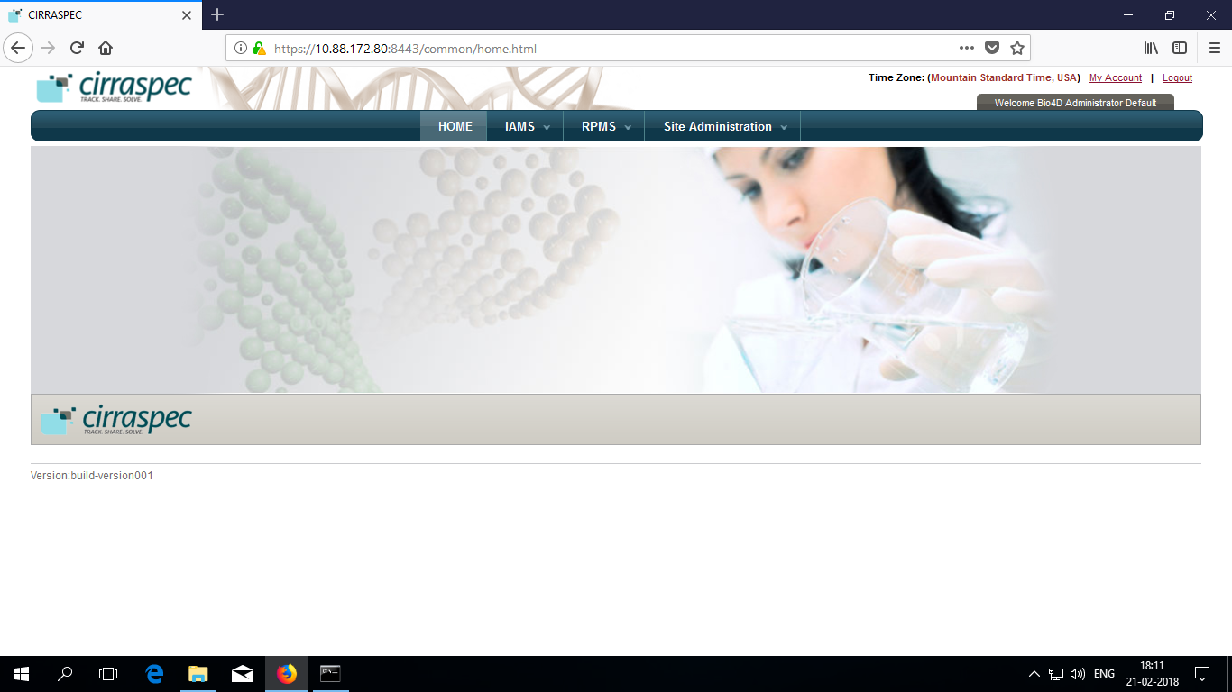

## Accessing the My Account Page

You can use the My Account page to update your user profile (language and location preferences) and your login password.

To access the **My Account** page:

1. In the upper-right corner of any page, click the **My Account** link.

The **My Account** page appears.

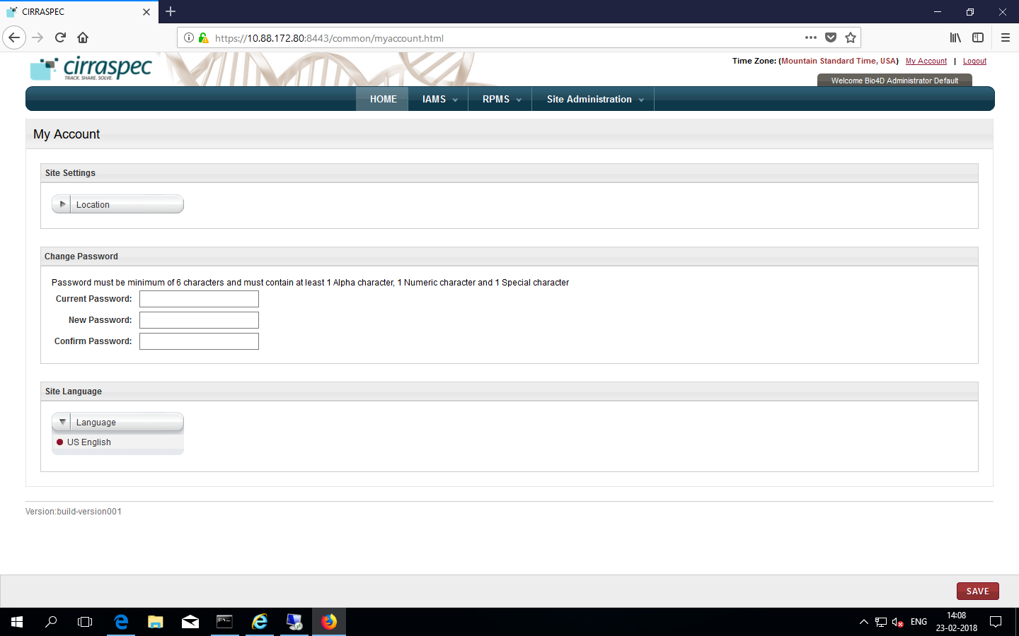

### 

### To set user profiles on My Account page :

### Site Settings

Allows you to select a different collection site location to view information and perform tasks associated with that location.

To select a different location:

1. Click on the **Location** list dropdown arrow.

Locations list displays all locations assigned to you based on your user role and access permissions.

1. Select the desired location.
2. Click **SAVE**.

The location is updated. Information associated with that location is displayed on the CIRRASPEC pages.

### Changing Your Password

Allows you to update the password for login to Cirraspec application.

Password Guidelines:

* The password must contain a minimum of six characters and is case sensitive.
* The password must contain at least one alphabet, one number and one special character such as !, @, #, &, etc.

To change your password:

1. In the **Current Password** boxof the **Change Password** area, type your current password.
2. In the **New Password** box, type a new password.
3. In the **Confirm Password** box, type the new password again.
4. Click **SAVE**.  
   Your password is changed.

**Note:** For assistance with the username or password, send an email to [cirraspec@tgen.org](mailto:Bio4Dhelp@tgen.org)

# Navigating through the application

IAMS tab:

|  |  |  |
| --- | --- | --- |
| Tab | Function | Events |
| Address Book | Allows to manage users, sites, couriers | Create & Manage Collection Sites, Processing sites, Storage sites, Couriers; Create Users |
| Forms Designer | Allows Forms management | Search and View the data collection forms; create or modify forms; Activate, deactivate, deprecate and reinstate forms. |
| Import Data | Allows Import Process using standard templates | Import Process Templates |
| Kits Designer | Allows Kit management | Search Kit Templates, View kit templates, Generate kit template manifest report.  Create or modify kit templates; Activate and deactivate kit templates. |
| Questions Designer | Allows Questions management | Search and View Questions Create or modify Questions; Activate, Deactivate, Deprecate and Reinstate questions |
| Storage Designer | Allows Storage Device Management | Search, View Storage devices; Create or modify storage devices; Move storage divisions within a device or to a different device; Generate storage report, Generate barcode labels. |

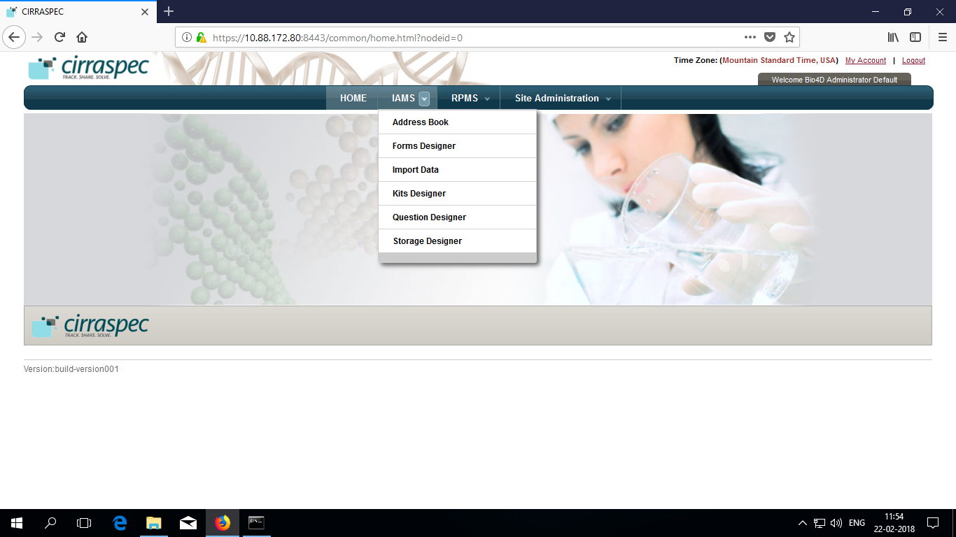

RPMS tab:

|  |  |  |
| --- | --- | --- |
| Tab | Function | Events |
| Configuration | Allows Project management | Search Projects, View Project, Create Projects |

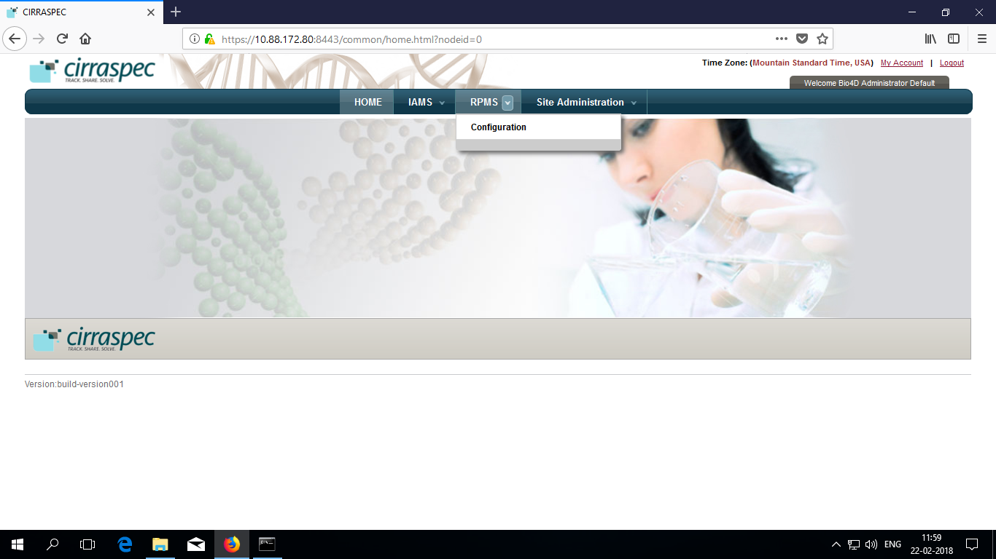

Site Administration:

|  |  |  |
| --- | --- | --- |
| Tab | Function | Events |
| Clear Application Cache | Allows Clear Cache | Clear Cache |
| Manage User Session | Allows user management | Enable User, Disable user accounts and force user logout |

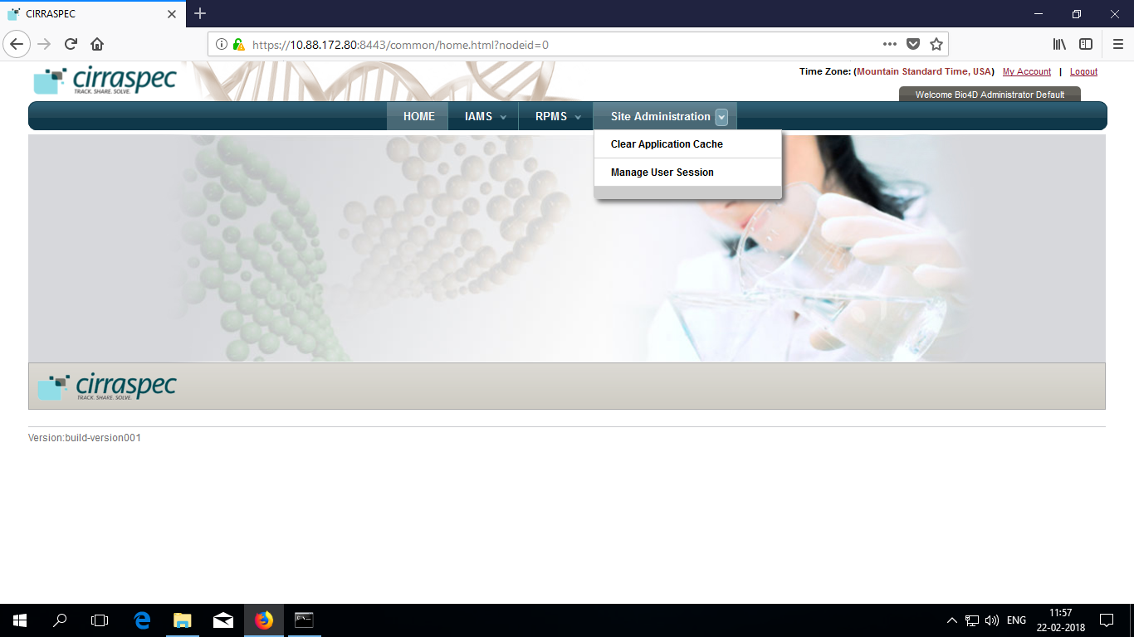

**NOTE:** You can scan barcode for the kit to enter source identifiers into the application.

# Workflow for an Administrator

An Administrator performs following tasks in same order to set up Cirraspec for Projects

### System Administration Tasks on page 14 to 46

Add Collection Site

Add Processing Site

Add Storage Site(s)

Add Courier(s)

Add User(s)

Create Questions

Create Forms

Create Kit Templates

Upload Sample Processing Templates (Optional)

### Project Management Tasks on page 147 to 199

Create Project

Create Collection(s)

Create Collection Event(s)

Publish Collection

Add Storage Device(s) on page 94

Understanding

Search Options, Search Results Display, Manage Events and File Upload

on page 200

# System Administrator Tasks

# Create and Manage Kits

### Viewing a List of Kit Templates

To view a list of kit templates:

1. Log on to the application using your login credentials.   
   The CIRRASPEC home page appears.
2. Point to the arrow of the **IAMS** tab, and then click **Kits Designer**.   
   The **Kit Template Search** page appears.
3. Click **SEARCH**.  
   The kit template search page displays a list of kit templates.

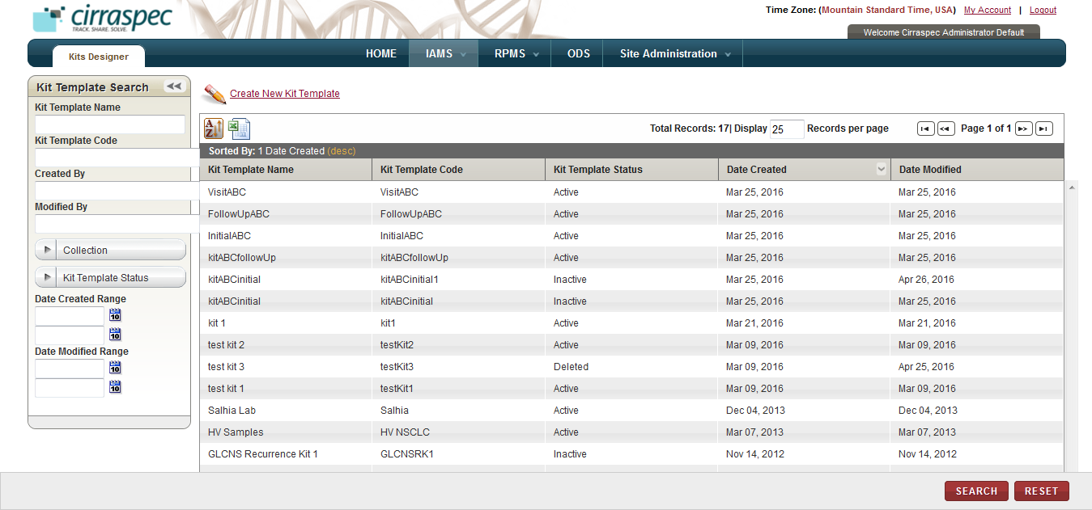

1. Kit Template Search page

**Note:** To re-sort the list, click the header of the column by which you want to sort. For more information about other ways to sort the list, see **Sorting Search Results**

On the kit templates search page, you can initiate the following tasks:

* **Print a kit list as an excel spreadsheet:** Click the **Export current view to CSV** icon 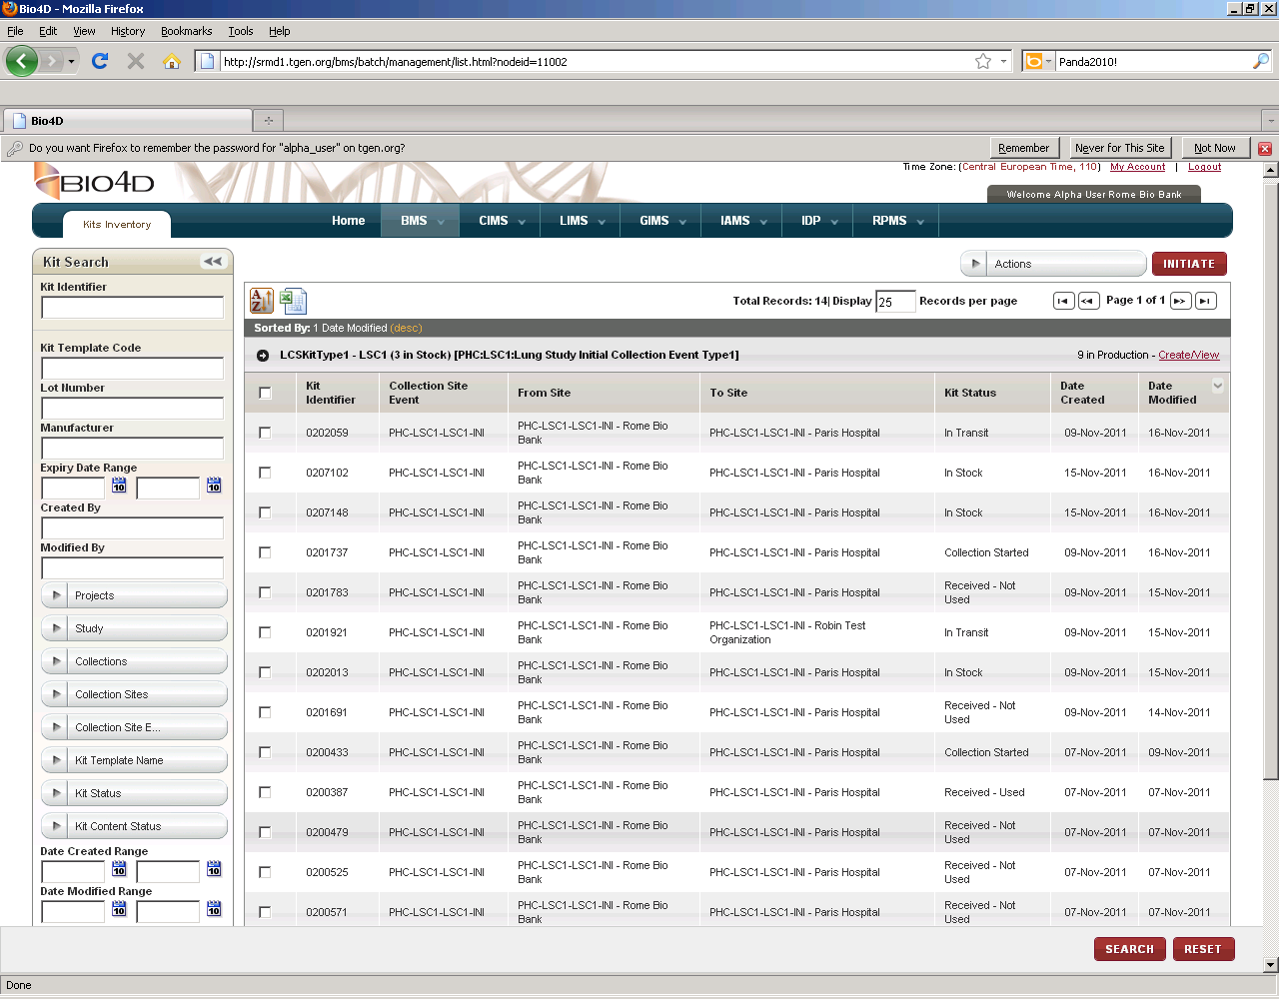, and then in the **File Download** window, click **Save**. The kit list file is saved to your machine for viewing/printing.
* **Perform a search for a kit template**: For more information about how to search for a specific kit or a group of kits, see **Searching for a Kit Template**.
* **View details of a kit template:** For more information about how to view the details of a kit, see **Viewing the Kit Template Details**.
* **Create a new kit template:** For more information about how to create a new a kit, see **Creating a Kit Template.**

### Searching for a Kit Template

To search for a specific kit template or a group of kit templates:

1. Point to the arrow of the **IAMS** tab, and then click **Kits Designer**.   
   The **Kit Template Search** page appears.
2. Click **SEARCH**.  
   The kit template search page displays the **Kit Template Search** pane.

Arrow hides/displays

the search pane



1. Kit Template Search page
2. Specify your search criteria by completing one or more fields in the **Kit Template Search** pane.

**Note:**

* You can use one field or a combination of fields to search for a kit template.
* You can type full or partial value in a search field along with an asterisk (*) before or after the partial value. For example, if you type **02\***, you obtain records that begin with 02. If you type **\*02**, you obtain records that end with 02

Following table lists each search field and its description.

Table : Kit Template Search Fields

| **Field** | **Description** |
| --- | --- |
| **Kit Template Name** | Type name of the kit template that you want to search. |
| **Kit Template Code** | Type kit template code to search for the group of kit templates associated with this code. |
| **Created By** | Type login username of the user to search for kit templates created by that user. |
| **Modified By** | Type login username of the user to search for kit templates modified by that user. |
| **Collection** | Click appropriate Collection to search for kit templates associated with it.  **Note:** To search for kit templates associated with all Collections, click **All**. |
| **Kit Template Status** | Click appropriate status to search for kit templates with this status.  **Note:** To search for kits with any status, click **All**. |
| **Date Created Range** | Click the date icon and then in the pop-up, select appropriate date option to search for kit templates created during this timeframe. For more information, see **Understanding the Date Range Search Options** |
| **Date Modified Range** | Click the date icon and then in the pop-up, select appropriate date option to search for kit templates modified in this timeframe. For more information, see **Understanding the Date Range Search Options** |

1. Click **SEARCH**.  
   The search results appear.   
     
   **Note:** Click the header of the column with respect to which you want to sort the results. For more information about how to sort the search results, see **Sorting Search Results**

### Viewing the Kit Template Details

To view the details of a kit template:

1. Log on to the application using your login credentials.

The CIRRASPEC home page appears.

1. Point to the arrow of the **IAMS** tab, and then click **Kits Designer**.

The **Kit Template Search** page appears.

1. Click **SEARCH**.

Thekit template search page displays a list of kit templates.

1. Click the row of the kit template whose details you want to view.

The **View Kit Template** page appears.  
  
**Note:** To expand the **Comments History** box to display additional historical comments, click the expand icon .

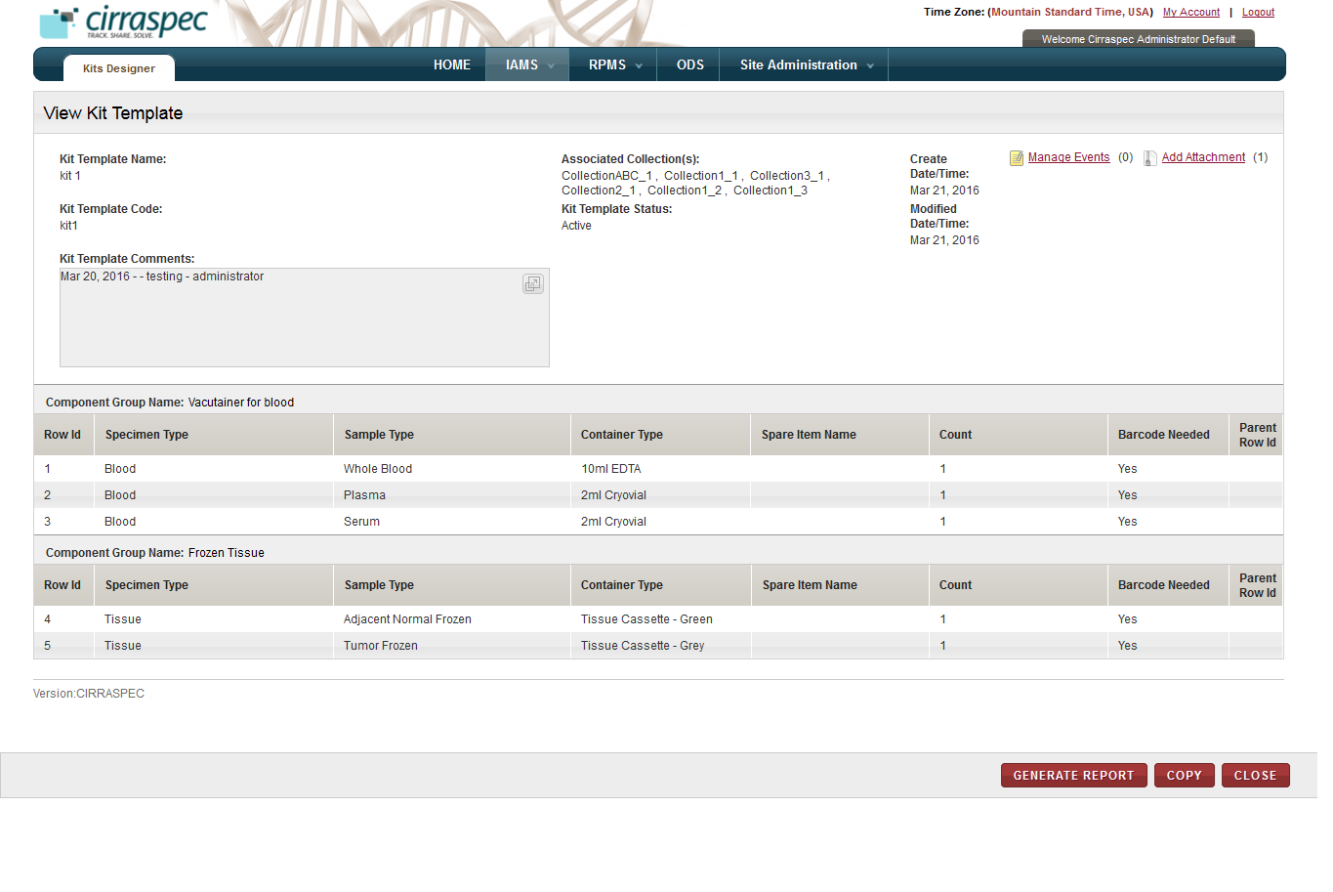

1. View Kit Template page

On the **View Kit Template** page, you can perform the following tasks:

* **Delete a kit template:** You can delete kit template which has the **Draft** status. For more information about how to delete a kit template, see **Deleting a Kit Template**.
* **Generate a report:** You can generate a kit template manifest report. For more information about how to generate a report for a kit template, see **Generating a Kit Template Manifest Report**.
* **Copy a kit template:** You can copy an existing kit template to create a new template. For more information about how to copy a kit template, see **Copying a Kit Template**.
* **Modify a kit template:** You can modify a **Draft** or **Inactive** kit template. For more information about how to modify a kit template, see **Modifying a Kit Template**.
* **Activate a kit template:** You can activate a **Draft** or **Inactive** kit template. For more information about how to activate a kit template, see **Activating a Kit Template**.
* **Deactivate a kit template:** You can deactivate an **Active** kit template. For more information about how to deactivate a kit template, see **Deactivating a Kit Template**.
* **Manage events:** You can view and add events to a kit by clicking the **Manage Events** link. For more information about how to manage events, see **Managing Events**
* **Add Attachment:** You can upload, download, and delete files that are attached to a kit by clicking the Add Attachment link. For more information about how to add files, see **Common File Upload**

### Creating a Kit Template

The **Create New Kit Template** link on the **Kit Template Search** page allows you to create a new kit template.

**Note:** The create procedure below uses a blank form to create a new kit template. To copy an existing kit template and create a new kit template using its information, see **Copying a Kit Template**.

To create a new kit template using a blank form:

1. Log on to the application using your login credentials.

The CIRRASPEC home page appears.

1. Point to the arrow of the **IAMS** tab, and then click **Kits Designer**.

The **Kit Template Search** page appears.

1. Click the **Create New Kit Template** link.

The **Create Kit Template** page appears.

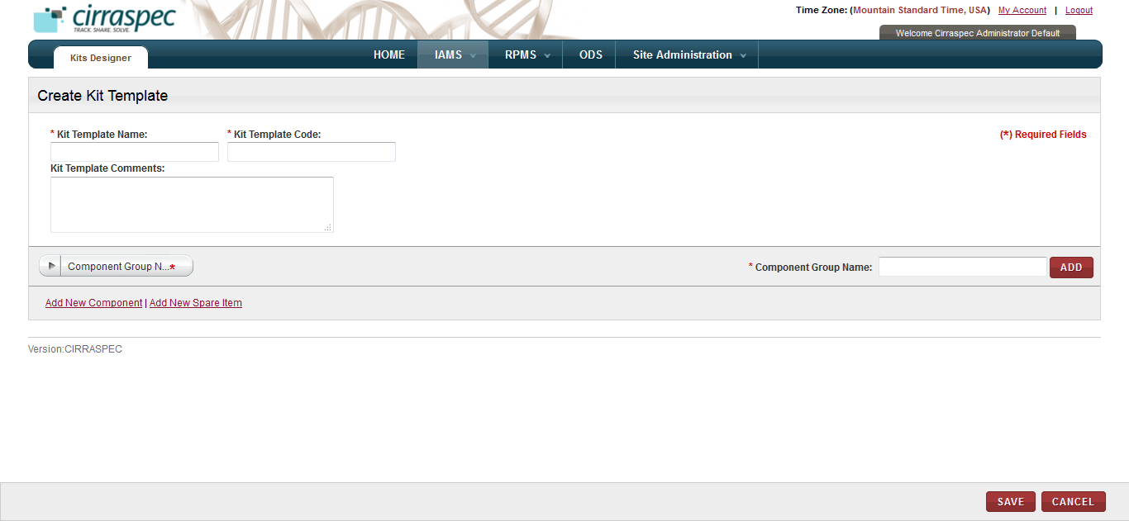

1. Create Kit Template page
2. Enter appropriate information in each field. Following table lists each field and its description.

**Note:** Fields that are marked with the red asterisk (*) are mandatory.

Table : Creating a kit template

|  |  |
| --- | --- |
| **Field** | **Description** |
| **Kit Template Name**\* | Type a name for this kit template. **Note:** Name cannot contain special characters. |
| **Kit Template Code**\* | Type a code for this kit template.  **Note:**   * Code cannot contain special characters * Length of this code must be at least 3 characters. * Combination of the kit template name and the code must be unique. |
| **Kit Template Comments** | Type your comments for this kit template, if applicable. |

1. To specify a component group for this kit template:  **Note:** You can specify multiple component groups but must specify them one at a time.

* To select an existing component group, in the **Component Group Name** list, click the appropriate component group.
* To add a component group that is not listed in the **Component Group Name** list, in the **Component Group Name** box, type a name for the component group, and then click **ADD**.

The component group name appears in the **Component Group Name** list.

1. To add a kit component for the component group you specified in the previous step:
2. Click the **Add New Component** link for the appropriate component group.

The add new component area appears.

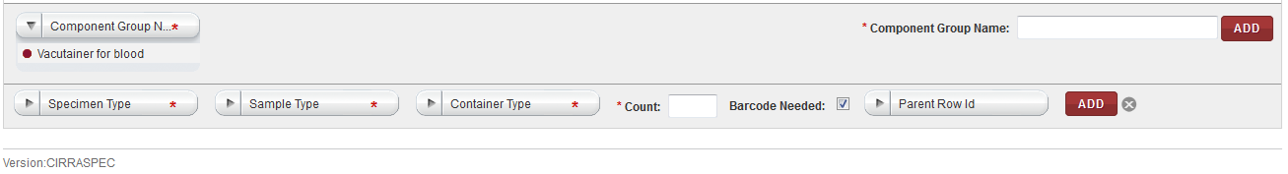

1. Add New Component area
2. Enter appropriate information in each field. Following table lists each field and itsdescription.

**Note:** Fields that are marked with the red asterisk (*) are mandatory.

Table : Adding a new component

|  |  |
| --- | --- |
| **Field** | **Description** |
| **Specimen Type**\* | Click appropriate specimen type for this component. |
| **Sample Type**\* | Click appropriate sample type for this component. |
| **Container Type**\* | Click appropriate container type for this component. |
| **Count**\* | Type the number of containers you want this component to have in the kit. |
| **Barcode Needed** | If you want a barcode template assigned to this component, select this check box.  **Note**: The checkbox is selected by default. |
| **Parent Row ID** | Skip this field. It is reserved for future use. |

1. Click **ADD**.

The component is added to the table under the component group.

**Note:** You can add multiple components to a component group.

1. To add a spare item for this component group:
2. Click the **Add New Spare Item** link for the appropriate component group.

The add new spare item area appears.

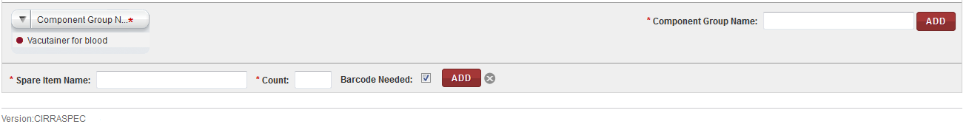

1. Add New Spare Item area
2. Enter appropriate information in each field. Following table lists each field and itsdescription.

**Note:** Fields that are marked with the red asterisk (*) are mandatory.

Table : Adding a new spare item

|  |  |
| --- | --- |
| **Field** | **Description** |
| **Spare Item Name**\* | Type the name for this spare item.  **Note:** Name must be unique for this kit template. |
| **Count**\* | Type the number of spare items you want this component group to have in the kit. |
| **Barcode Needed** | If you want a barcode template assigned to this spare item, select this check box.  **Note**: The checkbox is selected by default. |

1. Click **ADD**.

The spare item is added to the component group.

1. To add additional component groups, components and/or spare items to the kit template, repeat steps 6 to 8, as required.
2. To delete a component or a spare item:
3. Click the trash can icon  for the appropriate component or spare item.

**Note:** To delete all the components or spare items in the component group, click the trash can icon  in the header of the components list.   
A confirmation window appears.

1. Click **OK**.

The component or spare item is deleted from the kit template.

1. Click **SAVE**.  
   The kit template is created and its status is set to **Draft**.   
   **Note:** To use this new kit template, you must activate it. For more information about how to activate a kit template, see **Activating a Kit Template**.
2. Define barcode label format for kits and kit contents:

Steps:

1. Connect to the database and perform below queries:

**Barcode template:**

Make entries into the RPM_BARCODE table.

The IDENTIFIER_TYPE_ID column determines which barcode is for what entity

(See BIO_IDENTIFIER_TYPE table).

For ease of use, make a copy the current entry for IDENTIFIER_TYPE_ID = 2 and use the below text for the label format:

[identifierMasterDomain.identifierLabel]{TAB}[TemplateContentDomain.labelCode][COPY_TO_IDENTIFIER]

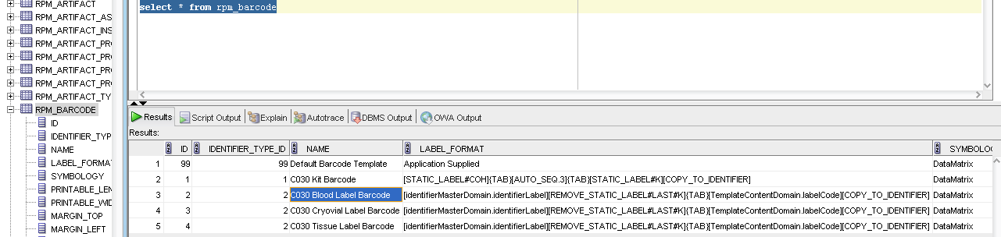

**Label Code**

This is sourced from the RPM_LABEL_CODE table.

You will need to make another entry in that table.

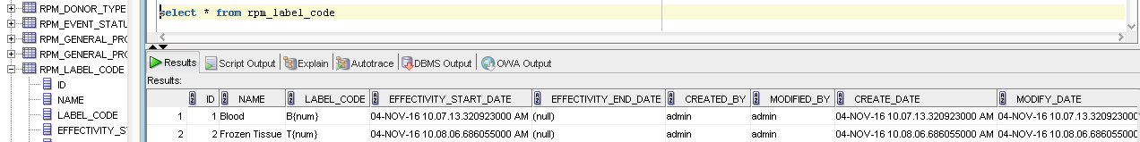

1. Multiple kit templates can be created. The same set of kit templates can be used for multiple sites.   
     
   **Example:** You can create a kit template for the Initial collection event, then a second kit template for a Follow-up event, and a third kit template for a Final event. The same kit templates can be used for multiple sites with the same events.

### Copying a Kit Template

**Copy** on the **View Kit Template** page allows you to copy an existing kit template and create a new kit template using the existing information.

To copy an existing kit template:

1. Log on to the application using your login credentials.

The CIRRASPEC home page appears.

1. Point to the arrow of the **IAMS** tab, and then click **Kits Designer**.

The **Kit Template Search** page appears.

1. Click **SEARCH**.

The **Kit Template Search** page displays a list of kit templates.

1. Click the row of the kit template that you want to copy.

The **View Kit Template** page appears.

1. Click **COPY**.

The **Create Kit Template** page appears with the component and spare item information copied from the existing kit template.

1. Enter appropriate information in each field. Following table lists each field and its description.

**Note:** Fields that are marked with the red asterisk (*) are mandatory.

Table : Copying a kit template

|  |  |
| --- | --- |
| **Field** | **Description** |
| **Kit Template Name**\* | Type a name for this kit template. |
| **Kit Template Code**\* | Type a code for this kit template.  **Note:**   * Length of this code must be at least 3 characters. * Combination of the kit template name and the code must be unique. |
| **Kit Template Comments** | Type your comments for this kit template, if applicable. |

1. To add a new component group for this kit template:  **Note:** You can specify multiple component groups but must specify them one at a time.

* To select an existing component group, in the **Component Group Name** list, click the appropriate component group.
* To add a new component group, in the **Component Group Name** box, type a name for the component group, and then click **ADD**.

The component group appears in the **Component Group Name** list.

1. To add a component for the new component group you added or to an existing component group:
2. Click the **Add New Component** link for the appropriate component group.

The add new component area appears.

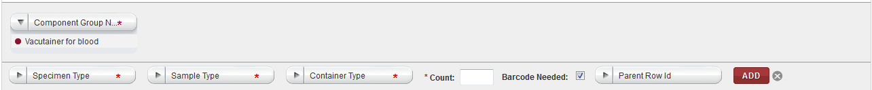

1. Add New Component area
2. Enter appropriate information in each field. Following table lists each field and itsdescription.

**Note:** Fields that are marked with the red asterisk (*) are mandatory.

Table : Adding a new component

|  |  |
| --- | --- |
| **Field** | **Description** |
| **Specimen Type**\* | Click appropriate specimen type for this component. |
| **Sample Type**\* | Click appropriate sample type for this component. |
| **Container Type**\* | Click appropriate container type for this component. |
| **Count**\* | Type the number of containers you want this component to have in the kit. |
| **Barcode Needed** | If you want a barcode template assigned to this component, select this check box.  **Note**: The checkbox is selected by default. |
| **Parent Row ID** | Skip this field. It is reserved for future use. |

1. Click **ADD**.

The component is added to the table under the component group.

**Note:** You can add multiple components to a component group.

1. To add a spare item to the new component group you added or to an existing component group:
2. Click the **Add New Spare Item** link for the appropriate component group.

The add new spare item area appears.

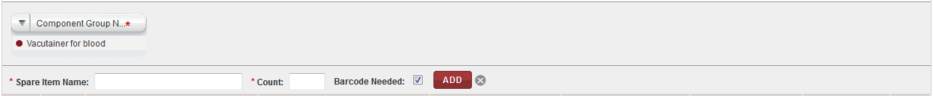

1. Add New Spare Item area
2. Enter appropriate information in each field. Following table lists each field and itsdescription.

**Note:** Fields that are marked with the red asterisk (*) are mandatory.

Table : Adding a new spare item

|  |  |
| --- | --- |
| **Field** | **Description** |
| **Spare Item Name**\* | Type a name for this spare item. **Note:** Name must be unique for this kit template. |
| **Count**\* | Type the number of spare items you want this component group to have in the kit. |
| **Barcode Needed** | If you want a barcode template assigned to this spare item, select this check box.  **Note**: The checkbox is selected by default. |

1. Click **ADD**.

The spare item is added to the component group.

1. To delete a component or a spare item:
2. Click the trash can icon  for the appropriate component or spare item.

**Note:** To delete all components or spare items in the component group, click the trash can icon  on the header of the components list.   
A confirmation window appears.

1. Click **OK**.

The component or spare item is deleted from the kit template.

1. Repeat steps 7 to 10 to add or delete components, as needed.
2. Click **SAVE**.  
   The kit template is created and its status is set to **Draft**.   
   **Note:** You must activate the kit template to make it available for use. For more information about how to activate a kit template, see **Activating a Kit Template**.

### Deleting a Kit Template

**Note:** You can only delete a kit template that has the **Draft** status.

To delete a kit template:

1. Log on to the application using your login credentials.

The CIRRASPEC home page appears.

1. Point to the arrow of the **IAMS** tab, and then click **Kits Designer**.

The **Kit Template** **Search** page appears.

1. Click **SEARCH**.

Thekit template search page displays a list of kit templates.

1. Click the row of the kit template that you want to delete.

The **View Kit Template** page appears.

1. Click **DELETE**.

A confirmation message appears.

1. Click **OK**.

The **Electronic Signature** window appears.

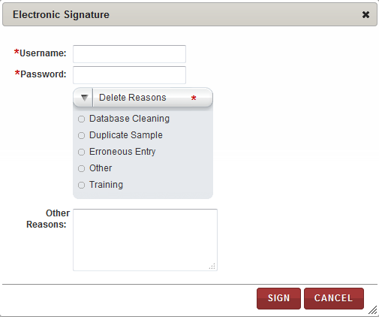

1. Electronic Signature window – Delete
2. Enter appropriate information in each field. Following table lists each field and itsdescription.

**Note:** Fields that are marked with the red asterisk (*) are mandatory.

Table : Deleting a kit template

|  |  |
| --- | --- |
| **Field** | **Description** |
| **Username**\* | Type your user login username. |
| **Password**\* | Type your password. |
| **Delete Reasons**\* | Click appropriate reason for deleting this kit template. |
| **Other Reasons** | If you clicked **Other** in the **Delete Reasons** list, type a reason for deleting this kit template. |

1. Click **SIGN**.

The kit template is deleted and its status changes to **Deleted**. You can now view the template but cannot modify it and it will not be available for use.

### Modifying a Kit Template

**Note:**

* You can modify only that kit template which has the **Draft** or **Inactive** status.
* To be able to modify a kit that has the **Active** status, you need to first deactivate it.

To deactivate, see **Deactivating a Kit Template**.

To modify a kit template:

1. Log on to the application using your login credentials.

The CIRRASPEC home page appears.

1. Point to the arrow of the **IAMS** tab, and then click **Kits Designer**.

The **Kit Template Search** page appears.

1. Click **SEARCH**.

Thekit template search page displays a list of kit templates.

1. Click the row of the kit template that you want to modify.

The **View Kit Template** page appears.

1. Click **MODIFY**.

The **Modify Kit Template** page appears.

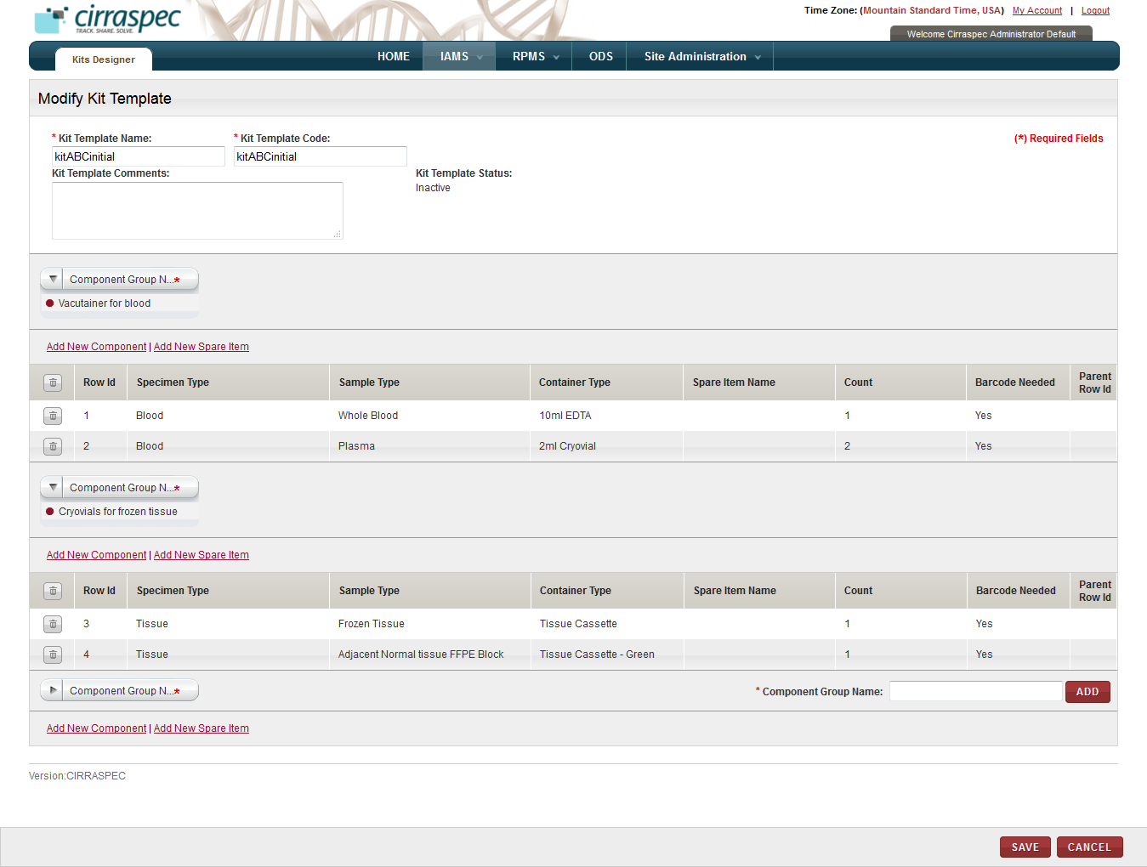

1. Modify Kit Template page
2. Enter appropriate information in each field. Following table lists each field and its description.

**Note:** Fields that are marked with the red asterisk (*) are mandatory.

Table : Modifying a kit template

|  |  |
| --- | --- |
| **Field** | **Description** |
| **Kit Template Name**\* | If you want to modify the name, type a new name for this kit template. |
| **Kit Template Code**\* | If you want to modify the code, type a new code for this kit template.  **Note:**   * Length of this code must be at least 3 characters. * Combination of the kit template name and the code must be unique. |
| **Kit Template Comments** | Type your comments for this kit template, if applicable. |

1. To add a new component group for this kit template:  **Note:** You can specify multiple component groups for this kit template.

* To select an existing component group, in the **Component Group Name** list, click the appropriate component group.
* To add a new component group, in the **Component Group Name** box, type a name for the component group, and then click **ADD**.

The component group appears in the **Component Group Name** list.

1. To add a component for the new component group you added or an existing component group:
2. Click the **Add New Component** link for the appropriate component group.

The add new component area appears.

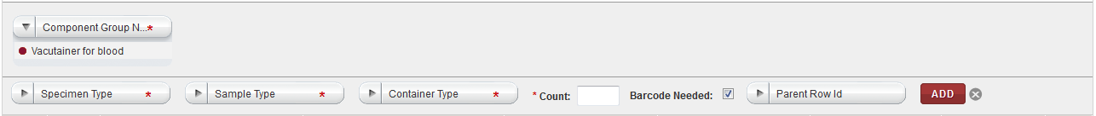

1. Add New Component area
2. Enter appropriate information in each field. Following table lists each field and itsdescription.

**Note:** Fields that are marked with the red asterisk (*) are mandatory.

Table : Adding a new component

|  |  |
| --- | --- |
| **Field** | **Description** |
| **Specimen Type**\* | Click appropriate specimen type for this component. |
| **Sample Type**\* | Click appropriate sample type for this component. |
| **Container Type**\* | Click appropriate container type for this component. |
| **Count**\* | Type the number of containers you want this component to have in the kit. |
| **Barcode Needed** | If you want a barcode template assigned to this component, select this check box.  **Note**: The checkbox is selected by default. |
| **Parent Row ID** | Skip this field. It is reserved for future use. |

1. Click **ADD**.

The component is added to the table under the component group.

**Note:** You can add multiple components to a component group.

1. To add a spare item to the new component group you added or to an existing component group:
2. Click the **Add New Spare Item** link for the appropriate component group.

The add new spare item area appears.

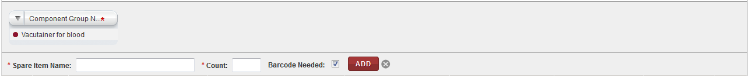

1. Add new spare item area
2. Enter appropriate information in each field. Following table lists each field and itsdescription.

**Note:** Fields that are marked with the red asterisk (*) are mandatory.

Table : Adding a new spare item

|  |  |
| --- | --- |
| **Field** | **Description** |
| **Spare Item Name**\* | Type a name for this spare item.  **Note:** Name must be unique for this kit template. |
| **Count**\* | Type the number of spare items you want this component to have in the kit. |
| **Barcode Needed** | If you want a barcode template assigned to this spare item, select this check box.  **Note**: The checkbox is selected by default. |

1. Click **ADD**.

The spare item is added to the component group.

1. To delete a component or a spare item:
2. Click the trash can icon  for appropriate component or spare item.

**Note:** To delete all components or spare items in the component group, click the trash can icon  on the header of the components list.   
A confirmation window appears.

1. Click **OK**.

The component or spare item is deleted from the kit template.

1. Click **SAVE**.

The **Electronic Signature** window appears only if the kit template is in the **Inactive** status.

**Note**: If the kit template is in the **Draft** status, then the **Electronic Signature** window does not appear, but the changes are saved for the kit template. Status of the kit template remains as **Draft**.

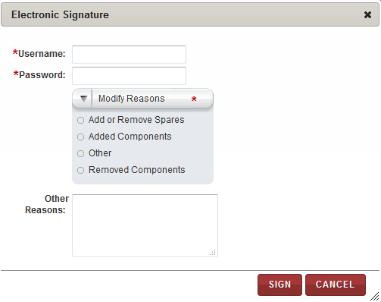

1. Electronic Signature window – Modify
2. Enter appropriate information in each field. Following table lists each field and itsdescription.

**Note:** Fields that are marked with the red asterisk (*) are mandatory.

Table : Activating a kit template

|  |  |
| --- | --- |
| **Field** | **Description** |
| **Username**\* | Type your user login username. |
| **Password**\* | Type your password. |
| **Modify Reasons**\* | Click appropriate reason for modifying this kit template. |
| **Other Reasons** | If you clicked **Other** in the **Modify Reasons** list, type a reason for modifying this kit template. |

1. Click **SIGN**.

The kit template is modified and its status changes to **Draft**.  
You must activate the kit template to make it available for use. For more information about how to activate a question, see **Activating a Kit Template**.

### Activating a Kit Template

**Note:** You can only activate a kit template that has the **Draft** or **Inactive** status.

To activate a kit template:

1. Log on to the application using your login credentials.

The CIRRASPEC home page appears.

1. Point to the arrow of the **IAMS** tab, and then click **Kits Designer**.

The **Kit Template Search** page appears.

1. Click **SEARCH**.

Thekit template search page displays a list of kit templates.

1. Click the row of the kit template that you want to activate.

The **View Kit Template** page appears.

1. Click **ACTIVATE**.

The **Electronic Signature** window appears.

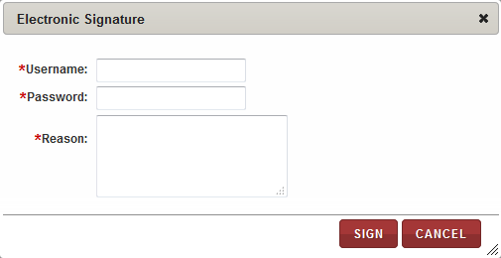

1. Electronic Signature window - Activate
2. Enter appropriate information in each field. Following table lists each field and itsdescription.

**Note:** Fields that are marked with the red asterisk (*) are mandatory.

Table : Activating a kit template

|  |  |
| --- | --- |
| **Field** | **Description** |
| **Username**\* | Type your user login username. |
| **Password**\* | Type your password. |
| **Reason**\* | Type a reason for activating this kit template. |

1. Click **SIGN**.

The kit template is activated and its status changes to **Active**.

### Deactivating a Kit Template

**Note:** You can only deactivate a kit template that has the **Active** status.

To deactivate a kit template:

1. Log on to the application using your login credentials.

The CIRRASPEC home page appears.

1. Point to the arrow of the **IAMS** tab, and then click **Kits Designer**.

The **Kit Template** **Search** page appears.

1. Click **SEARCH**.

Thekit template search page displays a list of kit templates.

1. Click the row of the kit template that you want to deactivate.

The **View Kit Template** page appears.

1. Click **DEACTIVATE**.

The **Electronic Signature** window appears.



1. Electronic Signature window - Deactivate
2. Enter appropriate information in each field. Following table lists each field and itsdescription.

**Note:** Fields that are marked with the red asterisk (*) are mandatory.

Table : Deactivating a kit template

|  |  |
| --- | --- |
| **Field** | **Description** |
| **Username**\* | Type your user login username. |
| **Password**\* | Type your password. |
| **Reason**\* | Type the reason for deactivating this kit template. |

1. Click **SIGN**.

The kit template is deactivated and its status changes to **Inactive**.

### Generating a Kit Template Manifest Report

To generate a kit template manifest report:

1. Log on to the application using your login credentials.

The CIRRASPEC home page appears.

1. Point to the arrow of the **IAMS** tab, and then click **Kits Designer**.

The **Kit Template** **Search** page appears.

1. Click **SEARCH**.

Thekit template search page displays a list of kit templates.

1. Click the row of the kit template for which you want to generate a report.

The **View Kit Template** page appears.

1. Click **GENERATE REPORT**.

The **Kit Template Manifest** report appears in a new window.

1. View, print and/or save the file, as needed.   
   **Note**: Hover the cursor over the icons in the horizontal and vertical navigation bars to identify tools for viewing multiple pages, printing the report and saving the file to your desktop.

Example of a report :



# View and Create Questions to be used in Forms

### Viewing a List of Questions

The **Questions Search** page provides a list of questions. This page allows you to search for questions.

To view the questions search page:

1. Log on to the application using your login credentials.

The CIRRASPEC home page appears.

1. Point to the arrow of the **IAMS** tab, and then click **Question Designer**.

The **Questions Search** page appears.

1. Click **SEARCH**.

Thequestions search page displays a list of questions.

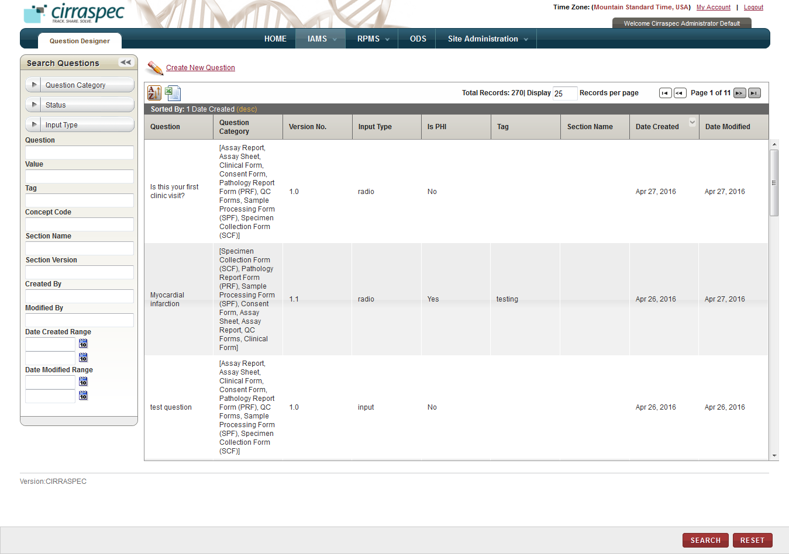

1. Questions Search page

**Note:** To re-sort the list, click the header of the column by which you want to sort. For more information about other ways to sort the list, see **Sorting Search Results**

On the questions search page, the System Administrator can initiate the following tasks:

* **Print a question list as an excel spreadsheet:** Click the **Export current view to CSV** icon , and then in the **File Download** window, click **Save**. The question list file is saved to your machine for viewing/printing.
* **Perform a search for a question**: For more information about how to search for a specific question or a group of questions, see **Performing a Search on the Questions Search Page**.
* **View details of a question:** For more information about how to view the details of a question, see **Viewing the Question Details**.
* **Create a new question:** For more information about how to create a new a question, see **Creating a Question****.**

### Performing a Search on the Questions Search Page

To search for a specific question or a group of questions:

1. Point to the arrow of the **IAMS** tab, and then click **Question Designer**.   
   The **Questions Search** page appears.
2. Click **SEARCH**.  
   The questions search page displays the **Search** **Questions** pane.

Arrow hides/displays the Search Questions pane



1. Question Search page
2. Specify your search criteria by completing one or more fields in the **Search** **Questions** pane.

**Note:**

* You can use one field or a combination of fields to search for questions.
* You can type the full or partial value in a search field along with an asterisk (*) before or after the partial value. For example, if you type **02\***, you obtain records that begin with 02. If you type **\*02**, you obtain records that end with 02

Following table lists each search field and its description.

Table : Questions search fields

| **Field** | **Description** |
| --- | --- |
| **Question Category** | Click appropriate category to search for all questions of this category.  **Note:** To search for questions of any category, click **All**. |
| **Status** | Click appropriate status to search for all questions with this status.  **Note:** To search for questions with any status, click **All**. |
| **Input Type** | Click appropriate input type to search for all questions with this input type.  **Note:** To search for questions with any input type, click **All**. |
| **Question** | Type the question that you want to search. |
| **Value** | Type a question’s answer value to search for all questions using that answer value. |
| **Tag** | Type a question tag to search for all questions associated with this tag. |
| **Concept Code** | Type a concept code to search for all questions associated with this code. |
| **Section Name** | Type the name of a form’s section to search for all questions associated with it. |
| **Section Version** | Type a form’s version to search for all questions associated with it. |
| **Created By** | Type the login username of the user to search for questions created by that user. |
| **Modified By** | Type the login username of the user to search for questions modified by that user. |
| **Date Created Range** | Click the date icon and then in the pop-up, select appropriate date option to search for questions created in this timeframe. For more information, see **Understanding the Date Range Options** |
| **Date Modified Range** | Click the date icon and then in the pop-up, select appropriate date option to search for questions modified in this timeframe. For more information, see **Understanding the Date Range Options** |

1. Click **SEARCH**.  
   The search results appear.   
     
   **Note:** Click the header of the column with which you want to sort the results. For more information about how to sort the search results, see **Sorting Search Results**

### Viewing the Question Details

To view the details of a question:

1. Log on to the application using your login credentials.

The CIRRASPEC home page appears.

1. Point to the arrow of the **IAMS** tab, and then click **Question Designer**.

The questions search page appears.

1. Click the row of the question for which you want to view the details.

The **View Question** page appears.  
**Note:** To expand the **Comments** box to display additional historical comments, click the expand icon .

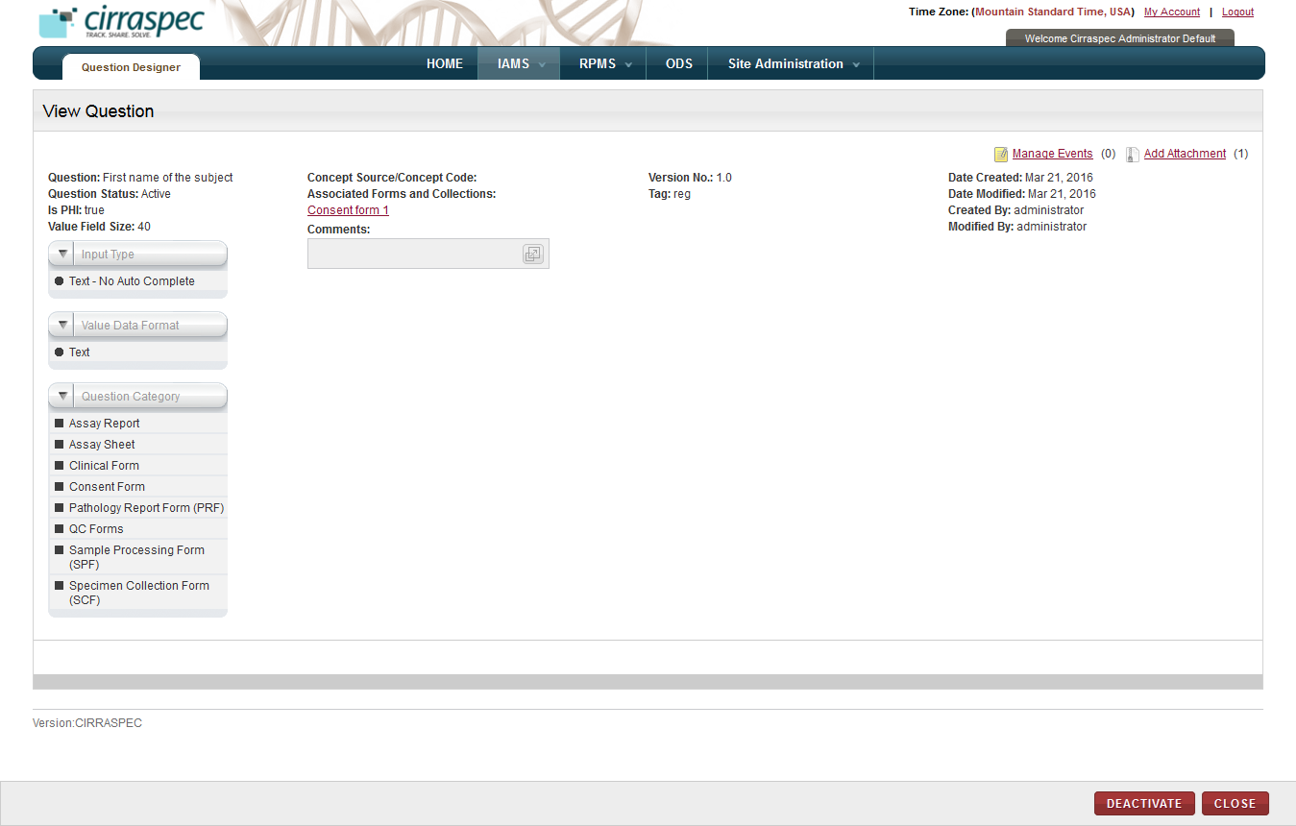

1. View Question page

On the **View Question** page, you can perform the following tasks:

* **View a form:** You can view a form associated with this question by clicking on the link under **Associated Forms and Collections**.
* **Modify a question:** For more information about how to modify a question, see **Modifying a Question**.
* **Delete a question:** For more information about how to delete a question, see **Deleting a Question**.
* **Activate a question:** For more information about how to activate a question, see **Activating a Question**.
* **Deactivate a question:** For more information about how to deactivate a question, see **Deactivating a Question**.
* **Deprecate a question:** For more information about how to deprecate a question, see **Deprecating a Question**.
* **Reinstate a question:** For more information about how to reinstate a question, see **Reinstating a Question**.
* **Manage events:** You can view and add events to a kit by clicking the **Manage Events** link. For more information about how to manage events, see **Managing Events**
* **Add Attachment:** You can upload, download, and delete files that are attached to a kit by clicking the Add Attachment link. For more information about how to add files, see **Common File Upload**

### Creating a Question

To create a question:

1. Log on to the application using your login credentials.

The CIRRASPEC home page appears.

1. Point to the arrow of the **IAMS** tab, and then click **Question Designer**.

The **Questions Search** page appears.

1. Click the **Create New Question** link.

The **Create/Modify Question** page appears.

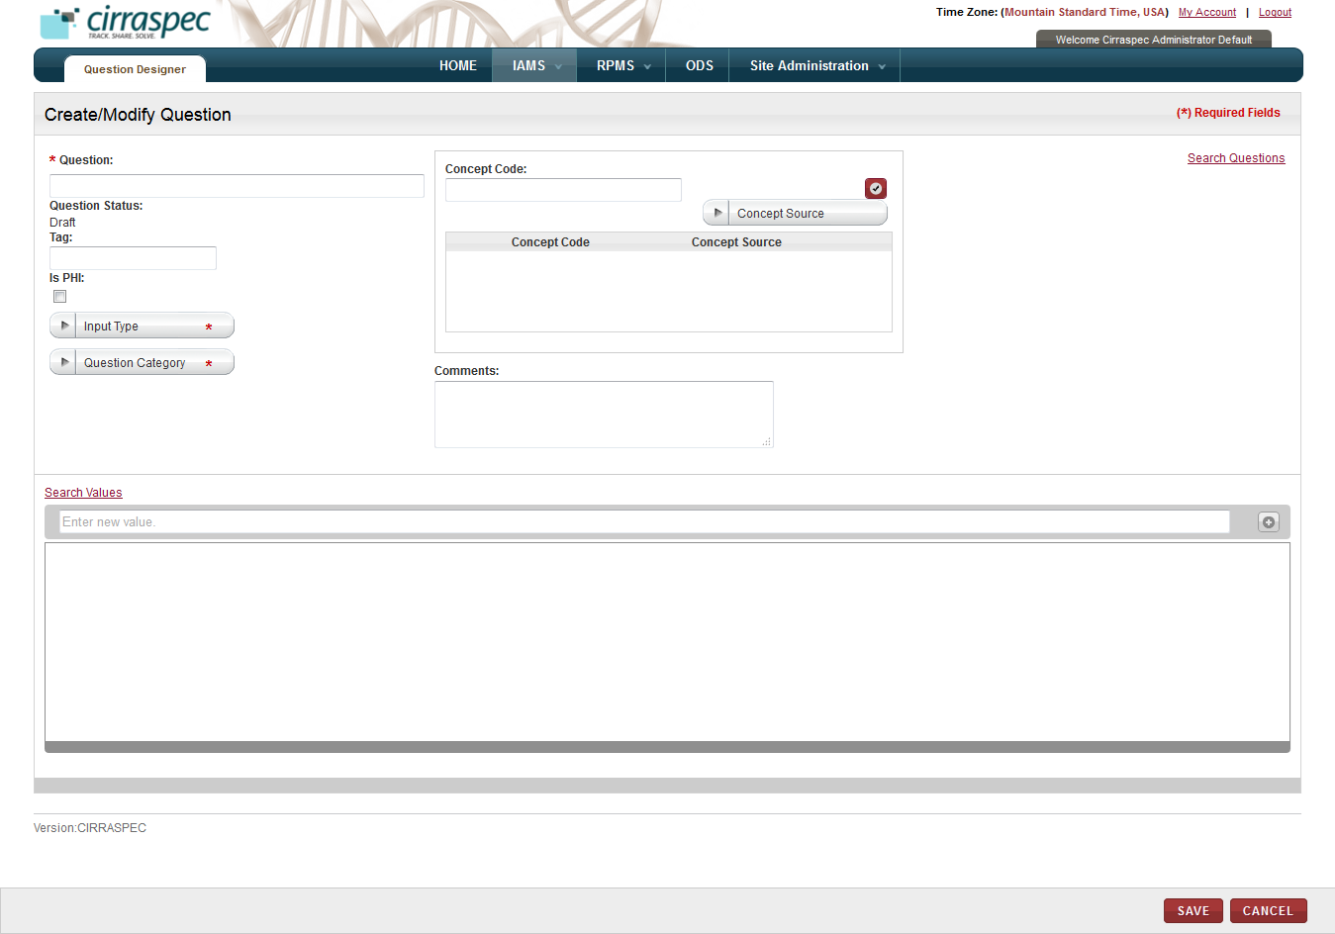

1. Create/Modify Question page
2. Enter appropriate information in each field. Following table lists each field and itsdescription.

**Note:** Fields that are marked with the red asterisk (*) are mandatory.

Table : Creating a question

|  |  |
| --- | --- |
| **Field** | **Description** |
| **Question**\* | Type the question. OR  To copy an existing question and modify it to create a new question:   1. Click the **Search Questions** link. The **Search Questions** window appears. 2. Type one of the following in the box for the question you want to search:  * tag associated with the question * entire question name * part of the question with an asterisk (*)  1. Click **Search**. **Question Results** list appears. 2. Click appropriate question. **Selected Question** list appears. 3. Click **ADD**. The search window closes and the selected question appears in this field on the **Create/Modify Question** page. For more information about how to search for an existing question, see **Using the Search Questions Window**. |
| **Tag** | Type a keyword tag that you can use to search for this question in the future. |
| **Input Type**\* | Click appropriate input type that you want for this question.  You can select any one of the following values:   * **Checkbox - Multi Selection:** To allow multiple selection of values using checkboxes * **Drop Down Select - Single Selection:** To allow single selection of values using a dropdown list * **Note:** To include instructions or explanation as a note. This note is visible for all the question searches. * **Radio Button:** To include radio buttons as input values for the question * **Text - Auto Complete Existing Values:** To allow the display of existing values for selection * **Text - No Auto Complete:** To include a date, time, number or decimal input field for this question. |
| **Value Field Size**\* | Type the maximum number of text characters that you want to allow when answering this question on a form.  **Note:**   * This field appears only when you click **Text - Auto Complete Existing Values** or **Text - No Auto Complete** in the **Input Type** list. * You must type a positive number that does not exceed 40. |
| **Value Data Format**\* | Click appropriate data format that you want to be used when answering this question on a form. **Note:** This field appears only when you click **Text - Auto Complete Existing Values** or **Text - No Auto Complete** in the **Input Type** list. |
| **Question Category**\* | Click one or multiple categories to define which form types can use this question. |
| **Comments** | Type your comments regarding this question, if applicable. |

1. To assign a concept code to this question, if applicable:   
   **Note:** Concept code is a designation in the Unified Medical Language System (UMLS) or other bio, pharma or medical related standards list for standardizing question concepts.
2. In the **Concept Code** box, type a known concept code.  
   **Note:** You can type all or part of the code. As you type, a list of codes that match your entry appears. You can select a code from this list or type a new code.
3. In the **Concept Source** list, click applicable medical related standards list that is the source of the concept code you are assigning.
4. Click the checkmark icon .

The combination of concept code and concept source is added to the list below.

**Note:**

* You can add multiple combinations to this list.
* To delete a combination, click the trash can icon  for the appropriate combination.

1. To add an answer value to this question, in the values box below the **Search Values** link, type the appropriate value, and then click **Add More** icon .

The value is added to the value list below. You can add multiple values to this list.

**Note:**

* This field appears only if you click **Check Box,** **Drop Down**, or **Radio Button** in the **Input Type** list.
* To search for an existing value, click the **Search Values** link. For more information about how to search for an existing value, see **Using the Search Question Values Window.**  
  Select the value and click **ADD**. The **Search Question Values** pop-up closes and the value is added to the value list below.
* To delete an answer value, click on the trash can icon  for the appropriate value.   
  The value is deleted from the value list. You can delete multiple values from the list one at a time.
* To change the order of the answer values: Place the cursor on the row of the value you want to move. Then click the left mouse button and ‘drag and drop’ the value to the row where you want to move it.  
  The values on the list appear in the new order.

1. Click **SAVE**.

The question is created with the **Draft** status.   
**Note**: You must activate the question to make it available for use on forms. For more information about how to activate a question, see **Activating a Question**.

### Modifying a Question

To modify an existing question:

1. Log on to the application using your login credentials.

The CIRRASPEC home page appears.

1. Point to the arrow of the **IAMS** tab, and then click **Question Designer**.

The **Questions Search** page appears.

1. Click **SEARCH**.  
   The questions search page displays a list of questions.
2. Click the row of the question that you want to modify.

The **View Question** page appears.

1. Click **MODIFY**.

**Note:** If the question status is **Active**, you must first click **DEACTIVATE** to deactivate the question and display the MODIFY button.

Deactivating the question includes a step of providing the electronic signature with the reason for performing this action.

The **Create/Modify Question** page appears with existing question information.

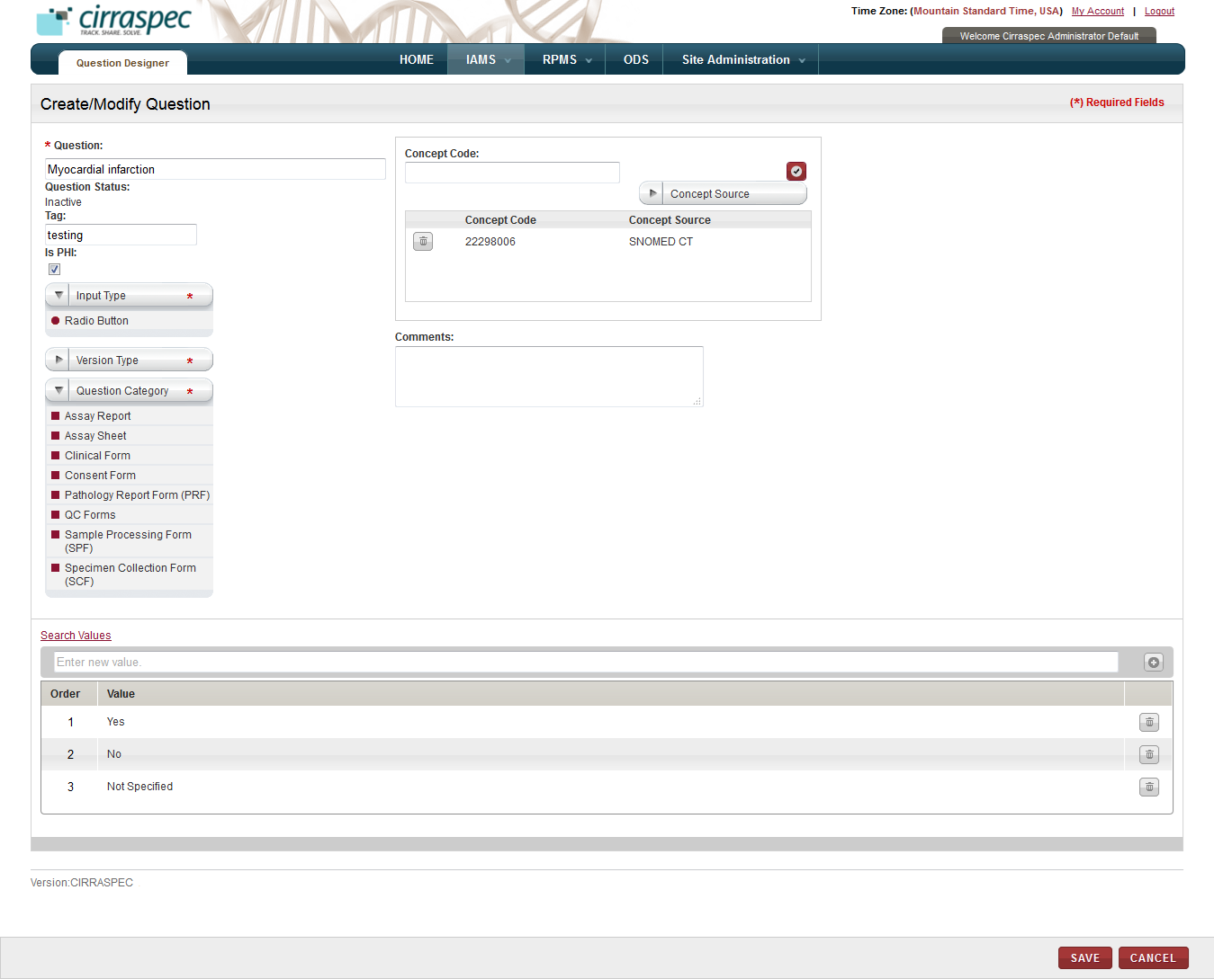

1. Create/Modify Question page
2. Enter appropriate information in each field. Following table lists each field and itsdescription.

**Note:** Fields that are marked with the red asterisk (*) are mandatory.

Table : Modifying a question

|  |  |
| --- | --- |
| **Field** | **Description** |
| **Question**\* | Type changes to the question name, if applicable. |
| **Tag** | Type a new keyword tag to search for the modified version of the question in future, if applicable. |
| **Input Type**\* | Click appropriate input type if you want to change it for this version of the question.  You can select any one of the following values:   * **Checkbox - Multi Selection:** To allow multiple selection of values using checkboxes * **Drop Down Select - Single Selection:** To allow single selection of values using a dropdown list * **Note:** To include instructions or explanation as a note. This note is visible for all question searches. * **Radio Button:** To include radio buttons as input values for the question * **Text - Auto Complete Existing Values:** To allow the display of existing values for selection * **Text - No Auto Complete:** To include a date, time, number or decimal input field for this question. |
| **Value Field Size**\* | Type the maximum number of text characters that you want to allow when answering this question on a form.  **Note:**   * This field appears only when **Input Type = Text - Auto Complete Existing Values** or **Text - No Auto Complete**. * You can type a positive number that does not exceed 40. |
| **Value Data Format**\* | Click appropriate data format that you want to be used when answering the question on a form. **Note:** This field appears only when **Input Type = Text - Auto Complete Existing Values** or **Text - No Auto Complete**. |
| **Version Type**\* | Click appropriate type to indicate how the question version number should be incremented when these changes are saved.  You can select any one of the following values:   * **Major:** Question version is increased to its next whole number. Ex. 2.3 🡪 3.0. * **Minor**: Question version is increased by a tenth of a number. Ex. 2.8 🡪 2.9. * **No Change**: Question version is not updated. |
| **Question Category**\* | Click one or multiple categories to change which form types can use this version of the question. |
| **Comments** | Type your comments regarding this version of the question, if applicable. |

1. To change the assigned concept code for this version of the question, if applicable:   
   **Note:** Concept code is a designation in the Unified Medical Language System (UMLS) or other bio, pharma or medical related standards list for standardizing question concepts.
2. In the **Concept Code** box, type a known concept code.  
   **Note:** You can type all or part of the code. As you type, a list of codes that match your entry appears. You can select a code from this list or type a new code.
3. In the **Concept Source** list, click the applicable medical related standards list that is the source of the concept code you are assigning.
4. Click the checkmark icon .

The combination of concept code and concept source is added to the list below.

**Note:**

* You can add multiple combinations to this list.
* To delete a combination, click the trash can icon  for the appropriate combination.

1. To change the answer values for this version of the question:
2. To add an answer value: In the values box below the **Search Values** link, type appropriate value, and then click the **Add More** icon .

The value is added to the value list below. You can add multiple values to this list.

**Note:**

* This field appears only if **Input Type = Check Box**, **Drop Down**, or **Radio Button**.
* To search for an existing value, click the **Search Values** link. For more information about how to search for an existing value, see **Using the Search Question** **Values Window**.

1. To delete an answer value: Click on the trash can icon  for the appropriate value.   
   The value is deleted from the value list. You can delete multiple values from the list
2. To change the order of the answer values: Place the cursor on the row of the value you want to move. Then click the left mouse button and ‘drag and drop’ the value to the row where you want to move it.  
   The values on the list appear in the new order.
3. Click **SAVE**.

The **Electronic Signature** window appears.



1. Electronic Signature window
2. Enter appropriate information in each field. Following table lists each field and itsdescription.

**Note:** Fields that are marked with the red asterisk (*) are mandatory.

Table : Modifying a question

|  |  |
| --- | --- |
| **Field** | **Description** |
| **Username**\* | Type your user login username. |
| **Password**\* | Type your password. |
| **Reason**\* | Type a reason for this action. |

1. Click **SIGN**.

The question is modified and the changes appear on the **View Question** page.  
**Note:** You must activate the question to make it available for use on forms. For more information about how to activate a question, see **Activating a Question**.

### Deleting a Question

To delete a question:

**Note:** You can only delete a question that has the **Draft** status.

1. Log on to the application using your login credentials.

The CIRRASPEC home page appears.

1. Point to the arrow of the **IAMS** tab, and then click **Question Designer**.

The **Questions Search** page appears.

1. Click **SEARCH**.  
   The questions search page displays a list of questions.
2. Click the row of the question that you want to delete.

The **View Question** page appears.

1. Click **DELETE**.

A confirmation window appears.

1. Click **OK**.

The question is deleted and its status appears as **Deleted** on the **Questions Search** page.   
**Note**: You can now only view this question.

### Activating a Question

To activate a question:   
  
**Note:** You can only activate a question that has the **Draft** or **Inactive** status.

1. Log on to the application using your login credentials.

The CIRRASPEC home page appears.

1. Point to the arrow of the **IAMS** tab, and then click **Question Designer**.

The **Questions Search** page appears.

1. Click **SEARCH**.  
   The questions search page displays a list of questions.
2. Click the row of the question that you want to activate.

The **View Question** page appears.

1. Click **ACTIVATE**.

The **Electronic Signature** window appears.

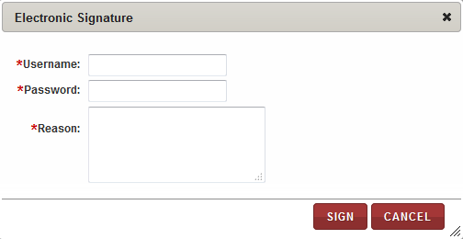

1. Electronic Signature window
2. Enter appropriate information in each field. Following table lists each field and itsdescription.

**Note:** Fields that are marked with the red asterisk (*) are mandatory.

Table : Activating a question

|  |  |
| --- | --- |
| **Field** | **Description** |
| **Username**\* | Type your user login username. |
| **Password**\* | Type your password. |
| **Reason**\* | Type a reason for this action. |

1. Click **SIGN**.

The question is activated and its status changes to **Active**.   
**Note:** You can now use this question for forms.

### Deactivating a Question

To deactivate a question:  
  
**Note:** You can only deactivate a question that has the **Active** status.

1. Log on to the application using your login credentials.

The CIRRASPEC home page appears.

1. Point to the arrow of the **IAMS** tab, and then click **Question Designer**.

The **Questions Search** page appears.

1. Click **SEARCH**.  
   The questions search page displays a list of questions.
2. Click the row of the question that you want to deactivate.

The **View Question** page appears.

1. Click **DEACTIVATE**.

The **Electronic Signature** window appears.

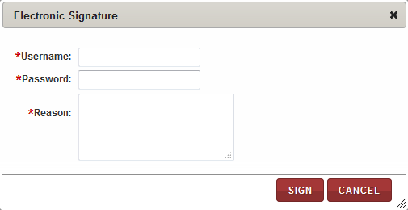

1. Electronic Signature window
2. Enter appropriate information in each field. Following table lists each field and itsdescription.

**Note:** Fields that are marked with the red asterisk (*) are mandatory.

Table : Deactivating a question

|  |  |
| --- | --- |
| **Field** | **Description** |
| **Username**\* | Type your user login username. |
| **Password**\* | Type your password. |
| **Reason**\* | Type a reason for this action. |

1. Click **SIGN**.

The question is deactivated and its status changes to **Inactive**.   
**Note:** To use this question for forms, you must activate the question.

### Deprecating a Question

To deprecate a question:  
  
**Note:**  You can only deprecate a question that has the **Inactive** status.

1. Log on to the application using your login credentials.

The CIRRASPEC home page appears.

1. Point to the arrow of the **IAMS** tab, and then click **Question Designer**.

The **Questions Search** page appears.

1. Click **SEARCH**.  
   The questions search page displays a list of questions.
2. Click the row of the question that you want to deprecate.

The **View Question** page appears.

1. Click **DEPRECATE**.

The question is deprecated and its status changes to **Deprecated**.   
**Note:** To use this question for forms, you must reinstate and then activate the question.

### Reinstating a Question

To reinstate a question:  
  
**Note:** You can only reinstate a question that has the **Deprecated** status.

1. Log on to the application using your login credentials.

The CIRRASPEC home page appears.

1. Point to the arrow of the **IAMS** tab, and then click **Question Designer**.

The **Questions Search** page appears.

1. Click **SEARCH**.  
   The questions search page displays a list of questions.
2. Click the row of the question that you want to reinstate.

The **View Question** page appears.

1. Click **REINSTATE**.

The question is reinstated and its status changes to **Inactive**.   
**Note:** To use this question for forms, you must activate the question.

### Using the Search Questions Window

You can access the **Search Questions** window from the **Create/Modify Question** page when creating a question. It allows you to search for an existing question to copy.

To search for an existing question to copy when creating a new question:

1. Log on to the application using your login credentials.

The CIRRASPEC home page appears.

1. Point to the arrow of the **IAMS** tab, and then click **Question Designer**.

The **Questions Search** page appears.

1. Click the **Create New Question** link.

The **Create/Modify Question** page appears.

1. Click on the **Search Questions** link.

If you have filled up any fields on this page, then a confirmation message appears stating that the search and add action will overwrite any information that you have already entered on the **Create/Modify Question** page.

1. Click **OK**.

The **Search Questions** window appears.

1. Click **SEARCH** to display all questions.

OR

In the box, type appropriate keyword tag or the question name, and then click **SEARCH**.  
All questions that match your search criteriaappear on the **Question Results** list.

**Note:**

* You can type the entire tag or question name, or you can type a part of it with an asterisk (*).
* To view the values that are associated with a question, click the arrow icon  next to the question.

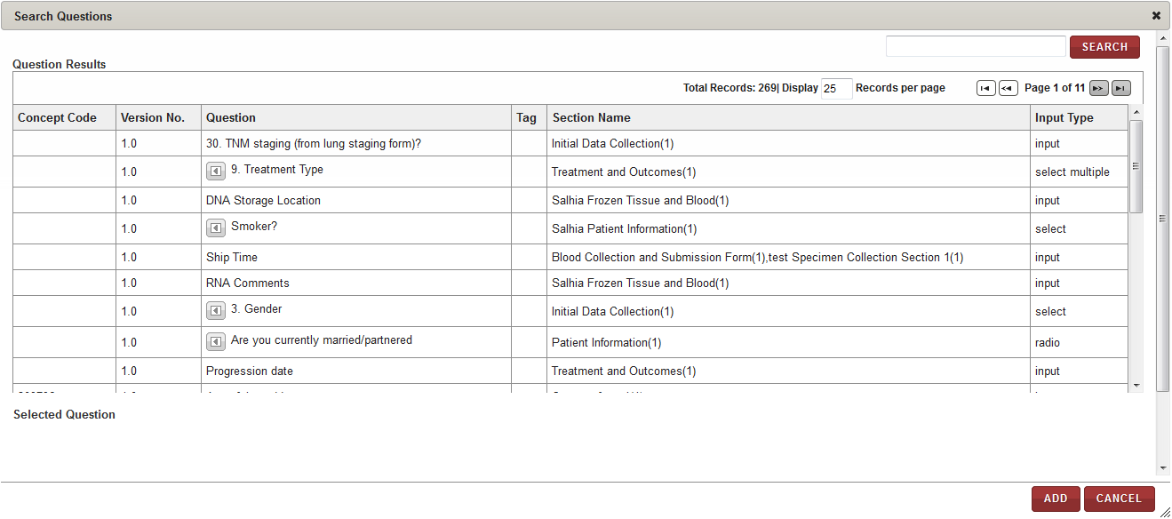

1. Search Questions window
2. Click the row of the question that you want to add.   
   The question appears in the **Selected Question** list.
3. To select a different question, click the appropriate question.  
   The previous question on the **Selected Question** list is replaced with the question.
4. To delete a question on the selected list, click the trash can icon  for the appropriate question.  
   The question is removed from the **Selected Question** list.
5. To include the answer values with the selected question, click the **Include Values** check box.

**Note:** This checkbox is selected by default.

You cannot select this check box for questions with **input** as the **Input Type.**

1. Click **ADD**.

If you had filled up any fields on the Create/Modify Question page, then a confirmation message appears stating that the search and add action will overwrite any information that you enter on the **Create/Modify Question** page.

1. Click **OK**.

The question that you selected appears on the **Create/Modify Question** page.   
If you selected the **Include Values** check box, the answer values associated with this question also appear on the **Create/Modify Question** page.

### Using the Search Question Values Window

You can access the **Search Question Values** window from the **Create/Modify Question** page when creating a new question or modifying an existing question. It allows you to search for answer values to add to the question.

To search for a question value:

1. Log on to the application using your login credentials.

The CIRRASPEC home page appears.

1. Point to the arrow of the **IAMS** tab, and then click **Question Designer**.

The **Questions Search** page appears.

1. If creating a new question, click the **Create New Question** link.

The **Create/Modify Question** page appears.   
OR  
If modifying an existing question, click the row of the question you want to modify and then click **MODIFY.**The **Create/Modify Question** page appears.

1. Click the **Search Values** link.

A confirmation message appears stating that the search and add action will overwrite any information that you have already entered on the **Create/Modify Question** page.

1. Click **OK**.

The **Search Question Values** window appears.

1. Click **SEARCH** to display all question values.   
   All values appear on the **Value Results** list.OR

In the box, type the question value that you want to search for, and then click **SEARCH**.

**Note:** You can type the entire value or part of it with an asterisk (*).

All values that match your search criteriaappear in the **Value Results** list.

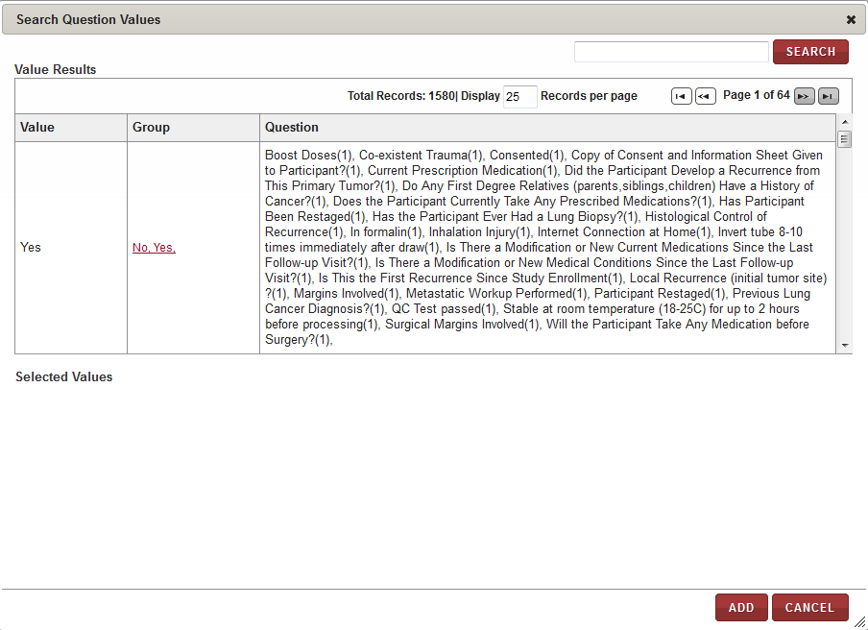

1. Search Question Values window
2. To add a question value, click the row of the value that you want to add.

The value appears in the **Selected Values** list.

**Note:** You can add multiple values to this list.  
OR  
To add question values that are grouped together based on Concept Code, click the link in the **Group** column for one of the values you want to add.  
All values associated with that group appear in the **Selected Values** list.

1. To delete a value from the selected list, click the trash can icon  for the appropriate value.  
   The value is removed from the **Selected Values** list.
2. Click **ADD**.

The **Search Question Values** pop-up closes and the value you selected appears on the **Create/Modify Question** page.

# Create and Manage Forms

### 

### Viewing a List of Forms

To view a list of data collection forms:

1. Log on to the application using your login credentials.

The CIRRASPEC home page appears.

1. Point to the arrow of the **IAMS** tab, and then click **Forms Designer**.

The **Forms Search** page appears.

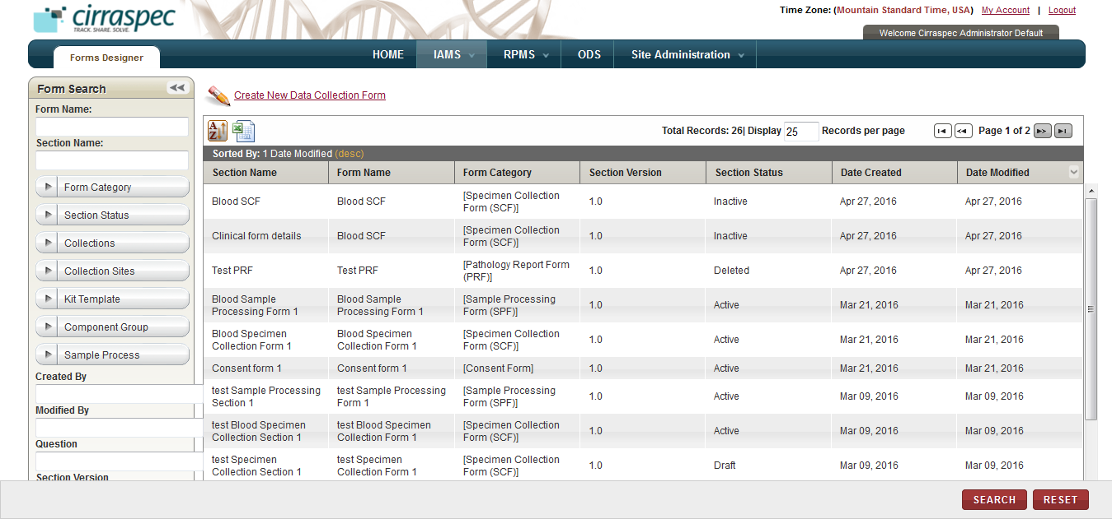

1. Forms Search page

**Note:** To re-sort the list, click the header of the column by which you want to sort. For more information about other ways to sort the list, see **Sorting Search Results**

On the forms search page, you can initiate the following tasks:

* **Print a forms list as an excel spreadsheet:** Click the **Export current view to CSV** icon , and then in the **File Download** window, click **Save**. The form list file is saved to your desktop for viewing/printing.
* **Search for a form**: For more information about how to search for a specific form or a group of forms, see **Searching for a Form**.
* **View details of a form:** For more information about how to view the details of a form, see **Viewing the Form Details**.
* **Create a new form:** For more information about how to create a new form, see **Creating a Form****.**

### Searching for a Form

To search for a specific data collection form or a group of forms:

1. Point to the arrow of the **IAMS** tab, and then click **Forms Designer**.   
   The **Forms Search** page appears.
2. Click **SEARCH**.  
   The forms search page displays the **Forms Search** pane.

Arrow hides/displays the Form Search pane



1. Forms search page
2. Specify your search criteria by completing one or more fields in the **Form Search** pane.

**Note:**

* You can use one field or a combination of fields to search for forms.
* You can type the full or partial value in a search field along with an asterisk (*) before or after the partial value. For example, if you type **02\***, you obtain records that begin with 02. If you type **\*02**, you obtain records that end with 02

Following table lists each search field and its description.

Table : Forms search fields

| **Field** | **Description** |
| --- | --- |
| **Form Name** | Type name of the form that you want to search. |
| **Section Name** | Type name of the section that you want to search. |
| **Form Category** | Click appropriate category to search for all forms of this category.  **Note:** To search for forms of any category, click **All**. |
| **Section Status** | Click appropriate status to search for all sections with this status.  **Note:** To search for sections with any status, click **All**. |
| **Collections** | Click appropriate Collection to search for forms associated with this Collection.  **Note:** To search for forms associated with all Collections, click **All**. |
| **Collection Sites** | Click appropriate Collection Site to search for forms associated with this Collection Site.  **Note:** To search for forms associated with all Collection Sites, click **All**. |
| **Kit Template** | Click name of the kit template to search for forms associated with this kit template. **Note:** To search for forms associated with all kit templates, click **All**. |
| **Component Group** | Click name of the kit component group to search for forms associated with this component group. **Note:** To search for forms associated with all component groups, click **All**. |
| **Sample Process** | Click name of the sample processing workflow to search for forms associated with this workflow. **Note:** To search for forms associated with all sample processing workflows, click **All**. |
| **Created By** | Type the login username of the user to search for forms created by that user. |
| **Modified By** | Type the login username of the user to search for forms modified by that user. |
| **Question** | Type the question that you want to search for. |
| **Section Version** | Type a version to search for all sections with this version. |
| **Date Created Range** | Click the date icon and then in the pop-up, select appropriate date option to search for forms created in this timeframe. For more information, see **Understanding the Date Range Options** |
| **Date Modified Range** | Click the date icon and then in the pop-up, select appropriate date option to search for forms modified in this timeframe. For more information, see **Understanding the Date Range Options** |

1. Click **SEARCH**.  
   The search results appear.   
   **Note:** Click the header of the column with which you want to sort the results. For more information about how to sort the search results, see **Sorting Search Results**

### Viewing the Form Details

To view the details of a data collection form:

1. Log on to the application using your login credentials.

The CIRRASPEC home page appears.

1. Point to the arrow of the **IAMS** tab, and then click **Forms Designer**.

The **Forms Search** page appears.

1. Click **SEARCH**.

The forms search page displays a list of forms.

1. Click the form for which you want to view the details.

The **View Form** page appears.

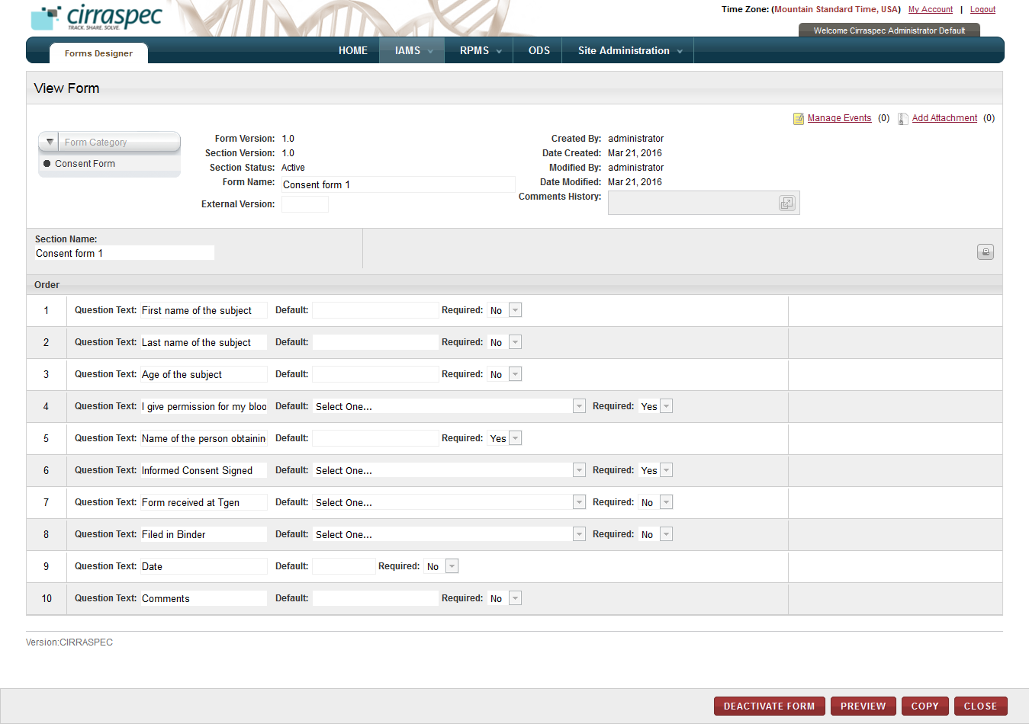

1. View Form page

**Note:**

* To expand the **Comments History** box to display additional historical comments, click the expand icon .
* If there are multiple sections to the form, to view a different section:
* Click the select box to the right of the **Section Name.  
  Note:** This select box only appears if there are multiple sections.
* Select the section in the list that you want to view.Information for the selected section appears on the **View Form** page.
* To print a list of the section fields on the **View Form** page:
* Click the print icon 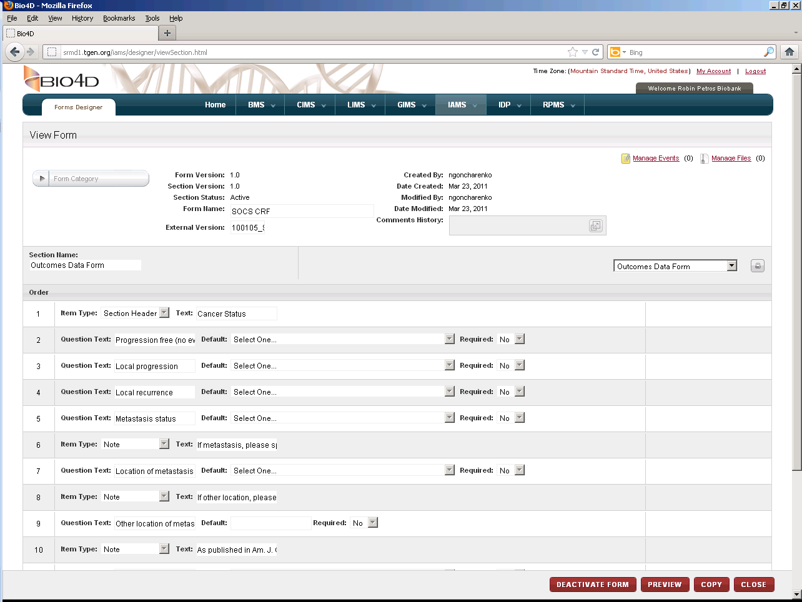 in the **Section Name** header (far right).
* Click **File** in the top navigation bar, and then click **Print**.

Note: Click the **Alt** button from the keyboard if the menu bar does not show up by default in the new window.

On the **View Form** page, you can perform the following tasks:

* **View the form layout:** You can view the actual form layout in a separate window by clicking on **PREVIEW**. For more information about how to preview a form, see **Previewing a Form****.**
* **Copy a form**: For more information about how to copy an existing form to create a new form, see **Copying a Form**.
* **Create a new form section**: For more information about how to create a new form section, see **Creating a New Section for a Form**.
* **Modify a form:** For more information about how to modify a form, see **Modifying a Form**.
* **Delete a form:** For more information about how to delete a form, see **Deleting a Form**.
* **Activate a form:** For more information about how to activate a form, see **Activating a Form**.
* **Deactivate a form:** For more information about how to deactivate a form, see **Deactivating a Form**.
* **Deprecate a form:** For more information about how to deprecate a form, see **Deprecating a Form**.
* **Reinstate a form:** For more information about how to reinstate a form, see **Reinstating a Form**.
* **Manage events:** You can view and add events to a kit by clicking the **Manage Events** link. For more information about how to manage events, see **Managing Events**
* **Add Attachment**: You can upload, download, and delete files that are attached to a kit by clicking the Add Attachment link. For more information about how to add files, see **Common File Upload**

Previewing a Form

To view the actual layout of a data collection form:

1. Log on to the application using your login credentials.

The CIRRASPEC home page appears.

1. Point to the arrow of the **IAMS** tab, and then click **Forms Designer**.

The **Forms Search** page appears.

1. Click **SEARCH**.

The forms search page displays a list of forms.

1. Click the form you want to preview.

The **View Form** page appears.

1. Click **PREVIEW**.  
   The form appears in a new window.

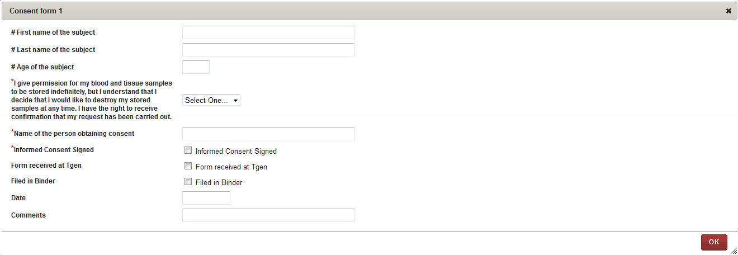

1. Preview Form

Note: PHI questions are marked with the hash symbol (#).

### Creating a Form

To create a data collection form:  
  
**Note:** The Create procedure below uses a blank form to create a new form. To copy an existing form and create a new form using its information, see **Copying a Form**.

1. Log on to the application using your login credentials.

The CIRRASPEC home page appears.

1. Point to the arrow of the **IAMS** tab, and then click **Forms Designer**.

The **Forms Search** page appears.

1. Click the **Create New Data Collection Form** link.

The **Create/Modify Form** page appears.

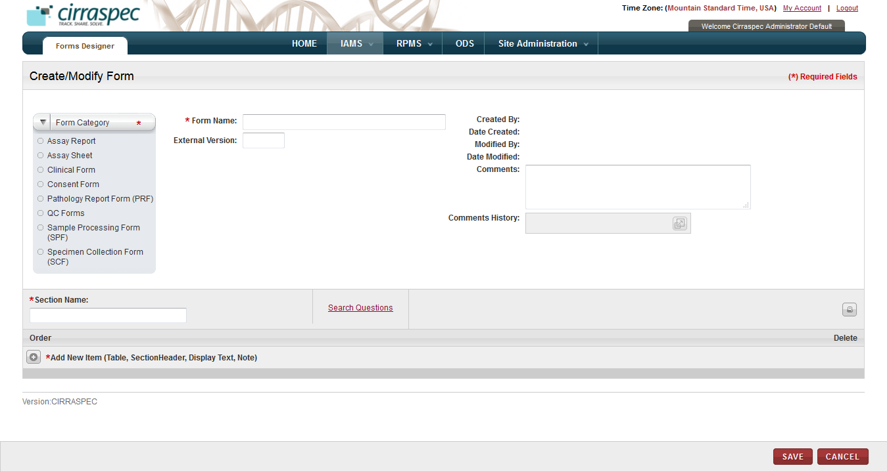

1. Create/Modify Form page
2. Enter appropriate information in each field. Following table lists each field and its description.

**Note:** Fields that are marked with the red asterisk (*) are mandatory.

Table : Creating a form

| **Field** | **Description** |
| --- | --- |
| **Form Category\*** | Click appropriate category for this form. |
| **Form Name\*** | Type name for this form. **Note:** You cannot use an existing form name. |
| **External Version** | Type the external version number you want to assign, if applicable. |
| **Comments** | Type your comments regarding this action, if applicable. |
| **Section Name\*** | Type name of the first section of this form. |

1. To add questions to this section:
2. Click the **Search Questions** link.

The **Search Questions** window appears.

1. Click **SEARCH** to display all questions.

OR

In the box, type appropriate key word tag or the question name, and then click **SEARCH**.  
All questions that match your search criteriaappear in the **Question Results** list. **Note:**

* You can type the entire tag or question name, or you can type part of it with an asterisk (*).
* To view values associated with a question, click the arrow icon  next to the question.

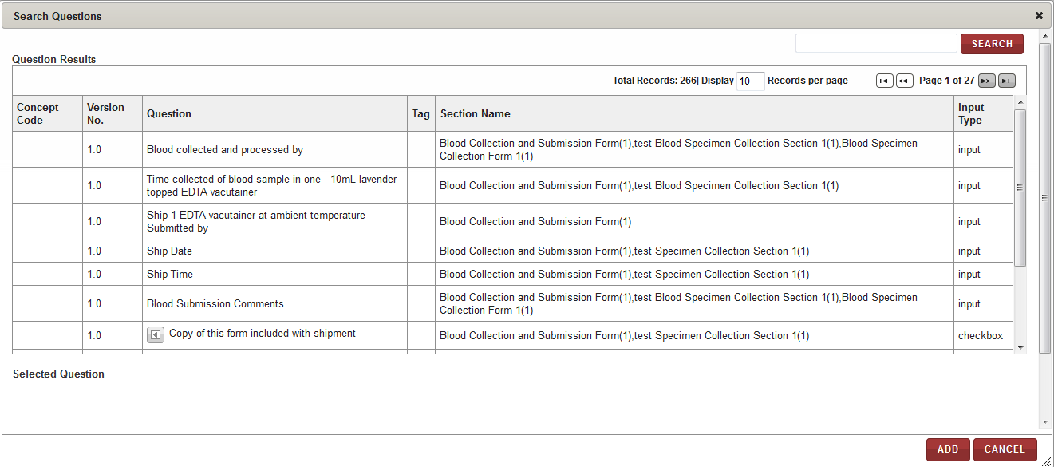

1. Search questions window
2. Click the rows of the questions that you want to add.   
   The **Selected Question** table displays the list of questions that you click.
3. To delete a question from the **Selected Question** table, click the trash can icon  for the appropriate question.
4. Click **ADD**.

The **Create/Modify Form** page displays the list of questions and their related fields.   
To modify the question text, in the **Question Text** box, type the new text.

1. To set the default answer options on this question, type the appropriate default answer in the box beside **Default,** or click **Select One** and then select the appropriate default answer.
2. To display a question as a mandatory field, in the **Required** list, click **Yes**.
3. To delete a question, click the trash can icon  for the appropriate question, and then in the confirmation window, click **OK**.
4. To change the order of the questions, click a question and drag it to the appropriate location in the list.

The rows are renumbered accordingly.

1. To add a new item to the section:
2. Click the **Add More** icon  next to **Add New Item (Table, Section Header, Display Text, Note)**.
3. In the **Item Type** list, click the appropriate item.

* If you click **Section Header** in the **Item Type** list, in the textbox, type the header you want to be displayed on the form.
* If you click **Note** in the **Item Type** list, in the textbox, type the text you want to be displayed on the form.

**Note:** The text that you type in this box appears in the *italics* font on the actual form.

* If you click **Table** in the **Item Type** list, enter appropriate information in each field. Following table lists each field and its description.

Table : Adding a table

| **Field** | **Description** |
| --- | --- |
| **Row** | Click appropriate number to indicate how many rows of answers you want the table on the form to have. |
| **Search Table Questions** | 1. Click this link.  **Search Questions** window appears. 2. Click **SEARCH** to display all questions.   OR  In the box, type appropriate key word tag or the question name, and then click **SEARCH**. All questions that match your search criteriaappear in the **Question Results** list. **Note:** You can type the entire tag or question name, or you can type part of it with an asterisk (*).   1. To view the answer values that are associated with a question, click the arrow icon arrow icon next to the question. 2. Click rows of the questions that you want to add.  The **Selected Question** table displays the list of questions that you click. 3. To delete a question from the **Selected Question** table, click the trash can icon trash can icon for the appropriate question. 4. Click **ADD**.   The **Create/Modify Form** page displays the list of questions and their related fields under the **Table** Item Type.  To modify the question text, in the **Header** box, type the new text.   1. To set the default answer options for this question, type the appropriate default answer in the box beside **Default,** or click **Select One** and then select the appropriate default answer. 2. To display a question as a mandatory field, in the **Required** list, click **Yes**. |

1. To delete an item, click the trash can icon  for the appropriate item, and then in the confirmation window, click **OK**.
2. To change the order of the items:
3. Place the cursor on the row of the value you want to move.
4. Click the left mouse button and ‘drag and drop’ the item into the row you want to move it.  
   The rows are numbered accordingly.
5. You may add multiple questions, section headers, tables and notes by repeating the steps above.
6. Click **SAVE**.

The form is created and appears on the **View Form** page. The status of this form is set to **Draft** and its version is set to **1.0.**  
**Note:**

* The form does not appear on the **Forms Search** page as a whole, but appears according to the sections it contains.
* To add an additional section to this form, see **Creating a New Section for a Form**.
* You must activate the form for it to be available for use. For more information about how to activate a form, see **Activating a Form**.

### Copying a Form

To copy an existing form and create a new form using the existing information:

1. Log on to the application using your login credentials.

The CIRRASPEC home page appears.

1. Point to the arrow of the **IAMS** tab, and then click **Forms Designer**.

The **Forms Search** page appears.

1. Click **SEARCH**.

The forms search page displays a list of forms.

1. Click the rowof the form that you want to copy.

The **View Form** page appears.

1. Click **COPY**.

The **Copy Form** window appears.

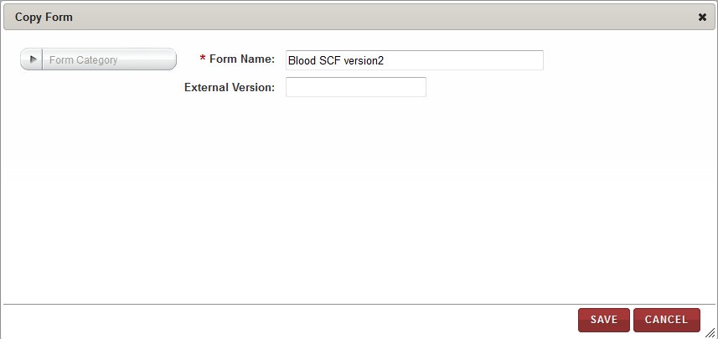

1. Copy Form window
2. Enter appropriate information in each field. Following table lists each field and its description.

Note: Fields that are marked with the red asterisk (*) are mandatory.

Table : Copying a form

| **Field** | **Description** |
| --- | --- |
| **Form Category**\* | Click the appropriate category for this form. **Note:**   * You may select multiple categories. * To select all categories, click **ALL**. |
| **Form Name**\* | Type the name for this form. **Note:** You cannot use an existing form name. |
| **External Version** | Type the external version number you want to assign, if applicable. |

1. Click **SAVE**.

A copy of the form is created and appears on the **View Form** page. The status of this form is set to **Draft**, and its version isset to **1.0**.   
**Note:**

* To modify the copied form, see **Modifying a Form**.
* To activate the copied form without any changes, see **Activating a Form**.

### Creating a New Section for a Form

**Note:** You can only add a section to a form with the **Draft** or **Inactive** status.

1. Log on to the application using your login credentials.

The CIRRASPEC home page appears.

1. Point to the arrow of the **IAMS** tab, and then click **Forms Designer**.

The forms search page appears.

1. Click **SEARCH**.

The forms search page displays a list of forms.

1. Click the rowof the form that you want to modify.

The **View Form** page appears.

1. Click the **Create New Section** link.  
   The **Create/Modify Form** page appears.

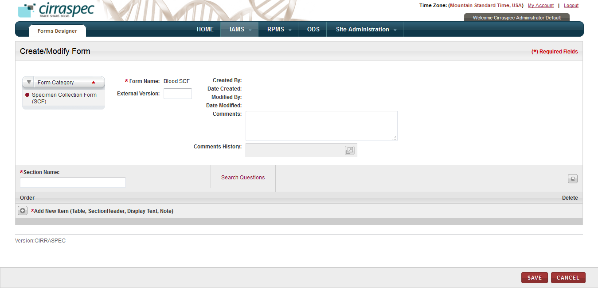

1. Create/Modify Form – Create New Section
2. Enter appropriate information in each field. Following table lists each field and its description.

**Note:** Fields that are marked with the red asterisk (*) are mandatory.

Table : Creating a new section

| **Field** | **Description** |
| --- | --- |
| **Form Category\*** | If you want to change the category for this form, select the appropriate category. |
| **External Version** | Type the external version number you want to assign, if applicable. |
| **Comments** | Type your comments regarding this action, if applicable. |
| **Section Name\*** | Type the section name you want to add to the form. |

1. To add questions to this section:
2. Click the **Search Questions** link.   
   The **Search Questions** window appears.
3. Click **SEARCH** to display all questions.

OR  
In the box, type the appropriate key word tag or the question name, and then click **SEARCH**.  
All questions that match your search criteriaappear on the **Question Results** list. **Note:**

* You can type the entire tag or question name, or you can type part of it with an asterisk (*).
* To view the values that are associated with a question, click the arrow icon  next to the question.

1. Click the rows of the questions that you want to add.   
   The **Selected Question** table displays the list of questions that you click.
2. To delete a question from the **Selected Question** table, click the trash can icon  for the appropriate question.
3. Click **ADD**.

The **Create/Modify Form** page displays the list of questions and their related fields.   
To modify the question text, in the **Question Text** box, type the new text.

1. To set a default answer option for this question, type the appropriate default answer in the box beside **Default,** or click **Select One** and then select the appropriate default answer.
2. To display a question as a mandatory field, in the **Required** list, click **Yes**.
3. To delete a question, click the trash can icon  for the appropriate question, and then in the confirmation window, click **OK**.
4. To change the order of the questions, click a question and drag it to the appropriate location in the list.

The rows are renumbered accordingly.

1. To add a new item to the section:
2. Click the **Add More** icon  next to **Add New Item (Table, Section Header, Display Text, Note)**.
3. In the **Item Type** list, click the appropriate item.

* If you click **Section Header** in the **Item Type** list, in the textbox, type the header you want to be displayed on the form.
* If you click **Note** in the **Item Type** list, in the textbox, type the text you want to be displayed on the form.

**Note:** The text that you type in this box appears in the *italics* font on the actual form.

* If you click **Table** in the **Item Type** list, enter the appropriate information in each field. Following table lists each field and its description.

Table : Adding a table

| **Field** | **Description** |
| --- | --- |
| **Row** | Click appropriate number to indicate how many rows of answers you want the table on the form to have. |
| **Search Table Questions** | 1. Click this link.  **Search Questions** window appears. 2. Click **SEARCH** to display all questions.   OR  In the box, type appropriate key word tag or the question name, and then click **SEARCH**. All questions that match your search criteriaappear in the **Question Results** list. **Note:** You can type the entire tag or question name, or you can type part of it with an asterisk (*).   1. To view the values that are associated with a question, click the arrow icon arrow icon next to the question. 2. Click the rows of the questions that you want to add.  The **Selected Question** table displays the list of questions that you click. 3. To delete a question from the **Selected Question** table, click the trash can icon trash can icon for the appropriate question. 4. Click **ADD**.   The **Create/Modify Form** page displays the list of questions and their related fields under the **Table** Item Type.  To modify the question text, in the **Header** box, type the new text.   1. To set a default answer option for this question, type the appropriate default answer in the box beside **Default,** or click **Select One** and then select the appropriate default answer. 2. To display a question as a mandatory field, in the **Required** list, click **Yes**. |

1. To delete an item, click the trash can icon  for the appropriate item, and then in the confirmation window, click **OK**.
2. To change the order of the items:
3. Place the cursor on the row of the value you want to move.
4. Click the left mouse button and ‘drag and drop’ the item into the row you want to move it.  
   The rows are numbered accordingly.
5. You may add multiple questions, section headers, tables and notes by repeating the steps above.
6. Click **SAVE**.

The new section of the form is created and appears on the **View Form** page. The status of the section is set to **Draft** and its version is set to **1.0.**  
**Note:**

* The form does not appear on the **Forms Search** page as a whole, but appears according to the sections it contains.
* To add an additional section to this form, see **Creating a New Section for a Form**.
* You must activate this section for it to be available for use. For more information about how to activate a form, see **Activating a Form**.

### Modifying a Form

To modify a form:  
  
**Note:** You can only modify a form with the **Draft** or **Inactive** status.

1. Log on to the application using your login credentials.

The CIRRASPEC home page appears.

1. Point to the arrow of the **IAMS** tab, and then click **Forms Designer**.

The **Forms Search** page appears.

1. Click **SEARCH**.

The forms search page displays a list of forms.

1. Click the rowof the form that you want to modify.

The **View Form** page appears.

1. To add a new section to this form, click on the **Create New Section** link and follow the procedures outlined in **Creating a New Section for a Form**.
2. If there are multiple sections to the form:

* Click the select box to the right of the **Section Name**.  
  **Note:** This select box only appears if there are multiple sections.
* Select the section you want to modify.

1. Click **MODIFY**.

The **Create/Modify Form** page appears.

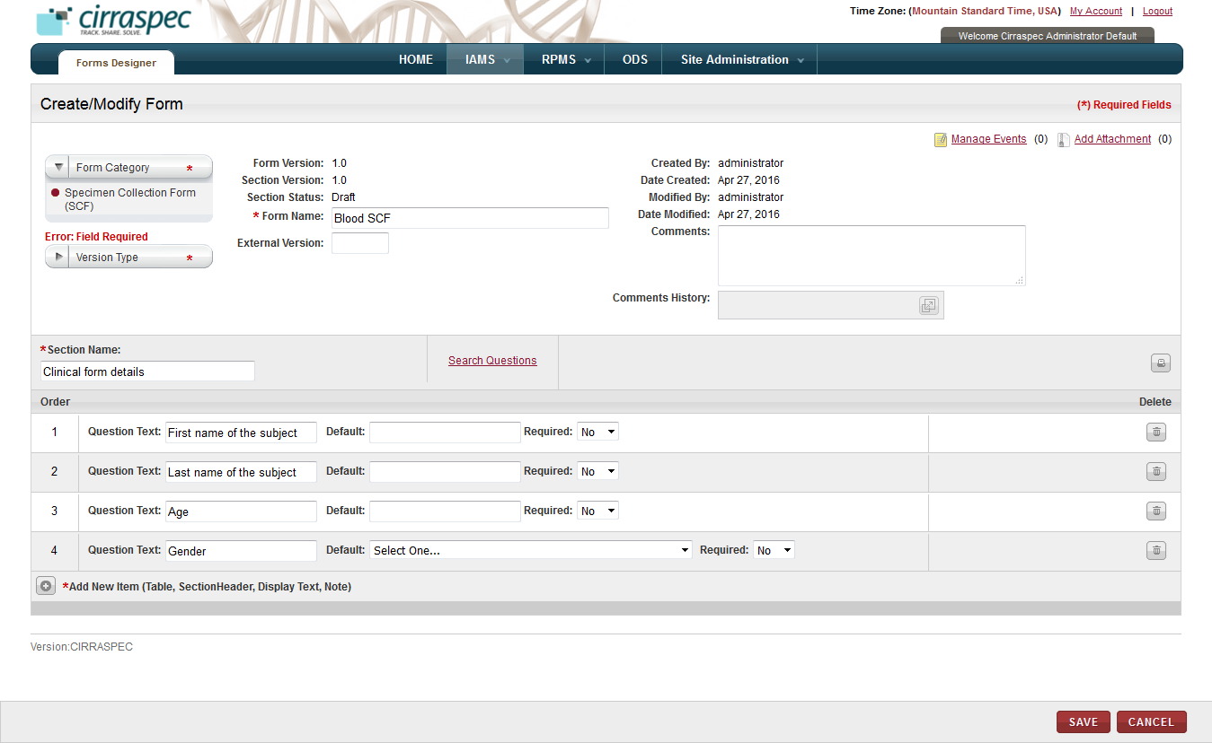

1. Create/Modify page
2. Enter appropriate information in each field. Following table lists each field and its description.

**Note:** Fields that are marked with the red asterisk (*) are mandatory.

Table : Modifying a form

| **Field** | **Description** |
| --- | --- |
| **Form Category\*** | If you want to modify the category for this form, select the appropriate category. |
| **Version Type\*** | Click the appropriate version type.  You can select one of the following version types:   * **Major:** The version number is incremented to next whole number (1.00 to 2.00). * **Minor:** The version number is incremented by one-tenth (.10) of one percent (1.1 to 1.2). * **No Change:** The version number does not change. |
| **Form Name\*** | If you want to change the form name, type a new name. |
| **External Version** | Type the external version number you want to assign, if applicable. |
| **Comments** | Type your comments regarding this action, if applicable. |
| **Section Name\*** | If you want to change the form name, type a new name. |

1. To add questions to this section:
2. Click the **Search Questions** link.   
   The **Search Questions** window appears.
3. Click **SEARCH** to display all questions.

OR  
In the box, type appropriate key word tag or the question name, and then click **SEARCH**.  
All questions that match your search criteriaappear in the **Question Results** list. **Note:**

* You can type the entire tag or question name, or you can type a part of it with an asterisk (*).
* To view the values that are associated with a question, click the arrow icon  next to the question.

1. Click the rows of the questions that you want to add.   
   The **Selected Question** table displays the list of questions that you click.
2. To delete a question from the **Selected Question** table, click the trash can icon  for the appropriate question.
3. Click **ADD**.

The **Create/Modify Form** page displays the list of questions and their related fields.   
To modify the question text, in the **Question Text** box, type the new text.

1. To set default answer options for these questions, type the appropriate default answer in the box beside **Default,** or click **Select One** and then select the appropriate default answer.
2. To display a question as a mandatory field, in the **Required** list, click **Yes**.
3. To delete a question, click the trash can icon  for the appropriate question, and then in the confirmation window, click **OK**.
4. To change the order of the questions, click a question and drag it to the appropriate location in the list.

The rows are renumbered accordingly.

1. To add a new item to the section:
2. Click the **Add More** icon  next to **Add New Item (Table, Section Header, Display Text, Note)**.
3. In the **Item Type** list, click the appropriate item.

* If you click **Section Header** in the **Item Type** list, in the textbox, type the header you want to displayed on the form.
* If you click **Note** in the **Item Type** list, in the textbox, type the text you want displayed on the form.

**Note:** The text that you type in this box appears in the *italics* font on the actual form.

* If you click **Table** in the **Item Type** list, enter the appropriate information in each field. The following table lists each field and its description.

Table : Adding a table

| **Field** | **Description** |
| --- | --- |
| **Row** | Click the appropriate number to indicate how many rows of question answers you want the table on the form to have. |
| **Search Table Questions** | 1. Click this link.  **Search Questions** window appears. 2. Click **SEARCH** to display all questions.   OR  In the box, type appropriate key word tag or the question name, and then click **SEARCH**. All questions that match your search criteriaappear in the **Question Results** list. **Note:** You can type the entire tag or question name, or you can type a part of it with an asterisk (*).   1. To view the values that are associated with a question, click the arrow icon arrow icon next to the question. 2. Click the rows of the questions that you want to add.  The **Selected Question** table displays the list of questions that you click. 3. To delete a question from the **Selected Question** table, click the trash can icon trash can icon for the appropriate question. 4. Click **ADD**.   The **Create/Modify Form** page displays the list of questions and their related fields under the **Table** Item Type.  To modify the question text, in the **Header** box, type the new text.   1. To set a default answer option for this question, type the appropriate default answer in the box beside **Default,** or click **Select One** and then select the appropriate default answer. 2. To display a question as a mandatory field, in the **Required** list, click **Yes**. |

1. To delete an item, click the trash can icon  for the appropriate item, and then in the confirmation window, click **OK**.
2. To change the order of the items:
3. Place the cursor on the row of the value you want to move.
4. Click the left mouse button and ‘drag and drop’ the item into the row you want to move it.  
   The rows are numbered accordingly.
5. You may add multiple questions, section headers, tables and notes by repeating the steps above.
6. Click **SAVE**.

The changes are saved and appear on the **View Form** page. The status of the section does not change. The form version and section version are increased based on your selection in **Version Type**.   
**Note:**

* The form does not appear on the **Forms Search** page as a whole, but appears according to the sections it contains.
* You must activate this section for it to be available for use. For more information about how to activate a form, see **Activating a Form**.

### Deleting a Form

**Note:** You can only delete a form with the **Draft** status.

To delete a form:

1. Log on to the application using your login credentials.

The CIRRASPEC home page appears.

1. Point to the arrow of the **IAMS** tab, and then click **Forms Designer**.

The **Forms Search** page appears.

1. Click **SEARCH**.

The forms search page displays a list of forms.

1. Click the rowof the form that you want to delete.

The **View Form** page appears.

1. Click **DELETE**.

A confirmation window appears.

1. Click **OK**.

The **Forms Search** page displays the form with the **Deleted** status. The form is only available for viewing and copying.

### Activating a Form

To activate a form:  
  
**Note:** You can only activate a form that has the **Draft** or **Inactive** status.

1. Log on to the application using your login credentials.

The CIRRASPEC home page appears.

1. Point to the arrow of the **IAMS** tab, and then click **Forms Designer**.

The **Forms Search** page appears.

1. Click **SEARCH**.

The forms search page displays a list of forms.

1. Click the rowof the form that you want to activate.

The **View Form** page appears.

1. Click **ACTIVATE FORM**.

The **Electronic Signature** window appears.

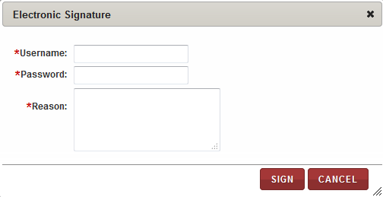

1. Electronic Signature window
2. Enter appropriate information in each field. Following table lists each field and its description.

Note: Fields that are marked with the red asterisk (*) are mandatory.

Table : Activating a form

| **Field** | **Description** |
| --- | --- |
| **Username**\* | Type your user login username. |
| **Password**\* | Type your password. |
| **Reason**\* | Type a reason for this action. |

1. Click **SIGN**.

The status of the form is set to **Active** on the **View Form** page. The form is now available for use.

### Deactivating a Form

**Note:** You can only deactivate a form that has the **Active** status.

To deactivate a form:

1. Log on to the application using your login credentials.

The CIRRASPEC home page appears.

1. Point to the arrow of the **IAMS** tab, and then click **Forms Designer**.

The **Forms Search** page appears.

1. Click **SEARCH**.

The forms search page displays a list of forms.

1. Click the rowof the form that you want to deactivate.

The **View Form** page appears.

1. Click **DEACTIVATE FORM**.

The **Electronic Signature** window appears.



1. Electronic Signature window
2. Enter appropriate information in each field. Following table lists each field and its description.

**Note:** Fields that are marked with the red asterisk (*) are mandatory.

Table : Deactivating a form

| **Field** | **Description** |
| --- | --- |
| **Username**\* | Type your user login username. |
| **Password**\* | Type your password. |
| **Reason**\* | Type a reason for this action. |

1. Click **SIGN**.

The status of the form changes to **Inactive**. You can use this form only after you activate it.  
For more information about how to activate a form, see **Activating a Form**.

### Deprecating a Form

**Note:** You can only deprecate a form that has the **Inactive** status.

To deprecate a form:

1. Log on to the application using your login credentials.

The CIRRASPEC home page appears.

1. Point to the arrow of the **IAMS** tab, and then click **Forms Designer**.

The **Forms Search** page appears.

1. Click **SEARCH**.

The forms search page displays a list of forms.

1. Click the rowof the form that you want to deprecate.

The **View Form** page appears.

1. Click **DEPRECATE**.

The status of the form changes to **Deprecated**. To use this form again, you must reinstate the form, and then activate it. For more information about how to reinstate a form, see **Reinstating a Form**.

### Reinstating a Form

**Note:** You can only reinstate a form that has the **Deprecated** status.

To reinstate a form:

1. Log on to the application using your login credentials.

The CIRRASPEC home page appears.

1. Point to the arrow of the **IAMS** tab, and then click **Forms Designer**.

The **Forms Search** page appears.

1. Click **SEARCH**.

The forms search page displays a list of forms.

1. Click the rowof the form that you want to reinstate.

The **View Form** page appears.

1. Click **REINSTATE**.

The status of the form changes to **Inactive**. To use this form, you must activate it.

For more information about how to activate a form, see **Activating a Form**.

# Import various Workflow Process Types using standardized Templates

### Uploading a Process Template

You can use this standardized spreadsheet template to populate fields in the Laboratory Information Management System (**LIMS**)module when initiating sample processing workflows. Each type of sample processing workflow has a template spreadsheet of pre-defined variables.  
  
Once a sample processing template is completed, uploaded in the **Import Data** module and assigned in the Research Project Management System (**RPMS**) module, the template can be used to auto-populate the **LIMS Create Workflow** screen fields with the pre-defined information from the template.

To upload a Process Template:

1. Complete the **Process Template** spreadsheet.   
   **Note:**

* You can obtain a copy of the template spreadsheet by contacting the System Administrator or sending an email request to [cirraspec@tgen.org](mailto:Bio4Dhelp@tgen.org).
* Template must be saved as an Excel Workbook with .xlsx extension.

Following table lists each field and its description.

**Note:** Fields that are marked with the red asterisk (*) are mandatory.

Table : Completing the Process Template spreadsheet

| **Field** | **Description** |
| --- | --- |
| **Template Name**\* | Type the name you want to use for the template. **Note:** This is the option that is displayed on the **Create Workflow** page when selecting a process template in the **LIMS** module. |
| **Template Description**\* | Type a brief description of the purpose of this template. **Note:** This is the workflow name that is displayed on the **Create Workflow** page when this process template is used in the **LIMS** module. |
| **Override Template** | If you want to replace a previous version of this same template:   * Click this field, and then click on the arrow to display a list. * Click **Yes**.   **Note:** The default for this field is **No**, which indicates that the template being uploaded is new and is not replacing an existing template. |
| **Process Type**\* | To indicate which workflow process this template is used for:   * Click this field, and then click on the arrow to display a list of options. * Click the appropriate process. |
| **SOP** | Skip this field. Reserved for future use. |
| **Instrument** | Skip this field. Reserved for future use. |
| **Workflow Name** | Type the name you want to use for the workflow, if applicable. **Note:** This is the workflow name that is displayed on the **LIMS Create Workflow** page when this process template is used. |
| **Comment** | Type your comments regarding the workflow, if applicable.  **Note:** This is the comment that is displayed on the **LIMS Create Workflow** page when this process template is used. |
| The following fields can be blank. However, values in these fields pre-populate the **Processing Details** window when this process template is used in the **LIMS** module. | |
| **Input Specimen Type** | To indicate the specimen type of the parent biospecimen for which this template is used:   * Click this field, and then click on the arrow to display a list of options. * Click the appropriate type. |
| **Input Consumed Quantity** | Type the amount of the biospecimen that is consumed by sample processing when using this template. |
| **Input Consumed Quantity Unit** | To indicate the unit of measure for the consumed quantity of the parent biospecimen when using this template:   * Click this field, and then click on the arrow to display a list of options. * Click the appropriate unit.   **Note:** This field is required if you entered an amount in **Input Consumed Quantity**. |
| **Input Consumed Concentration** | Type the concentration of the parent biospecimen that is consumed by sample processing when using this template. |
| **Input Consumed Concentration Unit** | To indicate the unit of measure for the consumed concentration:   * Click this field, and then click on the arrow to display a list of options. * Click the appropriate unit.   **Note:** This field is required if you entered an amount in **Input Consumed Concentration**. |
| **Input Adjusted Quantity** | To adjust the quantity of the parent biospecimen based on the current quantity being wrong, input the amount by which you want to increase or decrease the quantity.   * To decrease the quantity, input a negative amount. * To increase the quantity, input a positive amount.   **Note:**   * Only complete this fieldif you need to adjust the current quantity of the parent biospecimen separate from and in addition to the amount indicated in **Input Consumed Quantity**. * For example, if the initial quantity was wrong, the quantity should be adjusted. |
| **Input Adjusted Quantity Unit** | To indicate the unit of measure for the adjusted quantity:   * Click this field, and then click on the arrow to display a list of options. * Click the appropriate unit.   **Note:** This field is required if you entered an amount in **Input Adjusted Quantity**. |
| **Input Adjusted Quantity Reason** | To indicate the reason for the adjusted quantity:   * Click this field, and then click on the arrow to display a list of options. * Click the appropriate reason.   **Note:** This field is required if you entered an amount in **Input Adjusted Quantity**. |
| **Input Adjusted Concentration** | To adjust the concentration of the parent biospecimen based on the current concentration being wrong, input the amount by which you want to increase or decrease the concentration.   * To decrease the concentration, input a negative amount. * To increase the concentration, input a positive amount.   **Note:**   * Only complete this fieldif you need to adjust the current concentration of the parent biospecimen separate from and in addition to the amount indicated in **Input Consumed Concentration**. * For example, if the initial concentration was wrong, the concentration should be adjusted. |
| **Input Adjusted Concentration Unit** | To indicate the unit of measure for the adjusted concentration:   * Click this field, and then click on the arrow to display a list of options. * Click the appropriate unit.   **Note:** This field is required if you entered an amount in **Input Adjusted Concentration**. |
| **Input Adjusted Concentration Reason** | To indicate the reason for the adjusted concentration:   * Click this field, and then click on the arrow to display a list of options. * Click the appropriate reason.   **Note:** This field is required if you entered an amount in **Input Adjusted Concentration**. |
| **No of Outputs** | Type the number of output biospecimens you want created when using this template. |
| **Output Specimen Type** | To indicate the specimen type of the output biospecimen you want created when using this template:   * Click this field, and then click on the arrow to display a list of options. * Click the appropriate type. |
| **Output Sample Type** | To indicate the sample type of the output biospecimen you want created when using this template:   * Click this field, and then click on the arrow to display a list of options. * Click the appropriate type. |
| **Output Container Type** | To indicate the container type for the output biospecimen you want used when using this template:   * Click this field, and then click on the arrow to display a list of options. * Click the appropriate type. |
| **Protocol** | If you are completing a Derivative template, indicate the appropriate protocol when using this template:   * Click this field, and then click on the arrow to display a list of options. * Click the appropriate option.   **Note:** This field is only used for the Derivative processing template. |
| **Staining Technique** | If you are completing a Derivative template, indicate the appropriate staining technique when using this template:   * Click this field, and then click on the arrow to display a list of options. * Click the appropriate option.   **Note:** This field is only used for the Derivative processing template. |
| **Output Initial Quantity** | Type the amount of the output biospecimen that is created by the sample processing when using this template. |
| **Output Initial Quantity Unit** | To indicate the unit of measure for the initial quantity of the output biospecimen when using this template:   * Click this field, and then click on the arrow to display a list of options. * Click the appropriate unit.   **Note:** This field is required if you entered an amount in **Output Initial Quantity**. |
| **Output Initial Concentration** | Type the concentration of the output biospecimen that is created by the sample processing when using this template. |
| **Output Initial Concentration Unit** | To indicate the unit of measure for the initial concentration of the output biospecimen:   * Click this field, and then click on the arrow to display a list of options. * Click the appropriate unit.   **Note:** This field is required if you entered an amount in **Output Initial Concentration**. |
| **Output Adjusted Quantity** | To adjust the quantity of the output biospecimen that will remain after sample processing, input the amount by which you want to increase or decrease the quantity.   * To decrease the quantity, input a negative amount. * To increase the quantity, input a positive amount.   **Note:**   * Only complete this fieldif you need to adjust the resulting quantity of the output biospecimen separate from and in addition to the amount indicated in **Output Initial Quantity**. * For example, if the output sample is diluted during processing, the remaining quantity should be adjusted. |
| **Output Adjusted Quantity Unit** | To indicate the unit of measure for the adjusted quantity:   * Click this field, and then click on the arrow to display a list of options. * Click the appropriate unit.   **Note:** This field is required if you entered an amount in **Output Adjusted Quantity**. |
| **Output Adjusted Quantity Reason** | To indicate the reason for the adjusted quantity:   * Click this field, and then click on the arrow to display a list of options. * Click the appropriate reason.   **Note:** This field is required if you entered an amount in **Input Adjusted Quantity**. |
| **Output Adjusted Concentration** | To adjust the concentration of the output biospecimen that will remain after sample processing, input the amount by which you want to increase or decrease the concentration.   * To decrease the concentration, input a negative amount. * To increase the concentration, input a positive amount.   **Note:**   * Only complete this fieldif you need to adjust the current concentration of the parent biospecimen separate from and in addition to the amount indicated in **Input Consumed Concentration**. * For example, if the output sample is diluted during processing, the remaining concentration should be adjusted. |
| **Output Adjusted Concentration Unit** | To indicate the unit of measure for the adjusted concentration:   * Click this field, and then click on the arrow to display a list of options. * Click the appropriate unit.   **Note:** This field is required if you entered an amount in **Output Adjusted Concentration**. |
| **Output Adjusted Concentration Reason** | To indicate the reason for the adjusted concentration:   * Click this field, and then click on the arrow to display a list of options. * Click the appropriate reason.   **Note:** This field is required if you entered an amount in **Output Adjusted Concentration**. |

1. Log on to the application using your login credentials.

The CIRRASPEC home page appears.

1. Point to the arrow of the **IAMS** tab, and then click **Import Data**.

The **Import Data** page appears.

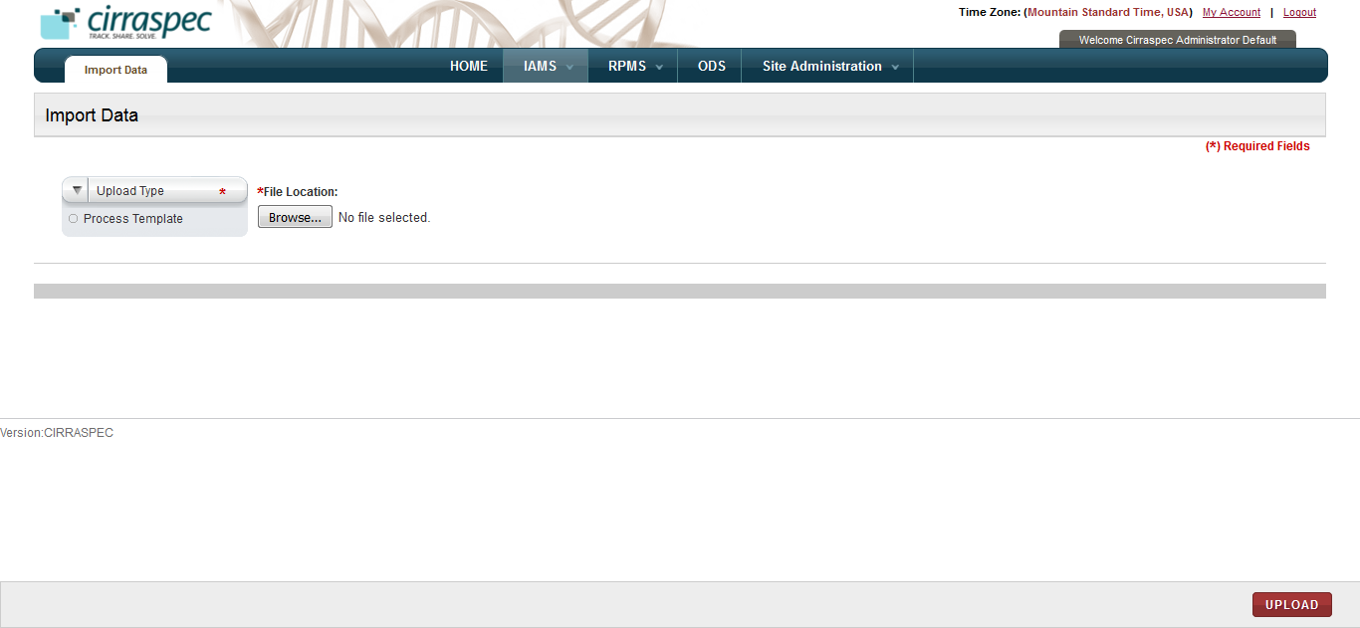

1. Import Data page
2. In the **Upload Type** list, click **Process Template**.
3. Click **Browse** below the **File Location** field, and then select the process template that you want to upload.

The path of the template that you select appears on the right side of the **Browse** button.

1. Click **UPLOAD**.

The process template is uploaded. The **Import Data** page displays the confirmation and summary of this upload.

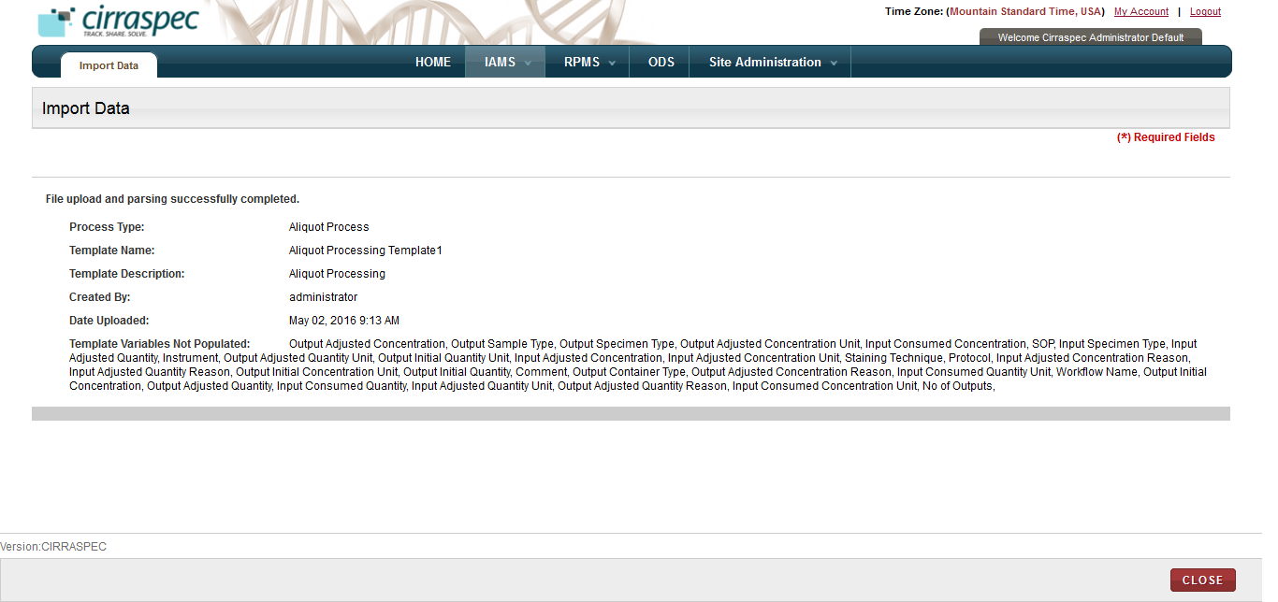

1. Upload confirmation

**Note:** To use this process template in **LIMS**, you must assign the template to the appropriate collection in the **RPMS** module.

### 

# Create and Manage Storage Devices

### Viewing a List of Storage Devices

To view a list of storage devices:

1. Log on to the application using your login credentials.

The CIRRASPEC home page appears.

1. Point to the arrow of the **IAMS** tab, and then click **Storage Designer**.

The **Storage Search** page appears.

1. Click **SEARCH**.

Thestorage search page displays a list of storage devices.

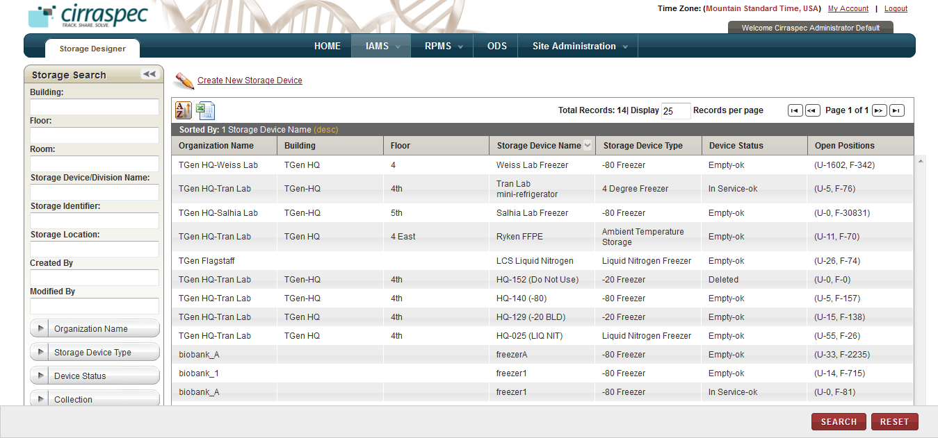

1. Storage Search page

**Note:** To re-sort the list, click the header of the column by which you want to sort. For more information about other ways to sort the list, see **Sorting Search Results**

On the storage search page, you can perform the following tasks:

* **Print a storage device list as an excel spreadsheet:** Click the **Export current view to CSV** icon , and then in the **File Download** window, click **Save**. The storage list file is saved to your machine for viewing/printing.
* **Search for a storage device:** For more information about how to search for a specific device or a group of devices, see **Searching for a Storage Device**.
* **Create a storage device:** For more information about how to create a storage device, see **Creating a Storage Device****.**
* **View the storage device details:** For more information about how to view the storage device details, see **Viewing the Storage Device Details**.

### Searching for a Storage Device

To search for a specific storage device or a group of devices:

1. Point to the arrow of the **IAMS** tab, and then click **Storage Designer**.   
   The **Storage Search** page appears.
2. Click **SEARCH**.  
   The storage search page displays the **Storage Search** pane.

Arrow hides/displays the Storage Search pane



1. Storage Search page
2. Specify your search criteria by completing one or more fields in the **Storage Search** pane.

**Note:**

* You can use one field or a combination of fields to search storage devices.
* You can type the full or partial value in a search field along with an asterisk (*) before or after the partial value. For example, if you type **02\***, you obtain records that begin with 02. If you type **\*02**, you obtain records that end with 02

Following table lists each search field and its description.

Table : Storage search fields

| **Field** | **Description** |
| --- | --- |
| **Building** | Type the name of the building to search for all devices associated with that building. |
| **Floor** | Type the floor to search for all devices associated with that floor. |
| **Room** | Type the room to search for all devices associated with that room. |
| **Storage Device/ Division Name** | Type name of the device or the division within a device to search for that device or division. |
| **Storage Identifier** | Type identifier of a device or division to search for that device or division. |
| **Storage Location** | Type location of a device or division to search for that device or division. |
| **Created By** | Type login username of the user to search for devices created by that user. |
| **Modified By** | Type login username of the user to search for devices modified by that user. |
| **Organization Name** | Click appropriate name to search for devices associated with this organization  **Note:** To search for devices associated with all organizations, click **All**. |
| **Storage Device Type** | Click appropriate device type to search for devices of this type.  **Note:** To search for all types, click **All**. |
| **Device Status** | Click appropriate status to search for devices with this status.  **Note:** To search for all statuses, click **All**. |
| **Collection** | Click appropriate Collection to search for devices associated with this Collection.  **Note:** To search for devices associated with all collections, click **All**. |

1. Click **SEARCH**.  
   The search results appear.   
     
   **Note:** Click the header of the column with which you want to sort the results. For more information about how to sort the search results, see **Sorting Search Results**

### Viewing the Storage Device Details

To view details of a storage device:

1. Log on to the application using your login credentials.

The CIRRASPEC home page appears.

1. Point to the arrow of the **IAMS** tab, and then click **Storage Designer**.

The **Storage Search** page appears.

1. Click **SEARCH**.

The storage search page displays a list of storage devices.

1. Click the row of the storage device for which you want to view details.

The **Storage Device Setup / Modify Storage Device** page appears with the details of the storage device that you selected.

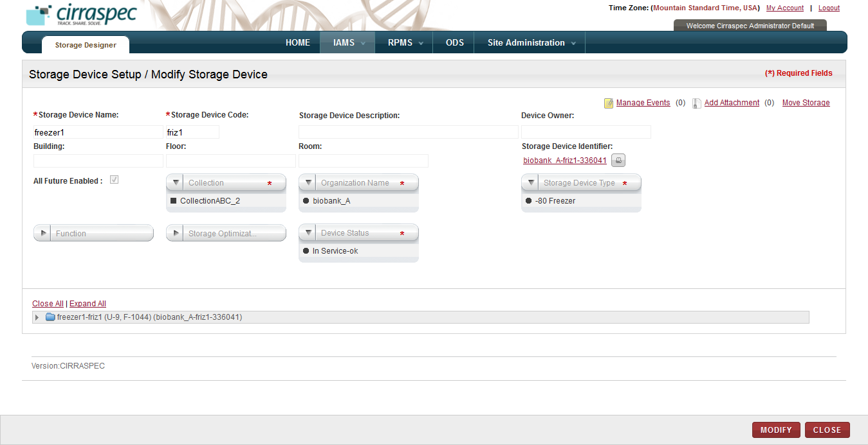

1. Storage Device Setup / Modify Storage Device page

On the **Storage Device Setup / Modify Storage Device** page, you can perform the following tasks:

* **Add a new storage identifier:** For more information about how to add a new storage identifier, see **Adding a New Identifier**.
* **Generate a storage map report:** For more information about how to generate a storage map report, see **Generating a Storage Map Report**.
* **Print a label for a storage device or division:** For more information about how to print a label, see **Printing a Barcode Label**.
* **Modify a storage device:** For more information about how to modify a storage device, see **Modifying a Storage Device**.
* **Modify a storage division:** For more information about how to modify a storage division, see **Modifying a Storage Division**.
* **Add a storage division:** For more information about how to modify a storage division, see **Adding a Storage Division**.
* **Move a storage division:** For more information about how to move a storage division, see **Moving a Storage Division**.
* **Manage events:** You can view and add events to a kit by clicking the **Manage Events** link. For more information about how to manage events, see **Managing Events**
* **Add Attachment:** You can upload, download, and delete files that are attached to a kit by clicking the Add Attachment link. For more information about how to add files, see **Common File Upload**

### Creating a Storage Device

To create a storage device:

1. Log on to the application using your login credentials.

The CIRRASPEC home page appears.

1. Point to the arrow of the **IAMS** tab, and then click **Storage Designer**.

The **Storage Search** page appears.

1. Click the **Create New Storage Device** link.   
   The **Storage Device Setup / Modify Storage Device** page appears.

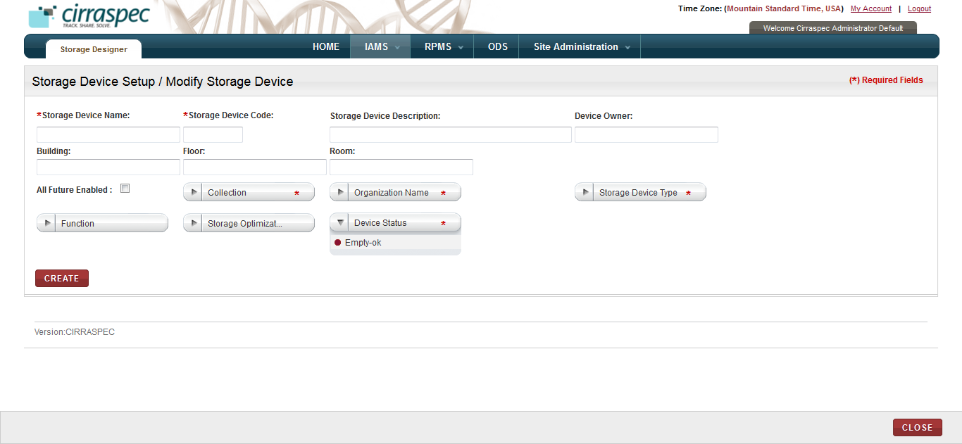

1. Storage Device Setup / Modify Storage Device page
2. Enter appropriate information in each field. Following table lists each field and its description.

**Note:** Fields that are marked with the red asterisk (*) are mandatory.

Table : Creating a storage device

| **Field** | **Description** |
| --- | --- |
| **Storage Device Name**\* | Type the name you want to use for this device. **Note:** You cannot use an existing device name. The name must be unique. |
| **Storage Device Code**\* | Type the code you want to use for this device.  **Note:** You cannot use an existing code. The code must be unique. |
| **Storage Device Description** | Type a description for this device. |
| **Device Owner** | Type name or login username of the owner of this device. **Note:** Must be an active User in IAMS>Address Book. |
| **Building** | Type the building name where this device is located. |
| **Floor** | Type the floor of the building where this device is located. |
| **Room** | Type the room of the building where this device is located. |
| **All Future Enabled** | Select this checkbox if you want this device available for use by all future Collections. |
| **Collection**\* | Click appropriate Collection for which biospecimens can be stored in this device. **Note:**   * You can select multiple Collections. * To select all the Collections, click **ALL**. |
| **Organization Name**\* | Click appropriate organization for which biospecimens can be stored in this device. |
| **Storage Device Type**\* | Click appropriate type for this device. |
| **Function** | Click appropriate function for this device. **Note:**   * You can select multiple functions. * To select all functions, click **ALL**. |
| **Storage Optimization** | Click appropriate value to specify whether storage optimization techniques should be enabled for automatic assignment of available storage locations for this device:   * Enabled – individual gaps in storage between biospecimens will be allowed in requests for vacant positions. * Disabled – only contiguous storage positions will be allowed. |
| **Device Status**\* | Click appropriate status for this device. **Note:** This field is by default set to **Empty-ok,** which means it is empty and is available for storing biospecimens. You may select a different status, if applicable:   * **In Service-ok** – contains samples; available for use * **Maintenance** – not available for use while being repaired or routine maintenance being preformed * **Out of Service** – not available for use |

1. Click **CREATE**.

The storage device is created and the hierarchy tree structure appears with the new device listed.

1. To add a new division to the storage device, click appropriate device node in the hierarchy tree structure on the lower half of the page, and then click the **Add Division(s)** link towards the right hand side of the lower half of the page.

The division fields appear.

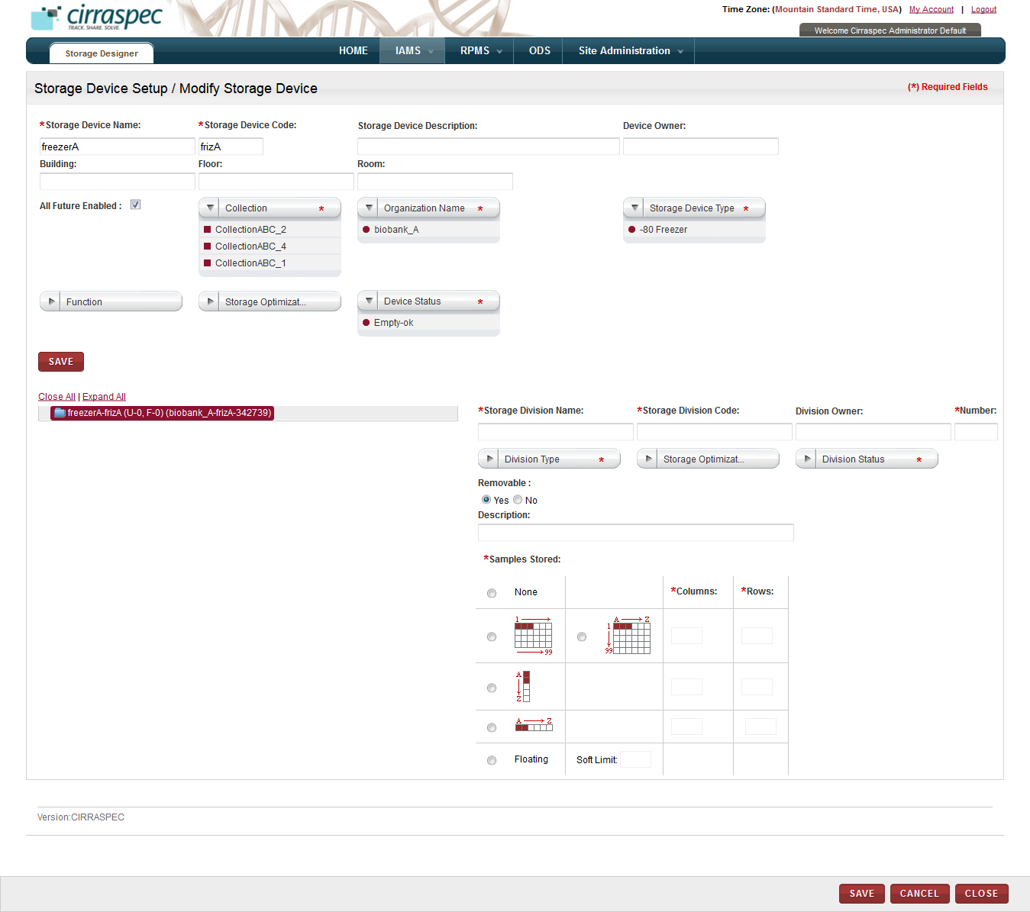

1. Division fields
2. Enter appropriate information in each field. Following table lists each field and its description.

**Note:** Fields that are marked with the red asterisk (*) are mandatory.

Table : Adding a division

| **Field** | **Description** |
| --- | --- |
| **Storage Division Name**\* | Type the name you want to use for this division. **Note:** You cannot use an existing division name. The name must be unique. |
| **Storage Division Code**\* | Type the code you want to use for this division.  **Note:** You cannot use an existing division code. The code must be unique. |
| **Division Owner** | Type the name or login username of the owner of this division. |
| **Number**\* | Type the number of division rows you want to add to the hierarchy tree for this device. |
| **Division Type**\* | Click appropriate type for this division. |
| **Storage Optimization** | Click appropriate value to specify whether storage optimization techniques should be enabled for automatic assignment of available storage locations for this division:   * **Enabled** – individual gaps in storage between biospecimens are allowed when assigning storage position * **Disabled** – only contiguous positions are allowed when assigning storage position |
| **Division Status**\* | Click appropriate status for this division:   * **In Service** – available for use * **Out of Service** – not available for use |
| **Removable** | Click **Yes** or **No** to indicate whether the division can be moved.  **Note**: The **Yes** option is selected by default. |
| **Description** | Type a description for this division. |
| **Samples Stored**\* | Click appropriate radio button to indicate how the biospecimens should be stored in this division:   * **None** – No biospecimen can be stored. * **1-99** – Biospecimens are stored in rows of cells designated in numerical order left to right. * **A1-A99-Z1-Z99** - Biospecimens are stored in rows of cells with columns designated in alphabetical order and rows designated in numerical order. For example, cells will be named as A1, B1, C1…A2, B2, C2 and so on. * **A-Z vertical** – Biospecimens are stored in one vertical column of cells designated in alphabetical order. * **A-Z horizontal** - Biospecimens are stored in one horizontal row of cells designated in alphabetical order. * **Floating** – Biospecimens are stored with no specific cell assignment. |
| **Columns**\* | If you selected **1-99** or **A1-A99-Z1-Z99** or **A-Z horizontal** as the **Samples Stored** option, type the number of columns of cell positions you want the division to have.  **Note**: This field is disabled for the other **Samples Stored** selections. |
| **Rows**\* | If you selected **1-99** or **A1-A99-Z1-Z99** or **A-Z vertical** as the **Samples Stored** option, type the number of rows of cell positions you want the division to have.  **Note**: This field is disabled for the other **Samples Stored** selections. |
| **Soft Limit** | If you selected **Floating** as the **Samples Stored** option, you must type the maximum number of biospecimens that can be stored in this division.  **Note**: This field is disabled for the other **Samples Stored** selections. |
| **Columns:  Numbering Type** * | If you selected **1-99** or **A1-A99-Z1-Z99** or **A-Z horizontal** as the **Samples Stored** option, click the appropriate type of numbering for the columns.  **Note**: This field is not displayed for the other **Samples Stored** selections. |
| **Rows: Numbering Type** * | If you selected **A1-A99-Z1-Z99** or **A-Z vertical** as the **Samples Stored** option, click the appropriate type of numbering for the rows.  **Note**: This field is not displayed for the other **Samples Stored** selections. |
| **Start Position Columns** | Type the number or letter that you want the column numbering scheme to start with. **Note:**   * When you select an option on the Columns **Numbering Type list**, the corresponding default value appears in this field. * This field is not displayed if you selected **None** as the **Samples Stored** option. |
| **Start Position Rows** | If you selected **1-99** or **A1-A99-Z1-Z99**, type the number or letter that you want the row numbering scheme to start with. **Note:**   * When you select an option on the Rows **Numbering Type list**, the corresponding default value appears in this field. * This field is not displayed for the other **Samples Stored** selections. |
| **All Future Enabled** | Select this checkbox if you want this division to be available for use by all future container types.  **Note:** This field is not displayed if you selected **None** as the **Samples Stored** option. |
| **Container Type**\* | Click the container types that can be stored in this division.  **Note:**   * You can select multiple types. * To select all types, click **ALL**. * This field is not displayed if you selected **None** as the **Samples Stored** option. |
| **All Future Enabled** | Select this checkbox if you want this division available for use by all future specimen types.  **Note:** This field is not displayed if you selected **None** as the **Samples Stored** option. |
| **Specimen Type** | Click the specimen types that can be stored in this division.  **Note:**   * You can select multiple types. * To select all types, click **ALL**. * This field is not displayed if you selected **None** as the **Samples Stored** option. |

1. Click **SAVE**.

The division is added to the device and appears on the hierarchy tree structure.

### Adding a New Identifier

To add a new identifier for a storage device or a division:

1. Log on to the application using your login credentials.

The CIRRASPEC home page appears.

1. Point to the arrow of the **IAMS** tab, and then click **Storage Designer**.

The **Storage Search** page appears.

1. Click **SEARCH**.

The storage search page displays a list of storage devices.

1. Click the row of the storage device for which you want to add a new identifier.

The **Storage Device Setup / Modify Storage Device** page appears.

1. To add a new identifier for the storage device, click the **Storage Device Identifier** link.   
   OR

To add a new identifier for a specific division:

1. Expand the hierarchy tree structure, and click the division for which you want to add a new identifier.   
   The division information fields appear.
2. Click the division identifier link next to the **Storage Map Report** link.

The **Add Identifier(s)** window appears.

1. Click the add icon .

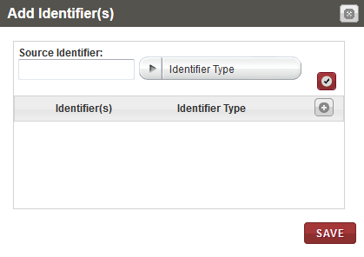

1. Add Identifier(s) window
2. In the **Source Identifier** box, type the identifier you want to add.
3. In the **Identifier Type** list, click the appropriate type, and then click the check mark icon .

The new identifier and identifier type appear in the list below.

1. Click **SAVE**.

The new identifier is added for the storage device or division and appears on the **Storage Device Setup / Modify Storage Device** page.

### Generating a Storage Map Report

To generate a storage map report:

1. Log on to the application using your login credentials.

The CIRRASPEC home page appears.

1. Point to the arrow of the **IAMS** tab, and then click **Storage Designer**.

The **Storage Search** page appears.

1. Click **SEARCH**.

The storage search page displays a list of storage devices.

1. Click the row of the storage device for which you want to generate a report.

The **Storage Device Setup / Modify Storage Device** page appears.

1. To generate a storage map report, expand the hierarchy tree structure, and then click the appropriate division.   
   The division information fields appear.

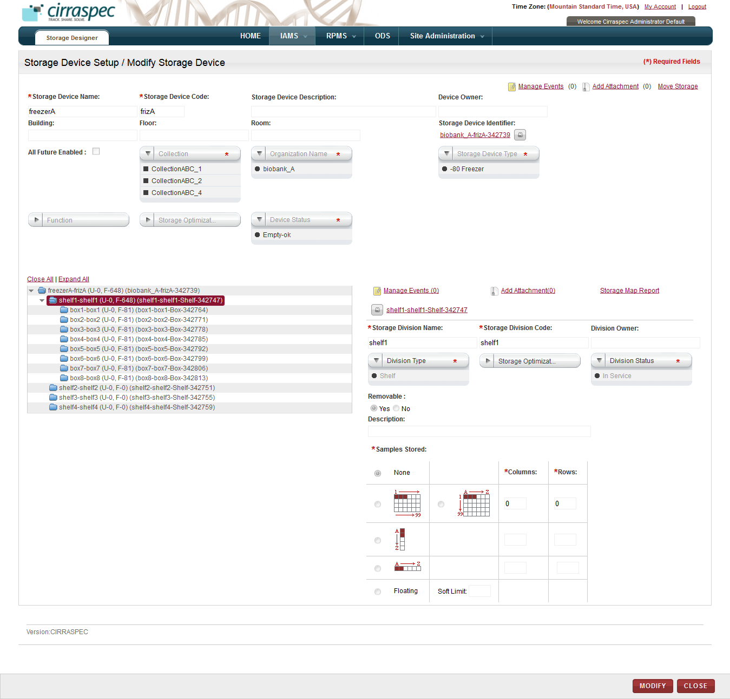

1. Storage Map Report link
2. Click the **Storage Map Report** link on the far right.

User is provided with the following 2 options:

* Report & Map
* Map Only

Click the required option. The respective report appears in a new window.

Example of a Storage Map Report:



Example of a Map Only Report:



1. View, print and/or save the file, as needed.   
     
   **Note**: Hover the cursor over the icons in the horizontal and vertical navigation bars to identify tools for viewing multiple pages, printing the report and saving the file to your machine.

### Printing a Barcode Label

To print barcode label for a storage device or a division:

1. Log on to the application using your login credentials.

The CIRRASPEC home page appears.

1. Point to the arrow of the **IAMS** tab, and then click **Storage Designer**.

The storage search page appears.

1. Click **SEARCH**.

The storage search page displays a list of storage devices.

1. Click the row of the storage device for which you want to generate a barcode label.

The **Storage Device Setup / Modify Storage Device** page appears.

1. To print a barcode label for the storage device, click the print icon  next to the storage device identifier link.   
   OR

To print a barcode label for a specific division:

1. Expand the hierarchy tree structure, and click the appropriate division.
2. Click the print icon  next to the division identifier link.

The print window appears.

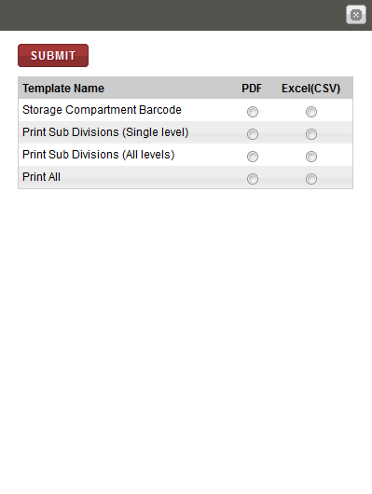

1. Barcode label window
2. Click **PDF** for the appropriate template name, and then click **SUBMIT**.

A PDF file is created with the image of the bar code label.

**Note**: To identify tools for viewing multiple labels, printing labels and saving the file to your machine, hover the cursor over the icons in the horizontal and vertical navigation bars in the window.

### Modifying a Storage Device

To modify a storage device:

1. Log on to the application using your login credentials.

The CIRRASPEC home page appears.

1. Point to the arrow of the **IAMS** tab, and then click **Storage Designer**.

The **Storage Search** page appears.

1. Click **SEARCH**.

The storage search page displays a list of storage devices.

1. Click the row of the storage device which you want to modify.

The **Storage Device Setup / Modify Storage Device** page appears.

1. Click **MODIFY**.

The **Storage Device Setup / Modify Storage Device** page displays fields that are enabled to modify data.

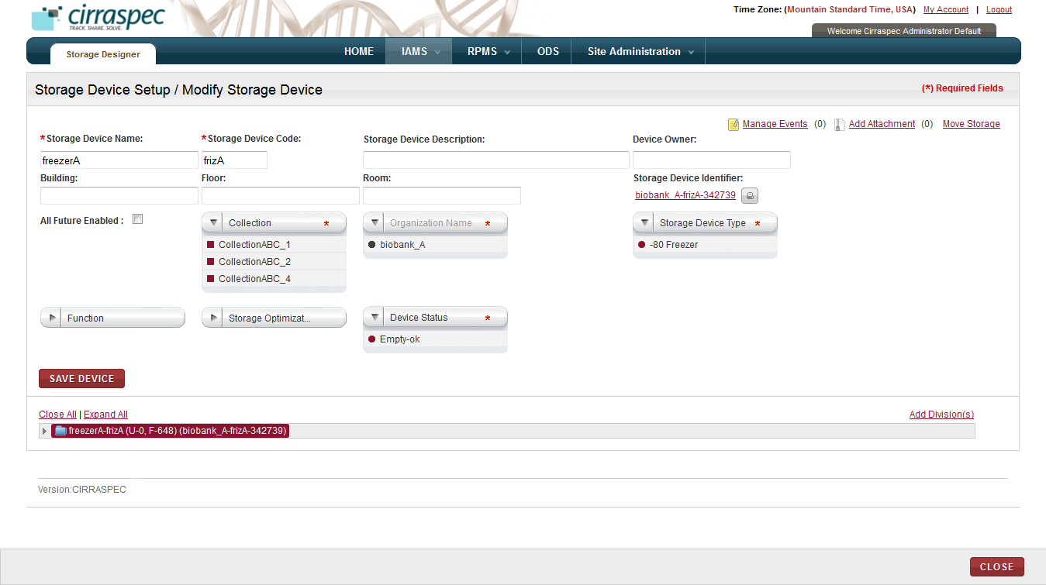

1. Storage Device Setup / Modify Storage Device page
2. To add a new division, see **Adding a Storage Division**.
3. To add a new identifier for the device, click the identifier link for the **Storage Device Identifier**. For more information about how to add a new identifier, see **Adding a New Identifier****.**
4. To print a barcode label for the device, click the print icon  next to the **Storage Device Identifier**. For more information about how to add a new identifier, see **Printing a Barcode Label****.**
5. Enter appropriate information in each field. Following table lists each field and its description.

**Note:** Fields that are marked with the red asterisk (*) are mandatory.

Table : Modifying a storage device

| **Field** | **Description** |
| --- | --- |
| **Storage Device Name**\* | If you want to change the name, type a new name for this device. **Note:** The name must be unique. |
| **Storage Device Code**\* | If you want to change the code, type a new code for this device.  **Note:** The code must be unique. |
| **Storage Device Description** | Type a description for this device. |
| **Device Owner** | Type the name or login username of the owner of this device. |
| **Building** | Type the name of the building where this device is located. |
| **Floor** | Type the floor of the building where this device is located. |
| **Room** | Type the room of the building where this device is located. |
| **All Future Enabled** | Select this checkbox if you want this device to be available for use by all future Collections. |
| **Collection**\* | If you want to change the Collections for which this device can be used, click the appropriate Collection. **Note:**   * You can select multiple Collections. * To select all Collections, click **ALL**. * You cannot deselect a Collection that is already selected if you are not assigned to that Collection. |
| **Organization Name**\* | If you want to change the organization, click the appropriate organization for which biospecimens can be stored in this device. |
| **Storage Device Type**\* | If you want to change the device type, click the appropriate type. |
| **Function** | Click appropriate function for this device. **Note:**   * You can select multiple functions. * To select all functions, click **ALL**. |
| **Storage Optimization** | Click appropriate value to specify whether storage optimization techniques should be enabled for automatic assignment of available storage locations for this device:   * **Enabled** – individual gaps in storage between biospecimens will be allowed in requests for vacant positions. * **Disabled** – only contiguous storage positions will be allowed. |
| **Device Status**\* | If you want to change the status, click the appropriate status.   * **Empty-ok** – empty and available for use * **In Service-ok** – contains samples; available for use * **Maintenance** – not available for use while being repaired or routine maintenance being preformed * **Out-of-Service** – not available for use   **Note**:   * You cannot modify the status for devices with **Deleted** status. * You can change device status to **Out of Service** regardless of whether or not biospecimens are stored in the device. * You can change device status to **Deleted** only if the current status is **Out of Service** or **Maintenance,** and only if there are no biospecimens stored in the device. |

1. Click **SAVE DEVICE**.   
   The **Electronic Signature** window appears.

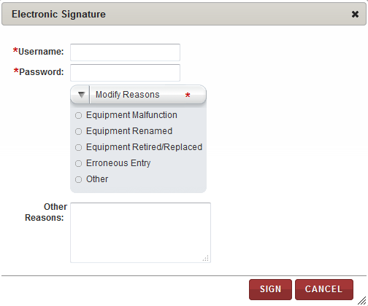

1. Electronic Signature window
2. Enter appropriate information in each field. Following table lists each field and itsdescription.

**Note:** Fields that are marked with the red asterisk (*) are mandatory.

Table : Modifying a storage device

|  |  |
| --- | --- |
| **Field** | **Description** |
| **Username**\* | Type your user log in ID. |
| **Password**\* | Type your password. |
| **Modify Reasons**\* | Click appropriate reason for modifying this device. |
| **Other Reasons** | If you clicked **Other** in the **Modify Reasons** list, type a reason for modifying this device. |

1. Click **SIGN**.

The storage device is modified and the new information appears on the **Storage Device Setup / Modify Storage Device** page.

### Modifying a Storage Division

1. Log on to the application using your login credentials.

The CIRRASPEC home page appears.

1. Point to the arrow of the **IAMS** tab, and then click **Storage Designer**.

The **Storage Search** page appears.

1. Click **SEARCH**.

The storage search page displays a list of storage devices.

1. Click the row of the storage device whose division you want to modify.

The **Storage Device Setup / Modify Storage Device** page appears.

1. Click **MODIFY**.

The **Storage Device Setup / Modify Storage Device** page displays the division fields.

1. To add a new division, see **Adding a Storage Division**.
2. To modify an existing division, expand the hierarchy tree and click the division you want to modify.

The division fields appear.

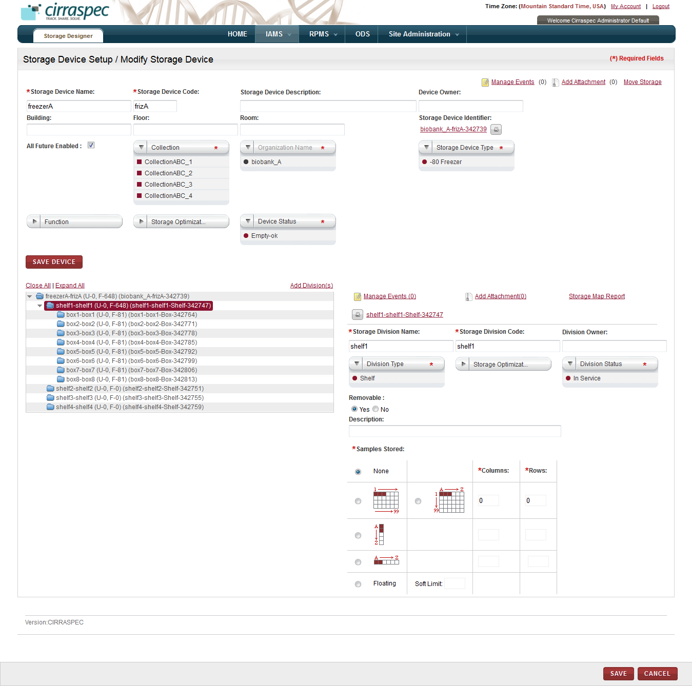

1. Division fields
2. To print a barcode label for the division, click the print icon  next to the appropriate identifier. For more information about how to add a new identifier, see **Printing a Barcode Label****.**
3. To generate a storage map report for a division, click the **Storage Map Report** link for the division. For more information about how to generate a storage map report, see **Generating a Storage Map Report.**
4. To move a storage division, click the **Move Storage** link. For more information about how to move a storage division, see **Moving a Storage Division**.
5. To add a new identifier for the division, click the identifier link for the device or division. For more information about how to add a new identifier, see **Adding a New Identifier.**
6. To modify division information, enter appropriate information in each field. Following table lists each field and its description.

**Note:** Fields that are marked with the red asterisk (*) are mandatory.

Table : Modifying a division

| **Field** | **Description** |
| --- | --- |
| **Storage Division Name**\* | If you want to change the division name, type the new name. **Note:** The name must be unique. |
| **Storage Division Code**\* | If you want to change the division code, type the new code.  **Note:** The code must be unique. |
| **Division Owner** | Type the name or login username of the owner of this division. |
| **Division Type**\* | If you want to change the division type, click appropriate type. |
| **Storage Optimization** | Click appropriate value to specify whether storage optimization techniques should be enabled for automatic assignment of available storage locations for this division:   * **Enabled** – individual gaps in storage between biospecimens are allowed when assigning storage position * **Disabled** – only contiguous positions are allowed when assigning storage position * **Don’t Care** – Reserved for future use |
| **Division Status**\* | If you want to change the status for this division, click the appropriate status:   * **In Service** – available for use * **Out of Service** – not available for use   **Note**:   * You can change the status to **Out of Service** regardless of whether or not biospecimens are stored here. * You cannot change the status of a sub-level division to **In Service** if its ‘parent” is **Out of Service**. * To delete a division: * Change status to **Out of Service.** * Click **save** to save the change, and then click **CANCEL** * Click **CLOSE** twice to exit. * Select the device on the **Storage Search** page. * Expand hierarchy tree and click on the division you want to delete. * Click **DELETE DIVISION**. * Provide your electronic signature and state the reason for the change made. |
| **Removable** | Click **Yes** or **No** to indicate whether the division can be moved.  **Note**: The **Yes** option is selected by default. |
| **Description** | Type a description for this division. |
| **Samples Stored**\* | If you want to change the storage configuration, click the appropriate radio button to indicate how the biospecimens should be stored in this division:   * **None** – No biospecimen can be stored. * **1-99** – Biospecimens are stored in rows of cells designated in numerical order left to right. * **A1-A99-Z1-Z99** - Biospecimens are stored in rows of cells with columns designated in alphabetical order and rows designated in numerical order. For example, A1, B1, C1…A2, B2, C2 and so on. * **A-Z vertical** – Biospecimens are stored in one vertical column of cells designated in alphabetical order. * **A-Z horizontal** - Biospecimens are stored in one horizontal row of cells designated in alphabetical order. * **Floating** – Biospecimens are stored with no specific cell assignment. |
| **Columns**\* | If you selected **1-99** or **A1-A99-Z1-Z99** or **A-Z horizontal** as the **Samples Stored** option, type the number of columns of cell positions you want the division to have.  **Note**: This field is disabled for the other **Samples Stored** selections. |
| **Rows**\* | If you selected **1-99** or **A1-A99-Z1-Z99** or **A-Z vertical** as the **Samples Stored** option, type the number of rows of cell positions you want the division to have.  **Note**: This field is disabled for the other **Samples Stored** selections. |
| **Soft Limit** | If you selected **Floating** as the **Samples Stored** option, you must type the maximum number of biospecimens that can be stored in this division.  **Note**: This field is disabled for the other **Samples Stored** selections. |
| **Columns:  Numbering Type** * | If you selected **1-99** or **A1-A99-Z1-Z99** or **A-Z horizontal** as the **Samples Stored** option, click the appropriate type of numbering for the columns.  **Note**: This field is not displayed for the other **Samples Stored** selections. |
| **Rows: Numbering Type** * | If you selected **A1-A99-Z1-Z99** or **A-Z vertical** as the **Samples Stored** option, click the appropriate type of numbering for the rows.  **Note**: This field is not displayed for the other **Samples Stored** selections. |
| **Start Position Columns** | Type the number or letter that you want the column numbering scheme to start with. **Note:**   * When you select an option on the Columns **Numbering Type list**, the corresponding default value appears in this field. * This field is not displayed if you selected **None** as the **Samples Stored** option. |
| **Start Position Rows** | If you selected **1-99** or **A1-A99-Z1-Z99**, type the number or letter that you want the row numbering scheme to start with. **Note:**   * When you select an option on the Rows **Numbering Type list**, the corresponding default value appears in this field. * This field is not displayed for the other **Samples Stored** selections. |
| **All Future Enabled** | Select this checkbox if you want this division to be available for use by all future container types.  **Note:** This field is not displayed if you selected **None** as the **Samples Stored** option. |
| **Container Type**\* | If you want to change the container types that can be stored in this division, click the appropriate type.  **Note:**   * You can select multiple types. * To select all types, click **ALL**. * This field is not displayed if you selected **None** as the **Samples Stored** option. |
| **All Future Enabled** | Select this checkbox if you want this division available for use by all future specimen types.  **Note:** This field is not displayed if you selected **None** as the **Samples Stored** option. |
| **Specimen Type** | Click the specimen types that can be stored in this division.  **Note:**   * You can select multiple types. * To select all types, click **ALL**. * This field is not displayed if you selected **None** as the **Samples Stored** option. |

1. Click **SAVE**.  
   The storage division is modified and the new information appears on the **Storage Device Create/Modify** page.

### Adding a Storage Division

1. Log on to the application using your login credentials.

The CIRRASPEC home page appears.

1. Point to the arrow of the **IAMS** tab, and then click **Storage Designer**.

The **Storage Search** page appears.

1. Click **SEARCH**.

The storage search page displays a list of storage devices.

1. Click the row of the storage device for which you want to add a storage division.

The **Storage Device Setup / Modify Storage Device** page appears.

1. Click **MODIFY**.

The **Storage Device Setup / Modify Storage Device** page displays the division fields.

1. Expand the hierarchy tree and click the device or division to which you want to add a division.
2. Click the **Add Division(s)** link.

The division fields appear.

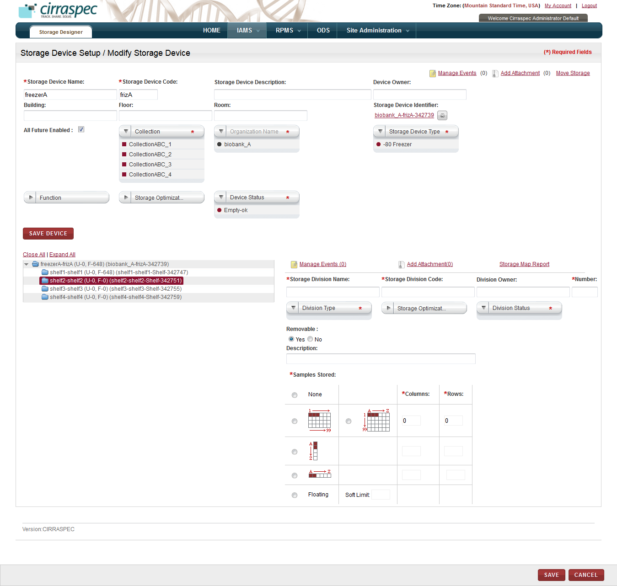

1. Division fields

1. Enter appropriate information in each field. Following table lists each field and its description.

**Note:** Fields that are marked with the red asterisk (*) are mandatory.

Table : Adding a division

| **Field** | **Description** |
| --- | --- |
| **Storage Division Name**\* | Type the name you want to use for this division. **Note:** You cannot use an existing division name. The name must be unique. |
| **Storage Division Code**\* | Type the code you want to use for this division.  **Note:** You cannot use an existing division code. The code must be unique. |
| **Division Owner** | Type the name or login username of the owner of this division. |
| **Number**\* | Type the number of division rows you want to add to the hierarchy tree for this device. |
| **Division Type**\* | Click appropriate type for this division. |
| **Storage Optimization** | Click appropriate value to specify whether storage optimization techniques should be enabled for automatic assignment of available storage locations for this division:   * **Enabled** – individual gaps in storage between biospecimens are allowed when assigning storage position * **Disabled** – only contiguous positions are allowed when assigning storage position * **Don’t Care** – this option is selected by default |
| **Division Status**\* | Click appropriate status for this division:   * **In Service** – available for use * **Out of Service** – not available for use |
| **Removable** | Click **Yes** or **No** to indicate whether the division can be moved.  **Note**: The **Yes** option is selected by default. |
| **Description** | Type a description for this division. |
| **Samples Stored**\* | Click appropriate radio button to indicate how the biospecimens should be stored in this division:   * **None** – No biospecimen can be stored. * **1-99** – Biospecimens are stored in rows of cells designated in numerical order left to right. * **A1-A99-Z1-Z99** - Biospecimens are stored in rows of cells with columns designated in alphabetical order and rows designated in numerical order. For example, A1, B1, C1…A2, B2, C2 and so on. * **A-Z vertical** – Biospecimens are stored in one vertical column of cells designated in alphabetical order. * **A-Z horizontal** - Biospecimens are stored in one horizontal row of cells designated in alphabetical order. * **Floating** – Biospecimens are stored with no specific cell assignment. |
| **Columns**\* | If you selected **1-99** or **A1-A99-Z1-Z99** or **A-Z horizontal** as the **Samples Stored** option, type the number of columns of cell positions you want the division to have.  **Note**: This field is disabled for the other **Samples Stored** selections. |
| **Rows**\* | If you selected **1-99** or **A1-A99-Z1-Z99** or **A-Z vertical** as the **Samples Stored** option, type the number of rows of cell positions you want the division to have.  **Note**: This field is disabled for the other **Samples Stored** selections. |
| **Soft Limit** | If you selected **Floating** as the **Samples Stored** option, you must type the maximum number of biospecimens that can be stored in this division.  **Note**: This field is disabled for the other **Samples Stored** selections. |
| **Columns:  Numbering Type** * | If you selected **1-99** or **A1-A99-Z1-Z99** or **A-Z horizontal** as the **Samples Stored** option, click the appropriate type of numbering for the columns.  **Note**: This field is not displayed for the other **Samples Stored** selections. |
| **Rows: Numbering Type** * | If you selected **A1-A99-Z1-Z99** or **A-Z vertical** as the **Samples Stored** option, click the appropriate type of numbering for the rows.  **Note**: This field is not displayed for the other **Samples Stored** selections. |
| **Start Position Columns** | Type the number or letter that you want the column numbering scheme to start with. **Note:**   * When you select an option on the Columns **Numbering Type list**, the corresponding default value appears in this field. * This field is not displayed if you selected **None** as the **Samples Stored** option. |
| **Start Position Rows** | If you selected **1-99** or **A1-A99-Z1-Z99**, type the number or letter that you want the row numbering scheme to start with. **Note:**   * When you select an option on the Rows **Numbering Type list**, the corresponding default value appears in this field. * This field is not displayed for the other **Samples Stored** selections. |
| **All Future Enabled** | Select this checkbox if you want this division to be available for use by all future container types.  **Note:** This field is not displayed if you selected **None** as the **Samples Stored** option. |
| **Container Type**\* | Click the container types that can be stored in this division.  **Note:**   * You can select multiple types. * To select all types, click **ALL**. * This field is not displayed if you selected **None** as the **Samples Stored** option. |
| **All Future Enabled** | Select this checkbox if you want this division available for use by all future specimen types.  **Note:** This field is not displayed if you selected **None** as the **Samples Stored** option. |
| **Specimen Type** | Click the specimen types that can be stored in this division.  **Note:**   * You can select multiple types. * To select all types, click **ALL**. * This field is not displayed if you selected **None** as the **Samples Stored** option. |

1. Click **SAVE**.

The division is added to the device and appears on the hierarchy tree structure.

To generate a storage map report for the new division, click the **Storage Map Report** link above **Division Owner**. For more information about how to generate a storage map report, see **Generating a Storage Map Report.**

### Moving a Storage Division

To move a division within a storage device or to a different storage device:

1. Log on to the application using your login credentials.

The CIRRASPEC home page appears.

1. Point to the arrow of the **IAMS** tab, and then click **Storage Designer**.

The **Storage Search** page appears.

1. Click **SEARCH**.

The storage search page displays a list of storage devices.

1. Click the row of the storage device whose division you want to move.

The **Storage Device Setup / Modify Storage Device** page appears.

1. Click the **MOVE STORAGE** link.

The **Move Storage** window appears.

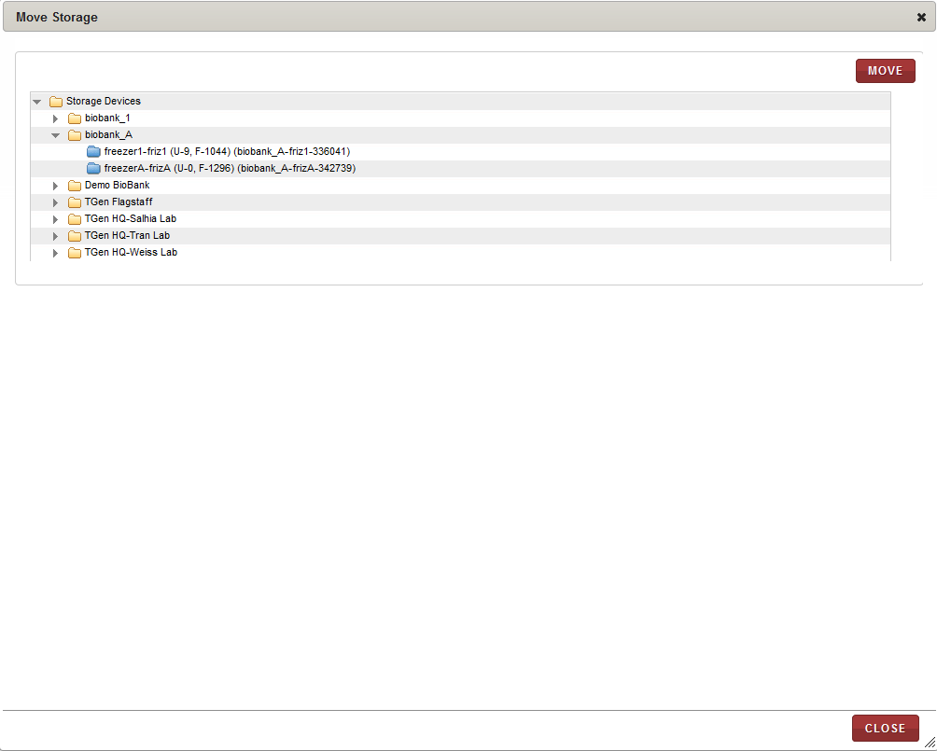

1. Move Storage window
2. Expand the hierarchy tree structure, and click the storage device node where the division you want to move is located.

The divisions that are associated with the selected storage device appear in a table in the right pane of the **Move Storage** window.

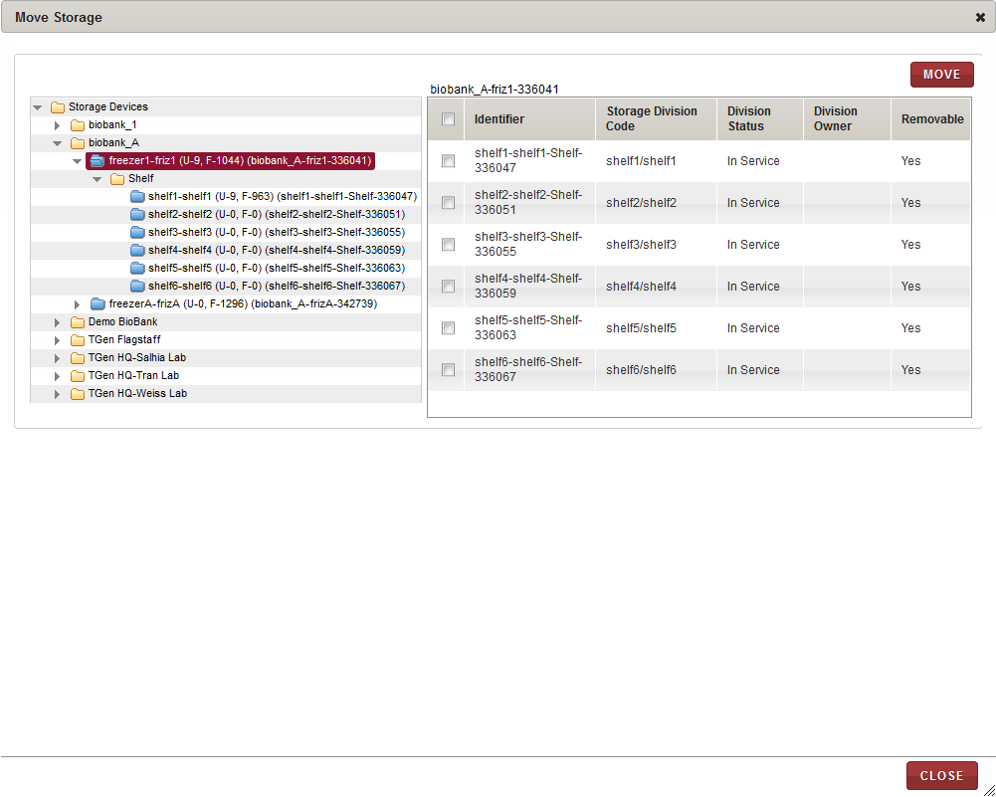

1. Divisions table
2. Select checkboxes for one or multiple divisions that you want to move.

**Note:** To move all the divisions to another location, select the checkbox in the header of the table.

1. Click **MOVE**.

The **Move Items** window appears.

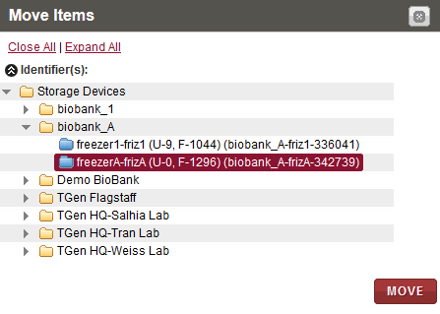

1. Move Items window
2. Expand the hierarchy tree and click the location where you want to move the divisions.
3. Click **MOVE**.   
   A confirmation message appears.
4. Click **OK**.

The **Electronic Signature** window appears.

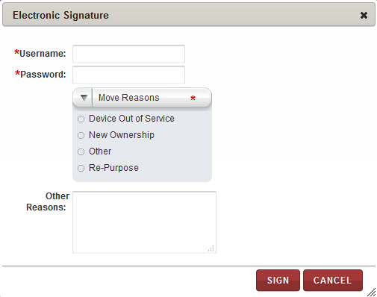

1. Electronic Signature window
2. Enter appropriate information in each field. Following table lists each field and itsdescription.

**Note:** Fields that are marked with the red asterisk (*) are mandatory.

Table : Moving a storage division

|  |  |
| --- | --- |
| **Field** | **Description** |
| **Username**\* | Type your user log in ID. |
| **Password**\* | Type your password. |
| **Move Reasons**\* | Click appropriate reason for moving this division. |
| **Other Reasons** | If you clicked **Other** in the **Move Reasons** list, type a reason for moving this division. |

1. Click **SIGN**.

The division that you selected is moved and is shown in its new location on the hierarchy tree in the **Move Storage** window.

1. Click **CLOSE.**

The **Move Storage** window closes.

# Create and Manage Sites, Users, Couriers

**Note:** You must create and activate the users, sites and couriers before you can use them in the application.

### Viewing a List of Address Book Entries

To view a list of address book entries:

1. Log on to the application using your login credentials.

The CIRRASPEC home page appears.

1. Point to the arrow of the **IAMS** tab, and then click **Address Book**.

The **Entry Search** page appears.

1. Click **SEARCH**.   
   The list of address book entries appears.

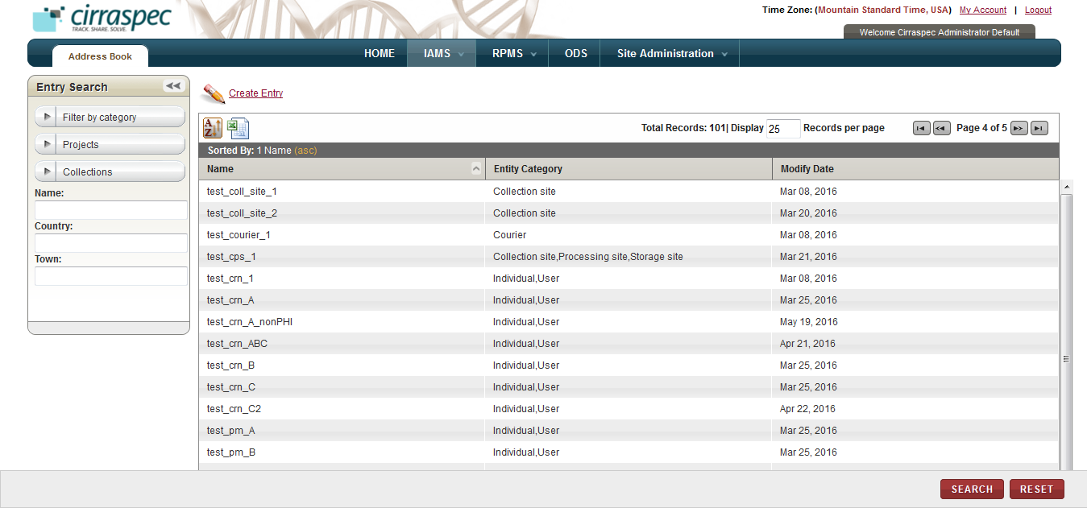

1. Entry Search page with list of address book entries

**Note:**

* To filter the list by entity category such as User or Collection site, click the **Filter by category** field under **Entry Search.** Select one option on the list, and then click **SEARCH**.
* To filter the list by Project or Collection, click the **Projects** or **Collections** fields under **Entry Search.** Select one or multiple options on the list, and then click **SEARCH**.
* For more information about other ways to sort the list, see **Sorting Search Results**

### Searching for an Entry

To search for an address book entry or a group of entries:

1. Point to the arrow of the **IAMS** tab, and then click **Address Book**.   
   The **Entry Search** page appears.
2. Click **SEARCH**.  
   The entry search page displays the **Entry Search** pane.

Arrow hides/displays the Entry Search pane



1. Entry Search page
2. To filter the list by entity category (Individual, User, Site type or Courier), click the **Filter by category** field. Select one option from the list, and then click **SEARCH**.

To filter the list by Project or Collection, click the **Projects** or **Collections** fields under **Entry Search**. Select one or multiple options from the list, and then click **SEARCH**.

1. To search for specific entries, specify your search criteria by completing one or more fields in the **Entry Search** pane.

**Note:**

* You can use one field or a combination of fields to search.
* You can type the full or partial value in a search field. As you type, existing values in the system are auto-populated in a list below for you to choose the required option.

Following table lists each search field and its description.

Table : Entry search fields

| **Field** | **Description** |
| --- | --- |
| **Name** | Type name of the entry that you want to search for. |
| **Country** | Type a country to search for entries with the address on record in this country. |
| **Town** | Type a town to search for entries with the address on record in this town. |

1. Click **SEARCH**.  
   The search results appear.   
     
   For more information about how to sort the search results, see **Sorting Search Results**

### Viewing Details for an Entry

To view the details of an address book entry:

1. Log on to the application using your login credentials.

The CIRRASPEC home page appears.

1. Point to the arrow of the **IAMS** tab, and then click **Address Book**.

The **Entry Search** page appears.

1. Click **SEARCH**.   
   The list of address book entries appears.
2. Select the row of the entry you want to view.

The **View Entry** page appears with details for the selected entry.

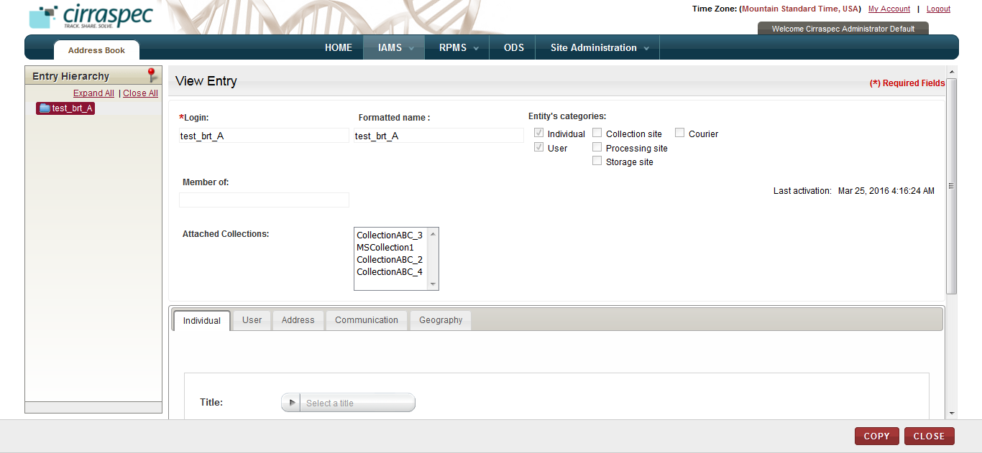

1. View Entry page
2. Click appropriate tab to view additional details.  
     
   **Note:** The information varies based on the category of the selected entry.

* For an Individual category, following tabs appear:
* Individual: Name, title and position.
* Address: mailing address
* Communication: phone, email, fax, language(s)
* Geography: time zone, global position, country locale
* For a User category, following tabs appear:
* Individual: Name, title and position.
* User: Account enabled, authentication source, login username, password, authorized site(s) , role(s), PHI authorization status  
  **Note:** User tab is only displayed for System Administrator.
* Address: mailing address
* Communication: phone, email, fax, language(s)
* Geography: time zone, global position, country locale
* For a Collection Site, Processing Site or a Storage Site category, following tabs appear:
* Attached users: users assigned to that site
* Address: mailing address
* Communication: phone, email, fax, language(s)
* Geography: time zone, global position, country locale
* For a Courier category, following tabs appear:
* Courier: tracking URL, allowed shipment types
* Address: mailing address
* Communication: phone, email, fax, language(s)
* Geography: time zone, global position, country locale

On the **View Entry** page, you can perform the following tasks:

* **Copy an entry**: For more information about how to copy an existing entry to create a new entry, see **Copying an Entry**.
* **Create a new entry**: For more information about how to create a new entry section, see **Creating an Entry**.
* **Modify an entry:** For more information about how to modify an entry, see **Modifying an Entry**.
* **Delete an entry:** For more information about how to delete an entry, see **Deleting an Entry**.
* **Activate an entry:** For more information about how to activate an entry, see **Activating an Entry**.
* **Deactivate an entry:** For more information about how to deactivate an entry, see **Deactivating an Entry**.

### Creating an Entry

To create a new Entry:

1. Log on to the application using your login credentials.

The CIRRASPEC home page appears.

1. Point to the arrow of the **IAMS** tab, and then click **Address Book**.

The **Entry Search** page appears.

1. Click the **Create Entry** link.  
   The **Create new entry** page appears.  
     
   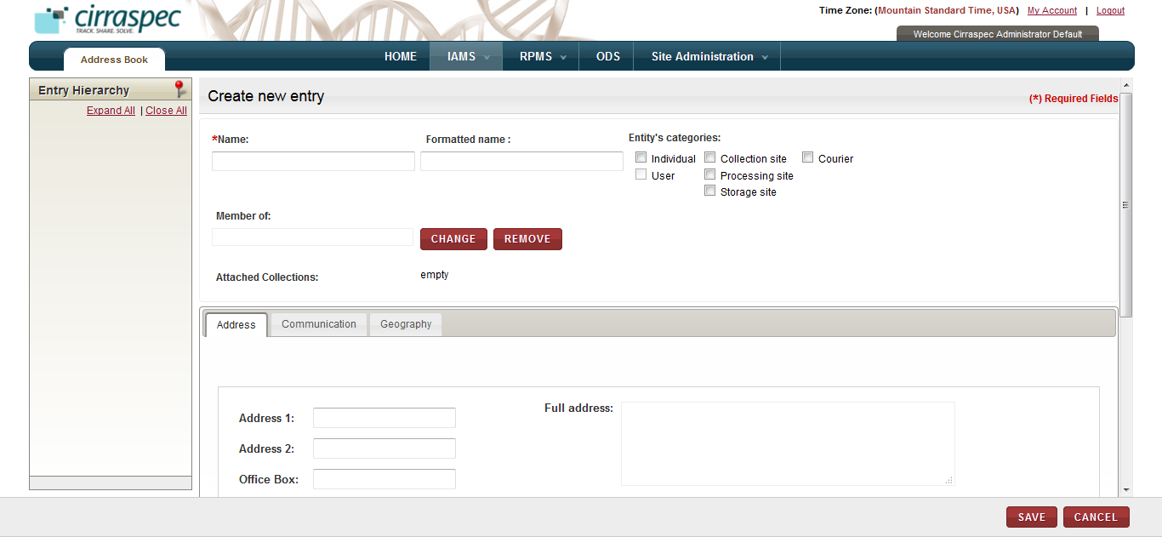
2. Create new entry page
3. Enter appropriate information in each field. Following table lists each field and its description.

**Note:** Fields that are marked with the red asterisk (*) are mandatory.

Table : Creating an Entry

| **Field** | **Description** |
| --- | --- |
| **Name**\*/  **Login**\* | For a User, type the login username.  For all other entities, type the name of the entity. **Note:** This is the name that will be shown on the entry list on the **Entry Search** page. |
| **Formatted Name  (Site Code)\*** | For an Individual, User or Courier, type the name of the entity.  For a Collection, Processing or Storage site, type the site code.  **Note:** This field is optional for an Individual, User or Courier, but is mandatory for a Collection, Processing or Storage site. |
| **Entity’s categories** | Click appropriate checkbox to indicate what type of entity you want to create.  **Note:**   * To deselect a box that has already been checked so you can make a different selection, click on the checkbox again. * To create a user entry, you must first check **Individual** checkbox, and then select **User**. Only the System Administrator can create a user entry. * To create a Biobank site, you must select the **Processing Site** and **Storage Site** checkboxes to ensure Collection Sites can ship biospecimens to the Biobank site. * To create a Processing Site, you must select the **Processing Site** and **Storage Site** checkbox if required, to ensure Collection Sites can ship biospecimens to the Processing site. * The **Entity Category** determines where this entry is listed in the **RPMS module** for assigning to a Collection. For example, Collection, Processing and Storage sites are listed on the **Sites** tab in **RPMS**; users are listed on the **Personnel** tab in **RPMS**; couriers are listed on the **Couriers** tab in **RPMS.** |
| **Member of** | Skip this field. It is reserved for future use. |
| **Change/Remove** | Skip these buttons. They are reserved for future use. |
| **Individual tab** | 1. Click the **Select a title** field, and then select a title, if applicable. 2. Type the **First name**\*and **Last name**\*. 3. Type the individual’s **Position**, if applicable.   **Note:** This tab only appears if the **Individual** or **User** box is checked. |
| **User tab** | 1. To enable the account, click **Account enabled**. 2. Select suitable **Authentication Source**\* from the dropdown. 3. The **Login**\* value is auto-populated from the value specified in the ‘Login’ field at the top of the page. 4. To create a temporary password for this user, click **CHANGE.** Type a password in **New Password** and **Confirm Password,** and then click **OK**. **Note:** User will be prompted to change the temporary password upon his first login. 5. To assign **Authorized sites**\* for this entry, click **ADD.** Click the appropriate site for which this user is authorized and click **ADD**. Repeat to assign additional sites, as needed. When done, click **CLOSE.** 6. To set a default site, click the site on the authorized list that you want to be the default, and click **MAKE DEFAULT.** 7. To assign a **Role** for this entry, click **ADD.** Click the appropriate role for which this user is authorized and click **ADD**. In case you need to add more than one role, click the required role and click **ADD**. When done, click **CLOSE**.   **Note**: It is currently not recommended to use the Project Manager role for users.   1. If the user needs to be a PHI authorized user, then select the **PHI authorized** checkbox.   **Note:**   * To remove a site or role from the list, click the item and click **REMOVE**. * The **PHI authorized** checkbox by default is not selected indicating that the user being created will be a Non-PHI authorized user.   Adminisitrator has to select this checkbox explicitly to make the new user PHI authorized.   * This tab only appears if the **User** checkbox is selected. * Only the System Administrator can create a user entry. |
| **Attached users tab** | 1. To assign **Attached users** for a site, click **ADD.** Click the appropriate user for whom you want to authorize access to this site and click **ADD**. Repeat to authorize additional users, as required. When done, click **CLOSE.**   **Note:**   * To remove a user from the list, click the item and click **REMOVE**. * This tab appears only if the **Collection Site, Processing Site** or **Storage Site** checkbox is selected. |
| **Courier tab** | 1. To provide a tracking link for shipments, copy/paste or type the URL of the Courier tracking website in **Tracking URL.** 2. Specify the type of shipments that this Courier allows in **Allowed shipment types**, if applicable. 3. If the Courier allows Express shipments, click the **Express** checkbox. 4. If the Courier allows international European Union shipments, click the **International EU** checkbox. 5. If the Courier allows worldwide shipments other than European Union, click the **International worldwide** checkbox.   **Note:**   * This tab only appears if the **Courier** checkbox is selected. * This tab determines the Courier information displayed in the Shipments module. |
| **Address tab** | 1. Type the mailing address in the address fields. 2. Click the **Select a country** dropdown, and then select the **Country** for the address. 3. Click **SAVE.**   **Note:** For Collection, Processing and Storage sites, this tab sets the address information displayed on the **Create Shipment** page in the **BMS Shipments** module. |
| **Communication tab** | 1. For Collection, Processing and Storage Site entries, type the name of the **Contact Person**\* for this entry. 2. For all entries, type all available contact information in the **Phone, Email, Fax, Instant messaging** and **Web address** fields. 3. To select a **Language**, click **ADD.** Then, in the **Select a language** window, select the appropriate language for this entry and click **ADD**. When done, click **CLOSE**.   **Note:**   * To remove a language from the list, click on the language and then click **REMOVE**. * For Collection, Processing and Storage sites, this tab sets the contact information displayed on the **Create Shipment** page in the **BMS Shipments** module. |
| **Geography tab** | 1. Click the **Select a time zone** dropdown and select the appropriate **Time Zone** for this entry. 2. Click **Daylight savings** checkbox if this entry’s location observes daylight savings time. 3. Type the latitude and longitude of this entry’s location in **Global position**, if applicable. 4. Click the **Select a locale** dropdown and select the appropriate **Country locale** for this entry. |

1. Click **SAVE**.

The new entry is created and appears on the **Search Entry** page.

**Note:** You must activate the entry before you can use it in the application. For information about how to activate an entry, see **Activating an Entry**.

### Copying an Entry

To copy an existing address book Entry and create a new Entry:

1. Log on to the application using your login credentials.

The CIRRASPEC home page appears.

1. Point to the arrow of the **IAMS** tab, and then click **Address Book**.

The **Entry Search** page appears.

1. Click **SEARCH**.   
   The list of address book entries appears.
2. Select the row of the entry you want to copy.

The **View Entry** page appears with details for the selected entry.

1. Click **COPY**.  
   The **Create new entry** page appears. The fields that can be copied are populated, and the fields that cannot be copied are blank.

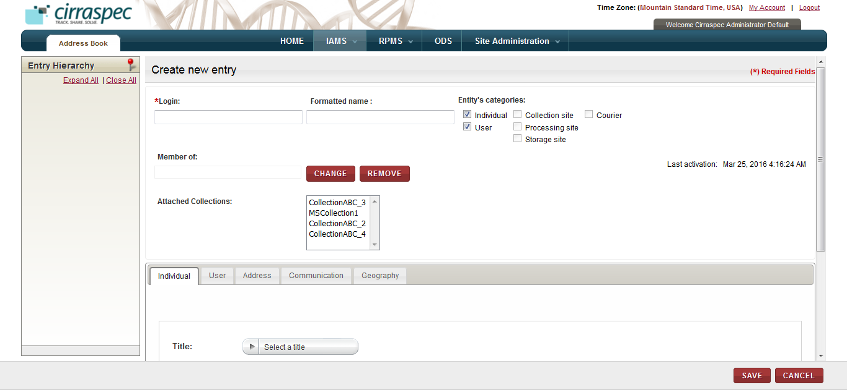

1. Create new entry page
2. Enter appropriate information in each field. Following table lists each field and its description.

**Note:** Fields that are marked with the red asterisk (*) are mandatory.

Table : Copying an Entry

| **Field** | **Description** |
| --- | --- |
| **Name**\*/  **Login**\* | For a User, type the login username.  For all other entities, type the name of the entity. **Note:** This is the name that will be shown on the entry list on the **Entry Search** page. |
| **Formatted Name  (Site Code)\*** | If you want to change the formatted name or site code, type the new value.   * For an Individual, User or Courier, type the name of the entity. * For a Collection, Processing or Storage site, type the site code.   **Note:** This field is optional for an Individual, User or Courier, but is mandatory for a Collection, Processing or Storage site. |
| **Entity’s categories** | Click appropriate checkbox to indicate what type of entity you want to create.  **Note:**   * To deselect a box that has already been checked so you can make a different selection, click on the checkbox again. * To create a user entry, you must first select **Individual** checkbox, and then select **User**. Only the System Administrator can create a user entry. * To create a Biobank site, you must check the **Processing Site** and **Storage Site** checkboxes to ensure Collection Sites can ship biospecimens to the Biobank site. * To create a Processing Site, you must check the **Processing Site** and the **Storage Site** box if required, to ensure Collection Sites can ship biospecimen to the Processing site. * The **Entity Category** determines where this entry is listed in the **RPMS module** for assigning to a collection. For example, Collection, Processing and Storage sites are listed on the **Sites** tab in **RPMS**; users are listed on the **Personnel** tab in **RPMS**; Couriers are listed on the **Couriers** tab in **RPMS.** |
| **Member of** | Skip this field. It is reserved for future use. |
| **Change/Remove** | Skip these buttons. They are reserved for future use. |
| **Individual tab** | 1. Click the **Select a title** field, and then select a title, if applicable. 2. Type the **First name**\*and **Last name**\*. 3. Type the individual’s **Position**, if applicable.   **Note:** This tab only appears if the **Individual** or **User** checkbox is selected. |
| **User tab** | 1. To enable the account, click **Account enabled**. 2. Select suitable **Authentication Source**\* from the dropdown. 3. The **Login**\* value is auto-populated from the value specified in the ‘Login’ field at the top of the page. 4. To create a temporary password for this user, click **CHANGE.** Type a password in **New Password** and **Confirm Password,** and then click **OK**. **Note:** User will be prompted to change the temporary password upon his first login. 5. To assign **Authorized sites**\* for this entry, click **ADD.** Click the appropriate site for which this user is authorized and click **ADD**. Repeat to assign additional sites, as needed. When done, click **CLOSE.** 6. To set a default site, click the site on the authorized list that you want to be the default, and click **MAKE DEFAULT.** 7. To assign a **Role** for this entry, click **ADD.** Click the appropriate role for which this user is authorized and click **ADD**. In case you need to add more than one role, click the required role and click **ADD**. When done, click **CLOSE**.   **Note**: It is currently not recommended to use the Project Manager role for users.   1. If the user needs to be a PHI authorized user, then select the **PHI authorized** checkbox.   **Note:**   1. To remove a site or role from the list, click the item and click **REMOVE**. 2. The **PHI authorized** checkbox by default is not selected indicating that the user being created will be a Non-PHI authorized user.   Adminisitrator has to select this checkbox explicitly to make the new user PHI authorized.   1. This tab only appears if the **User** checkbox is selected. 2. Only the System Administrator can create a user entry. |
| **Attached users tab** | 1. To assign **Attached users** for this site, click **ADD.** Click the appropriate user you for whom want to authorize access to this site and click **ADD**. Repeat to authorize additional users, as required. When done, click **CLOSE.**   **Note:**   * To remove a user from the list, click the item and click **REMOVE**. * This tab only appears if the **Collection Site, Processing Site** or **Storage Site** checkbox is selected. |
| **Courier tab** | 1. To provide a tracking link for shipments, copy/paste or type the URL of the Courier tracking website in **Tracking URL.** 2. Specify the type of shipments that this Courier allows in **Allowed shipment types**, if applicable. 3. If the Courier allows Express shipments, click the **Express** checkbox. 4. If the Courier allows international European Union shipments, click the **International EU** checkbox. 5. If the Courier allows worldwide shipments other than European Union, click the **International worldwide** checkbox.   **Note:**   * This tab only appears if the **Courier** checkbox is selected. * This tab determines the Courier information displayed in the **Shipments** module. |
| **Address tab** | 1. Type the mailing address in the address fields. 2. Click on the **Select a country** dropdown, and then select the **Country** for the address. 3. Click **SAVE.**   **Note:** For Collection, Processing and Storage sites, this tab sets the address information displayed on the **Create Shipment** page in the **BMS Shipments** module. |
| **Communication tab** | 1. For Collection, Processing and Storage Site entries, type the name of the **Contact Person**\* for this entry. 2. For all entries, type all available contact information in the **Phone, Email, Fax, Instant messaging** and **Web address** fields. 3. To select a **Language,** click **ADD.** Then, in the **Select a language** window, select the appropriate language for this entry and click **ADD**.   **Note:**   * To remove a language from the list, click the item and click **REMOVE**. * For collection, processing and storage sites, this tab sets the contact information displayed on the **Create Shipment** page in the **BMS Shipments** module. |
| **Geography tab** | 1. Click the Select a time zone dropdown and select the appropriate Time Zone for this entry. 2. Click **Daylight savings** checkbox if this entry’s location observes daylight savings time. 3. Type the latitude and longitude of this entry’s location in **Global position**, if applicable. 4. Click the **Select a locale** dropdown and select the appropriate **Country locale** for this entry. |

1. Click **SAVE**.

The new entry is created and appears on the **Search Entry** page.

**Note:** You must activate the entry before you can use it in the application. For information about how to activate an entry, see **Activating an Entry**.

### Modifying an Entry

**Note:** You cannot modify an address book Entry if it is activated. You must first deactivate the Entry and, if it is assigned to a Collection, you must unpublish the Collection in order to deactivate the entry. For information about how to deactivate an Entry, see **Deactivating an Entry**.

To modify a deactivated address book entry:

1. Log on to the application using your login credentials.

The CIRRASPEC home page appears.

1. Point to the arrow of the **IAMS** tab, and then click **Address Book**.

The **Entry Search** page appears.

1. Click **SEARCH**.   
   The list of address book entries appears.
2. Select the row of the entry you want to modify.

The **View Entry** page appears with details for the selected entry.

1. Click **MODIFY**.

The **Modify Entry** page appears with the information for the selected entry.  
  
  
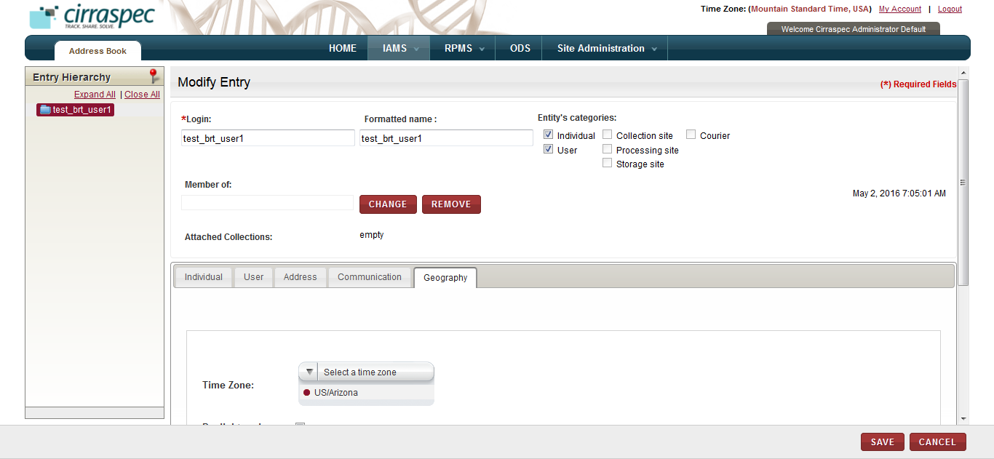

1. Modify Entry page
2. Enter appropriate information in each field. Following table lists each field and its description.

**Note:** Fields that are marked with the red asterisk (*) are mandatory.

Table : Modifying an Entry

| **Field** | **Description** |
| --- | --- |
| **Name**\*/  **Login**\* | If you want to change the name, type the new name. |
| **Formatted Name  (Site Code)\*** | If you want to change the formatted name or site code, type the new value.   * For an Individual, User or Courier, type the name of the entity. * For a Collection, Processing or Storage site, type the site code.   **Note:** This field is optional for an Individual, User or Courier, but is required for a Collection, Processing or Storage site. |
| **Entity’s categories** | If you want to change the **Entity’s category**, click the appropriate checkbox to indicate what type.  **Note:**   * To deselect a box that has already been checked so you can make a different selection, click on the checkbox again. * To create a user entry, you must first select **Individual** checkbox, and then select **User**. Only the System Administrator can create a user entry. * To create a Biobank site, you must check the **Processing Site** and **Storage Site** checkboxes to ensure Collection Sites can ship biospecimens to the Biobank site. * To create a Processing Site, you must check the **Processing Site** and the **Storage Site** box if required, to ensure Collection Sites can ship biospecimen to the Processing site. * The **Entity Category** determines where this entry is listed in the **RPMS module** for assigning to a collection. For example, Collection, Processing and Storage sites are listed on the **Sites** tab in **RPMS**; users are listed on the **Personnel** tab in **RPMS**; Couriers are listed on the **Couriers** tab in **RPMS.** |
| **Member of** | Skip this field. It is reserved for future use. |
| **Change/Remove** | Skip these buttons. They are reserved for future use. |
| **Individual tab** | 1. Click the **Select a title** field, and then select a title, if applicable. 2. If you want to change the name, type the **First name**\*and **Last name**\*. 3. Type the individual’s **Position**, if applicable.   **Note:** This tab only appears if the **Individual** or **User** checkbox is selected. |
| **User tab** | 1. To enable the account, click **Account enabled**. 2. Select suitable **Authentication Source**\* from the dropdown. 3. The **Login**\* value is auto-populated from the value specified in the ‘Login’ field at the top of the page. 4. To create a temporary password for this user, click **CHANGE.** Type a password in **New Password** and **Confirm Password,** and then click **OK**. **Note:** User will be prompted to change the temporary password upon his first login. 5. To assign new **Authorized sites**\* for this entry, click **ADD.** Click the appropriate site for which this user is authorized and click **ADD**. Repeat to assign additional sites, as needed. When done, click **CLOSE.** 6. To set a default site, click the site on the authorized list that you want to be the default, and click **MAKE DEFAULT.** 7. To assign a different **Role** for this entry, click **ADD.** Click the appropriate role for which this user is authorized and click **ADD**. In case you need to add more than one role, click the required role and click **ADD**. When done, click **CLOSE**.   **Note**: It is currently not recommended to use the Project Manager role for users.   1. If the user needs to be a PHI authorized user, then select the **PHI authorized** checkbox.   **Note:**   1. To remove a site or role from the list, click the item and click **REMOVE**. 2. The **PHI authorized** checkbox by default is not selected indicating that the user being created will be a Non-PHI authorized user.   Adminisitrator has to select this checkbox explicitly to make the new user PHI authorized.   1. This tab only appears if the **User** checkbox is selected. 2. Only the System Administrator can create a user entry. |
| **Attached users tab** | 1. To assign Attached users for this site, click ADD. Click the appropriate user you for whom want to authorize access to this site and click ADD. Repeat to authorize additional users, as required. When done, click CLOSE.   **Note:**   * To remove a user from the list, click the item and click **REMOVE**. * This tab only appears if the **Collection Site, Processing Site** or **Storage Site** checkbox is selected. |
| **Courier tab** | 1. To provide a tracking link for shipments, copy/paste or type the URL of the Courier tracking website in Tracking URL. 2. Specify the type of shipments that this Courier allows in **Allowed shipment types**, if applicable. 3. If the Courier allows Express shipments, click the **Express** checkbox. 4. If the Courier allows international European Union shipments, click the **International EU** checkbox. 5. If the Courier allows worldwide shipments other than European Union, click the **International worldwide** checkbox.   **Note:**   * This tab only appears if the **Courier** checkbox is selected. * This tab determines the Courier information displayed in the **Shipments** module. |
| **Address tab** | 1. Type the mailing address in the address fields. 2. Click on the **Select a country** dropdown, and then select the **Country** for the address. 3. Click **SAVE.**   **Note:** For Collection, Processing and Storage sites, this tab sets the address information displayed on the **Create Shipment** page in the **BMS Shipments** module. |
| **Communication tab** | 1. For Collection, Processing and Storage Site entries, type the name of the Contact Person* for this entry. 2. For all entries, type all available contact information in the **Phone, Email, Fax, Instant messaging** and **Web address** fields. 3. To select a **Language,** click **ADD.** Then, in the **Select a language** window, select the appropriate language for this entry and click **ADD**.   **Note:**   * To remove a language from the list, click the item and click **REMOVE**. * For collection, processing and storage sites, this tab sets the contact information displayed on the **Create Shipment** page in the **BMS Shipments** module. |
| **Geography tab** | 1. Click the Select a time zone dropdown and select the appropriate Time Zone for this entry. 2. Click **Daylight savings** checkbox if this entry’s location observes daylight savings time. 3. Type the latitude and longitude of this entry’s location in **Global position**, if applicable. 4. Click the **Select a locale** dropdown and select the appropriate **Country locale** for this entry. |

1. Click **SAVE**.

The entry is modified and the new information appears on the **View Entry** page.

**Note:**

* You must activate the entry before you can use the entry in the application. For information about how to activate an entry, see **Activating an Entry**.
* If you unpublished a Collection in order to deactivate and modify this Entry, you must publish the Collection in the **RPMS** module for the Collection to be used in the application. For more information about how to publish a Collection, refer to the **CIRRASPEC User’s Manual – Research Project Management System (RPMS)** documentation.

### Deleting an Entry

**Note:**

* You cannot delete an address book Entry if it is activated. You must first deactivate the Entry and, if it is assigned to a Collection, you must unpublish the Collection in order to deactivate the Entry. For information about how to deactivate an Entry, see **Deactivating an Entry**.
* Only the System Administrator can delete a user entry.

To delete a deactivated address book entry:

1. Log on to the application using your login credentials.

The CIRRASPEC home page appears.

1. Point to the arrow of the **IAMS** tab, and then click **Address Book**.

The **Entry Search** page appears.

1. Click **SEARCH**.   
   The list of address book entries appears.
2. Select the row of the entry you want to delete.

The **View Entry** page appears with details for the selected entry.

1. Click **DELETE**.  
   A confirmation window appears.
2. Click **YES**.

The entry is deleted and no longer appears on the **Entry Search** page. **Note:**

* If you unpublished any Collections in order to deactivate and delete this entry, you must unassign this entry and publish the Collections.

For more information about how to unassign a user or site and publish a Collection, refer to the **CIRRASPEC User’s Manual – Research Project Management System (RPMS)** documentation.

### Activating an Entry

To use an address book Entry in the application, you must first activate the Entry.

To activate an entry:

1. Log on to the application using your login credentials.

The CIRRASPEC home page appears.

1. Point to the arrow of the **IAMS** tab, and then click **Address Book**.

The **Entry Search** page appears.

1. Click **SEARCH**.   
   The list of address book entries appears.
2. Select the row of the entry you want to activate.

The **View Entry** page appears with details for the selected entry.

1. Click **ACTIVATE**.  
   The entry is activated for use in the application.   
     
   **Note**:

* When activated, you cannot modify or delete this entry.
* If an activated user tries to access the application but the user is not yet assigned to a Collection in the **RPMS Configuration** module, an “Access Denied” message appears.

For more information about how to assign a user to a Collection, refer to the **CIRRASPEC User’s Manual – Research Project Management System (RPMS)** documentation.

### Deactivating an Entry

To modify or delete an address book Entry, you must first deactivate the Entry.

To deactivate an entry:

1. Log on to the application using your login credentials.

The CIRRASPEC home page appears.

1. Point to the arrow of the **IAMS** tab, and then click **Address Book**.

The **Entry Search** page appears.

1. Click **Search**.   
   The list of address book entries appears.
2. Select the row of the entry you want to deactivate.

The **View Entry** page appears with details for the selected entry.

1. Click **DEACTIVATE.**

If the entry is not actively being used in the application, the entry is deactivated. You may modify, delete or activate the entry.

**Note:** Exceptions:

* If you click **DEACTIVATE** and receive an error message, the Entry is activated and in use in the application. You must unpublish the Collection(s) to which the Entry is assigned, and unassign the Entry prior to deactivating the Entry. Proceed to the next step.
* If the **DEACTIVATE** button is not displayed and the **ACTIVATE** button is displayed, the Entry is already deactivated. You may modify, delete or activate the Entry.
* If both **DEACTIVATE** and **ACTIVATE** buttons are not displayed, the Entry is activated and in use in the application. You must unpublish the Collection(s) to which the Entry is assigned, and unassign the Entry prior to deactivating the Entry. Proceed to the next step.

1. If the **Entity’s Category** on the **View Entry** page for the Entry you want to deactivate is **User**, verify if the Entry is assigned to a published Collection:
2. Point to the arrow of the **RPMS** tab in the top navigation bar, and then click **Configuration**.  
   The **RPMS Search** page appears.
3. Click **SEARCH**.  
   The list of Projects and Collections appears.
4. Click on the row of the first item with **Collection** as the **Type** and **Published** as the **Publication Status**.  
   The **View Collection** page appears for the selected Collection.
5. Click the **Personnel** tab**.**
6. Expand the hierarchy tree list in the **Personnel** section, and verify if the user you want to deactivate is listed under **Bio_Repository_Technician** or **Clinical_Reserach Nurse**.

* If the user you want to deactivate is not listed, click **CLOSE** to return to the **RPMS Search** page. Then repeat steps b. – e. for each Collection listed that has the **Published** status.
* If the user you want to deactivate is listed, proceed to step f.

1. Click **UNPUBLISH**.  
   The Collection is unpublished.
2. Click **CLOSE** to return to the **RPMS Search** page. Then repeat steps b. – g. for each Collection listed that has the **Published** status.
3. If the **Entity’s Category** on the **View Entry** page for the Entry you want to deactivate is **Collection Site, Processing Site or Storage Site**, verify if the Entry is assigned to a published Collection:
4. Point to the arrow of the **RPMS** tab in the top navigation bar, and then click **Configuration**.  
   The **RPMS Search** page appears.
5. Click **SEARCH**.  
   The list of Projects and Collections appears.
6. Click on the row of the first item with **Collection** as the **Type** and **Published** as the **Publication Status**.  
   The **View Collection** page appears for the selected Collection.
7. Click the **Sites** tab.
8. Expand the hierarchy tree list in the **Sites** section, and verify if the site Entry you want to deactivate is listed under **Collection** or **Processing** or **Storage**.

* If the Entry you want to deactivate is not listed, click **CLOSE** to return to the **RPMS Search** page. Then repeat steps b. – e. for each Collection listed that has the **Published** status.
* If the Entry you want to deactivate is listed, proceed to step f.

1. Click **UNPUBLISH**.  
   The Collection is unpublished.
2. Click **CLOSE** to return to the **RPMS Search** page. Then repeat steps b. – g. for each Collection listed that has the **Published** status.
3. Once all Collections to which the address book Entry you want to deactivate is assigned are unpublished, click **DEACTIVATE**.  
   The Entry is deactivated. You may modify or delete the Entry.  
     
   **Note**:

* You cannot use a deactivated site Entry in the application.
* If a deactivated user tries to access the application, an “Access Denied” message appears.
* To modify the Entry, see **Modifying an Entry**.
* To delete the Entry, see **Deleting an Entry**.

# Site Administration

### Clear Application Cache

To clear application cache:

1. Login into Cirraspec using your login credentials.

**Home page** appears.

1. Point to the arrow of the **Site Administration** tab, and then click **Clear Application Cache**

**Clear Application Cache** page is displayed.

Message as below is displayed on screen

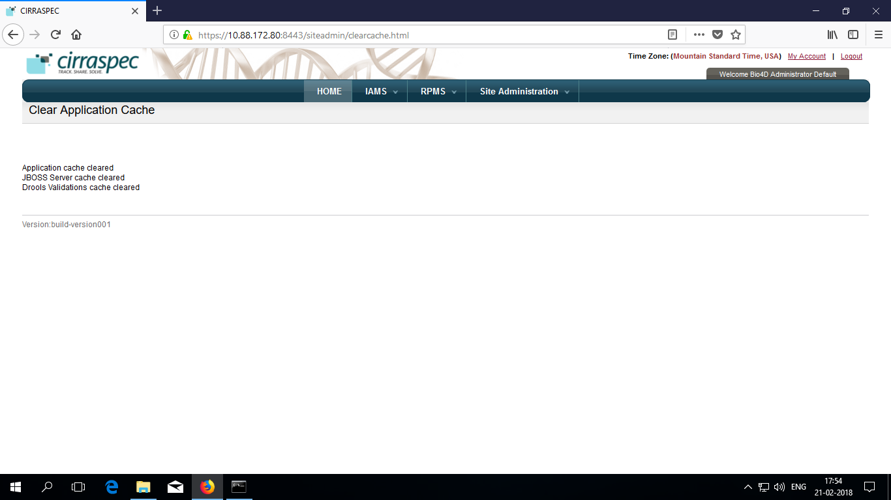

### Manage User Session

1. Login into Cirraspec using your login credentials.

**Home page** appears.

1. Point to the arrow of the **Site Administration** tab, and then click **Manage User Session.**

**Manage User Session** page displays a list of all users and their current account status.

On this page as seen below :

To enable an user account : Click **Enable User**

To disable an user account : Click **Disable User**

To force log out a userlogged in **:** Click **Force log out user**

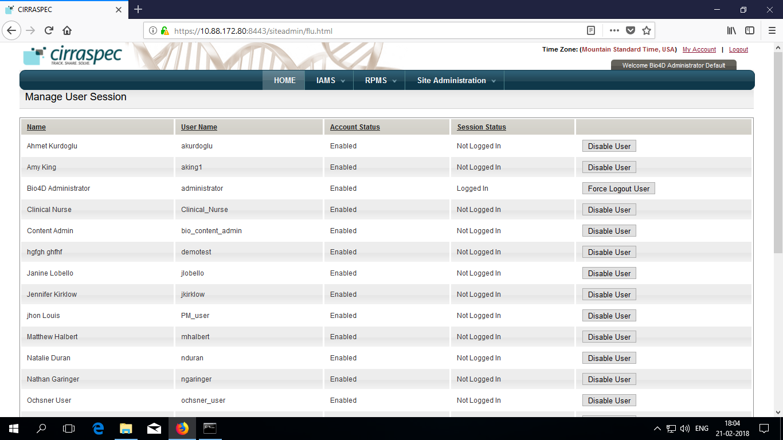

# Project Management

## Overview

**Relational Diagram**

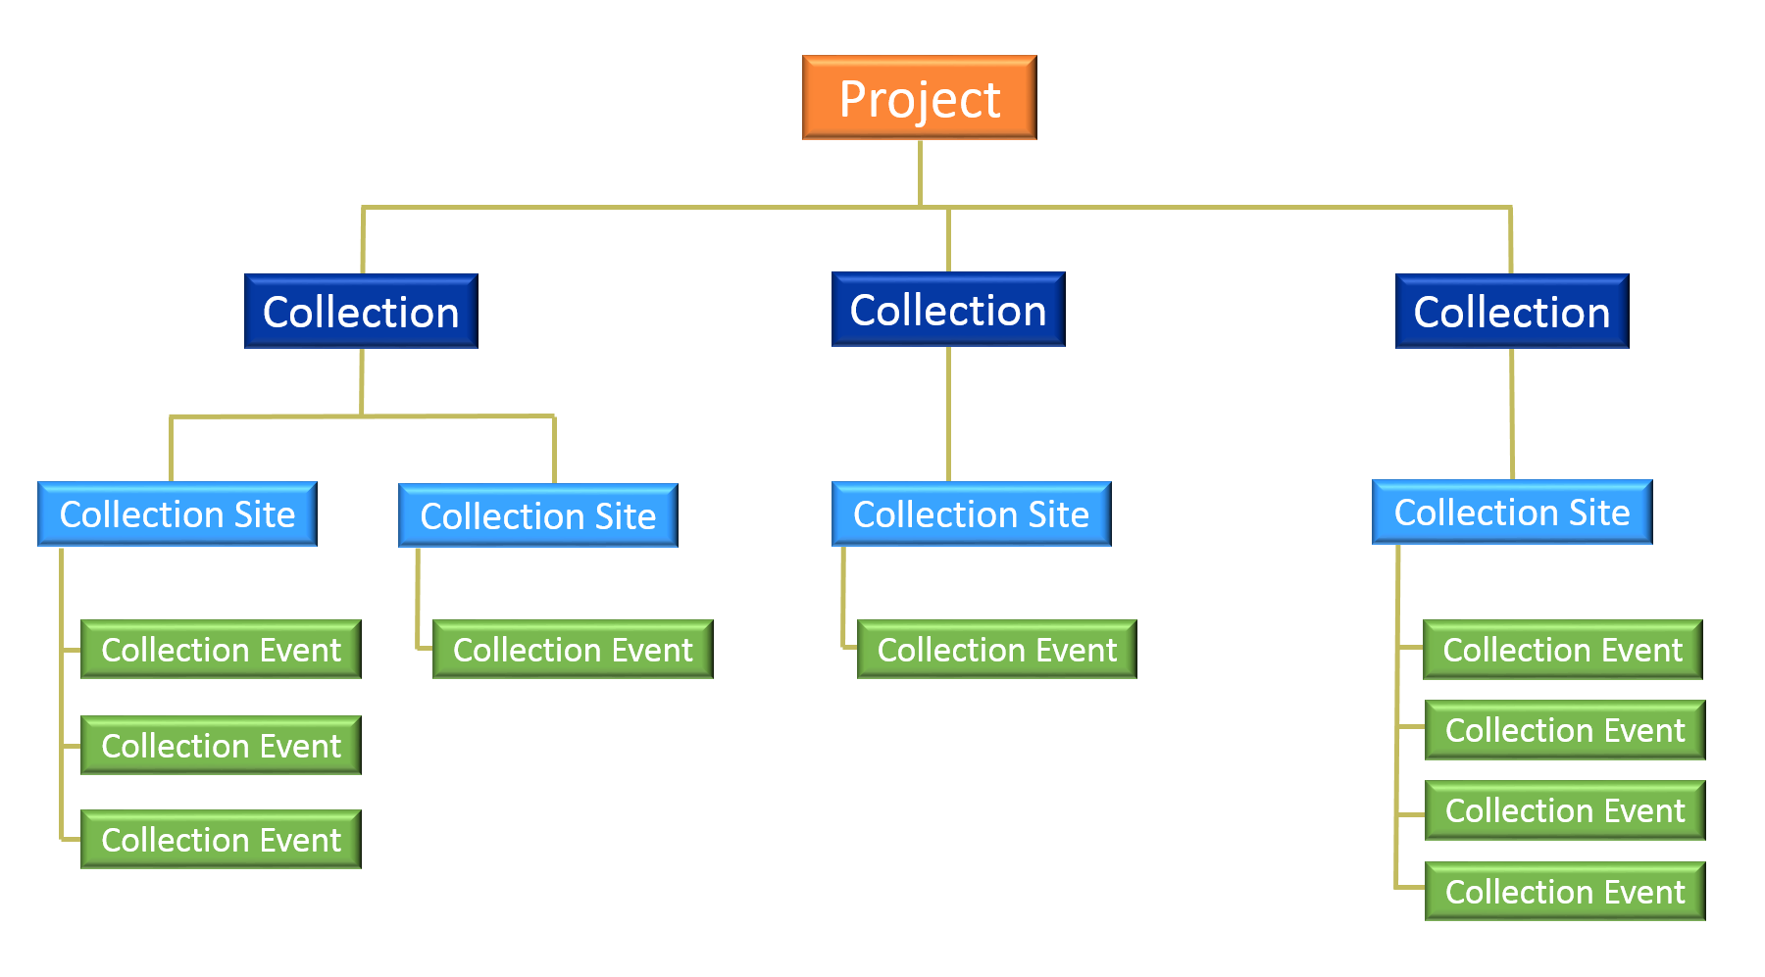

* A Project may contain one or more Collections.
* Each Collection may contain one or more Collection Sites.
* Each Collection Site may contain one or more Collection Events.
* Collection Sites, Personnel, Kit Templates, Form Templates, Process Workflow Templates and Couriers are assigned to a Collection.
* Samples are associated with a Collection.

## Definitions

**Project**

* A project is an entity grouping of collections with a common collection goal characteristic as the research subject.
* The project level allows consolidation in reports of information about the collections it contains.

**Collection**

* A collection is linked directly to a project. Several collections can be linked to the same project.
* A collection is a set of biospecimens collected from subjects for creating aliquots, derivatives, etc. for scientific research.
* Biospecimens may be gathered from one or multiple collection sites through a series of collection events.

**Virtual Collection**

* A virtual collection is a collection made up of samples from other collections. A virtual collection can be made up of several other entire collections or individual samples taken from other collections.
* Creating a virtual collection does not change the collections from which it is derived.
* Samples can belong to several virtual collections.

### Viewing a List Projects and Collections

To view a list of projects and collections:

1. Log on to the application as the System Administrator.
2. Point to the arrow of the **RPMS** tab, and then click **Configuration**.   
   The **RPMS Search** page appears.
3. Click **SEARCH**.  
   The RPMS search page displays a list of projects and collections.

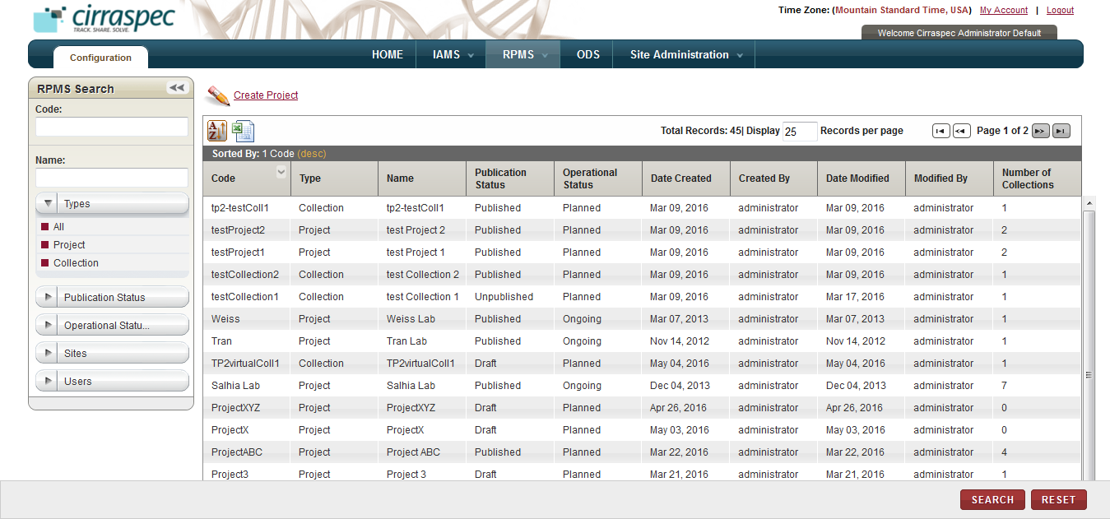

1. RPMS Search page

**Note:** To re-sort the list, click the header of the column by which you want to sort.

On the RPMS search page, you can initiate the following tasks:

* **Perform a search for a project or a collection**: For more information about how to search for a specific project or a collection, see **Searching for a Project or a Collection**.
* **View details of a project:** For more information about how to view the details of a project and its related collections, see **Viewing the Project Hierarchy Details**.
* **Create a new project:** For more information about how to create a new a project and its related collections, see **Creating a Project Hierarchy****.**

### Searching for a Project or a Collection

To search for a specific project or a collection:

1. Point to the arrow of the **RPMS** tab, and then click **Configuration**.   
   The **RPMS Search** page appears.
2. Click **SEARCH**.  
   The RPMS search page displays the **RPMS Search** pane.

Arrow hides/displays the RPMS Search pane



1. RPMS Search page
2. Specify your search criteria by completing one or more fields in the **RPMS Search** pane.

**Note:**

* You can use one field or a combination of fields to search.
* You can type the full or partial value in a search field along with an asterisk (*) before or after the partial value. For example, if you type **02\***, you obtain records that begin with 02. If you type **\*02**, you obtain records that end with 02

Following table lists each search field and its description.

Table : RPMS Search Fields

| **Field** | **Description** |
| --- | --- |
| **Code** | Type the project or collection code to search for the project or collection associated with this code. |
| **Name** | Type the project or collection name to search for the project or collection associated with this name. |
| **Types** | Click the appropriate item type to search for this type.  **Note:** To search for all types, click **All**. |
| **Publication Status** | Click the appropriate status to search for items with this publication status.  **Note:** To search for all statuses, click **All**. |
| **Operational Status** | Click the appropriate status to search for items with this operational status.  **Note:** To search for all statuses, click **All**. |
| **Sites** | Click the appropriate site to search for all items associated with this site.  **Note:** To search for all sites, click **All**. |
| **User** | Click the appropriate user to search for projects and collections to which this user is assigned.  **Note:** To search for all users, click **All**. |

1. Click **SEARCH**.  
   The search results appear.   
     
   **Note**: Click the header of the column with which you want to sort the results.

### Viewing the Project Hierarchy Details

To view details for a project hierarchy:

1. Log on to the application as the System Administrator.

The CIRRASPEC home page appears.

1. Point to the arrow of the **RPMS** tab, and then click **Configuration**.

The **RPMS Search** page appears.

1. Click **SEARCH**.

TheRPMS search page displays a list of projects and collections.

1. Click the row of the item for which you want to view details.

The **Project Hierarchy** page appears.  
  
**Note:**

* To expand the **Project Hiearchy** tree to display all levels, click the **Expand All** link.
* To view project details, select the project name on the hierarchy tree.   
  The project details appear on the right side of the screen.
* To view collection details, select the collection name on the hierarchy tree.   
  The collection details appear on the right side of the screen.
* To view collection event details, select the collection event name on the hierarchy tree.   
  The collection event details appear on the right side of the screen.

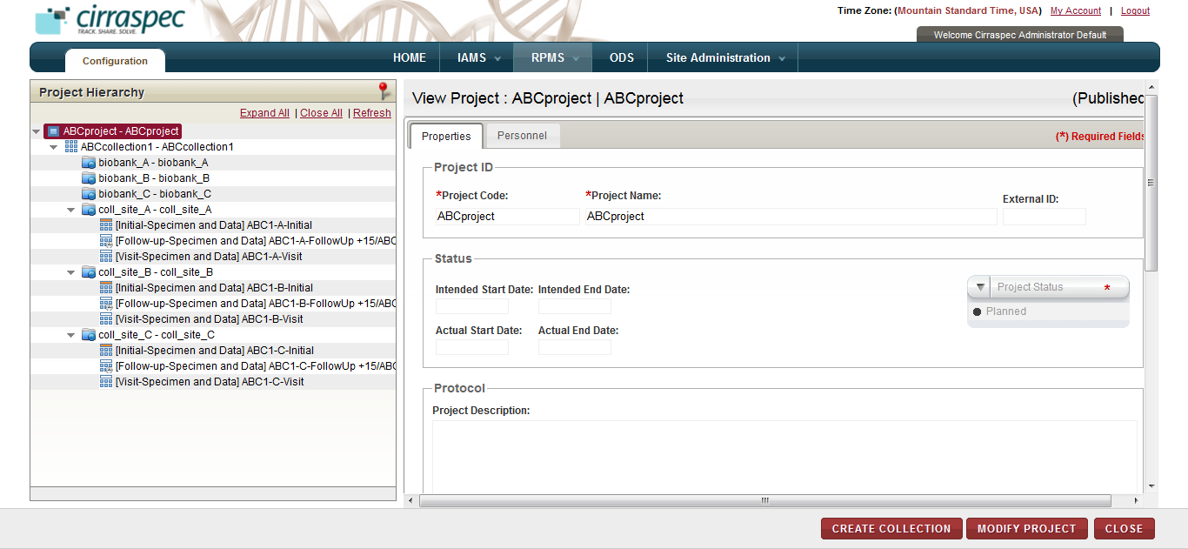

1. View Project Hierarchy page

On the **Project Hierarchy** page, you can perform the following tasks:

* **Add a collection:** For more information, see **Adding a Collection to an Existing Project****.**
* **Add a collection event:** For more information, see **Adding a Collection Event to an Existing Collection****.**
* **Modify a project**: For more information, see **Modifying the Project Details****.**
* **Modify a collection**: For more information, see **Modifying the Collection Details****.**
* **Delete a collection**: For more information, see **Deleting a Collection****.**
* **Modify a collection event**: For more information, see **Modifying the Collection Event Details****.**
* **Delete a collection event:** For more information, see **Deleting a Collection Event****.**

### Creating a Project Hierarchy

The **Create Project** link on the **RPMS Search** page allows you to create a new project hierarchy.

To create a project hierarchy:

1. Log on to the application as the System Administrator.

The CIRRASPEC home page appears.

1. Point to the arrow of the **RPMS** tab, and then click **Configuration**.

The **RPMS Search** page appears.

1. Click the **Create Project** link.

The **Create Project** page appears.

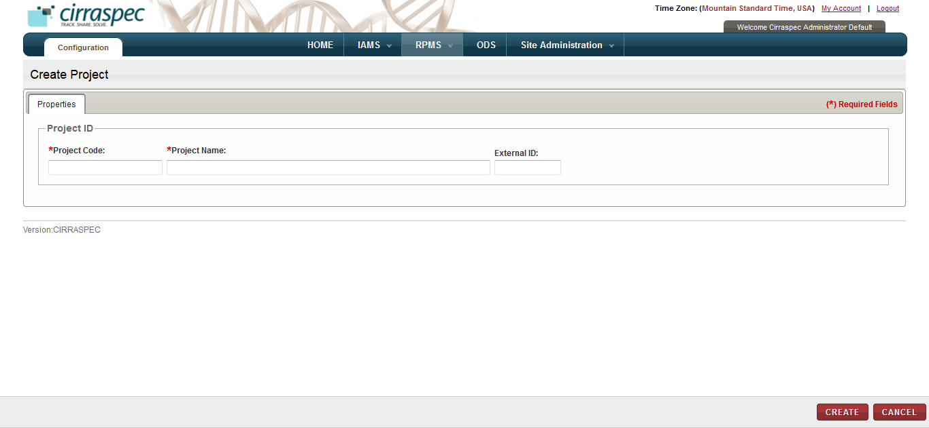

1. Create Project page
2. Enter appropriate information in each field. Following table lists each field and its description.

**Note:** Fields that are marked with the red asterisk (*) are mandatory.

Table : Creating a project

|  |  |
| --- | --- |
| **Field** | **Description** |
| **Project Code**\* | Type a code for this project. |
| **Project Name**\* | Type a name for this project. **Note:** Combination of the code and the name must be unique. |
| **External ID** | Type an external identifier, if applicable. |

1. Click **CREATE**.  
   The project is created with the status as **Draft**. The **Project Hierarchy** page appears with the hierarchy tree on the left and the project information fields on the right.  
     
   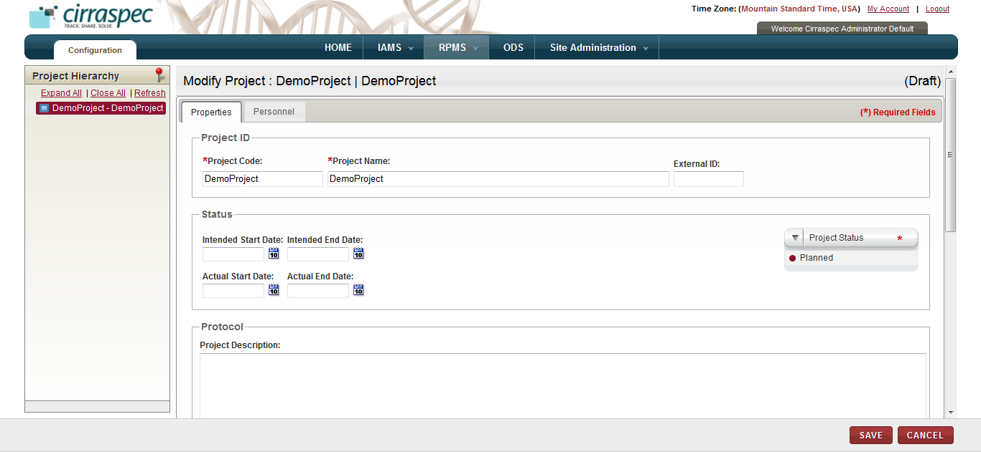
2. Project Hierarchy page
3. Enter appropriate information in each field. Following table lists each field and its description.

**Note:**

* Fields that are marked with the red asterisk (*) are mandatory.
* The **Project Description** and **Project Characteristics** fields can be expanded by placing the cursor on the bottom right corner of the box and resizing the box.

Table : Creating a project

|  |  |
| --- | --- |
| **Field** | **Description** |
| **Intended Start Date** | Click the date icon and then in the pop-up, select the appropriate start date for this project. |
| **Intended End date** | Click the date icon and then in the pop-up, select the appropriate end date for this project. |
| **Actual Start Date** | Skip this field. |
| **Actual End date** | Skip this field. |
| **Project Status \*** | Click the appropriate status for this project:   * **Planned**: No kit has been created yet in the system and all collections have not started yet. * **Ongoing**: The first collection associated with this project has started. Preconditions for the availability of this status are: * All mandatory fields in the collection form have been filled. * At least one collection has been assigned to the project. * All mandatory fields of an assigned collection have been filled. * At least one assigned collection has got the approval of all required committees. * **On Hold**: Work on all collections associated with this project has been temporarily stopped due to a specific reason, which should be documented in the **Description** field. * **Closed**: The work on all collections associated with this project has been completed. |
| **Project Description** | Type a brief description of this project, if applicable. |
| **Project Characteristics** | Type a summary of the project charactereistics, if applicable. |

1. Click **SAVE**.

Project information is saved.

1. Click **Create Collection**.  
   The **Create Collection** page appears.  
     
   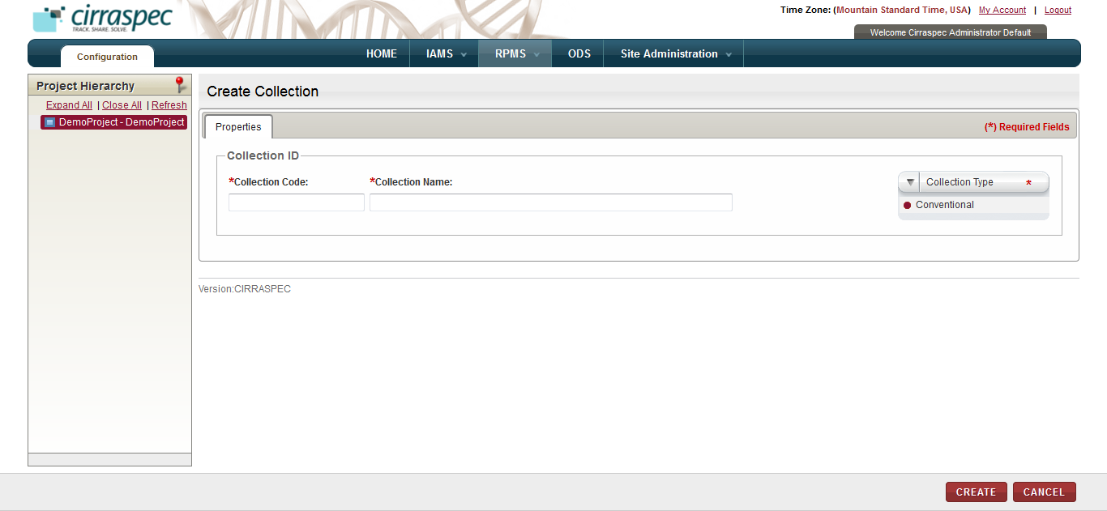
2. Create Collection page
3. Enter appropriate information in each field. Following table lists each field and its description.

**Note:** Fields that are marked with the red asterisk (*) are mandatory.

Table : Creating a collection

|  |  |
| --- | --- |
| **Field** | **Description** |
| **Collection Code**\* | Type a code for this collection. |
| **Collection Name**\* | Type a name for this collection. **Note:** Combination of the code and the name must be unique. |
| **Collection Type\*** | Click the appropriate type for this collection:   * **Conventional**: Select this type for a conventional collection that includes biospecimens collected through this collection. * **Virtual**: Select this type for a collection that groups already collected biospecimens together from other collections.  **Note:** Since a virtual collection is composed of already collected specimens, collection events are not defined for and do not apply to virtual collections. * **Not Applicable**: Select this type if neither Virtual nor Conventional apply to this collection. |

1. Click **CREATE**.  
   The collection is created with the status as **Draft**. The **Project Hierarchy** page appears with the collection added to the hierarchy tree on the left, and the collection information fields on the right.

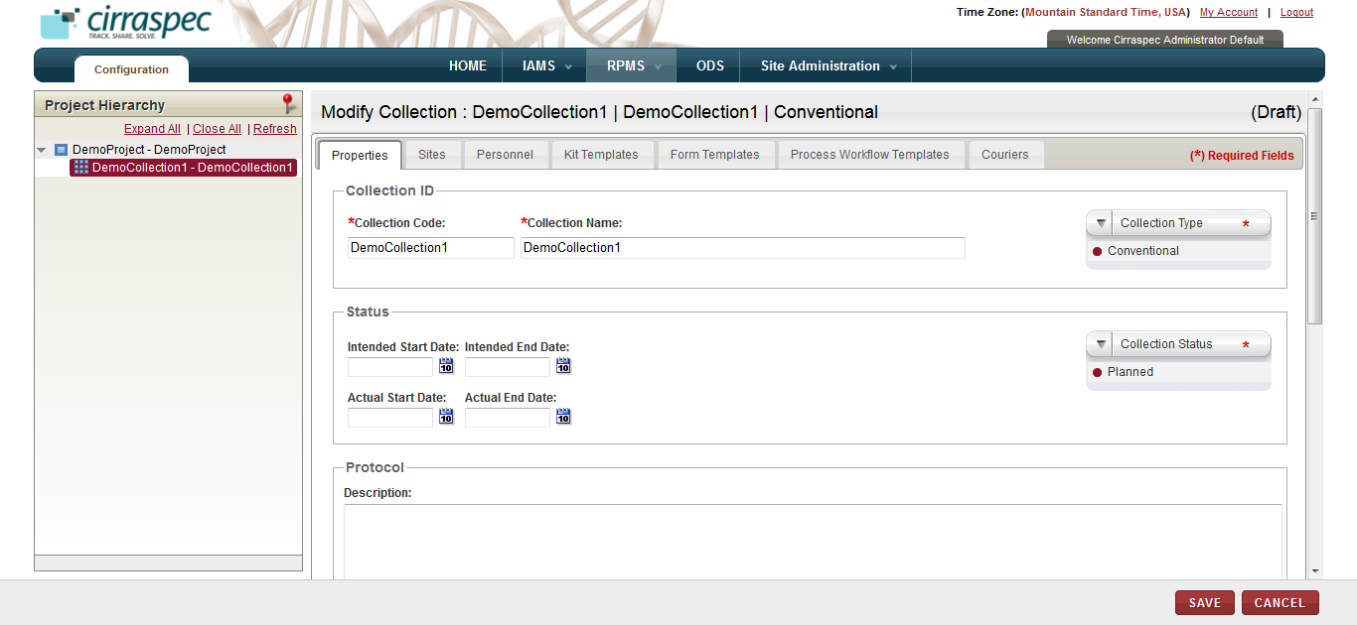

1. Collection properties page
2. Enter appropriate information in each field. Following table lists each field and its description.

**Note:**

* Fields that are marked with the red asterisk (*) are mandatory.
* The **Description** field can be expanded by placing the cursor on the bottom right corner of the box and resizing the box.

Table : Creating a collection

|  |  |
| --- | --- |
| **Field** | **Description** |
| **Intended Start Date** | Click the date icon and then in the pop-up, select the appropriate start date for this collection. |
| **Intended End date** | Click the date icon and then in the pop-up, select the appropriate end date for this collection. |
| **Actual Start Date** | Skip this field. |
| **Actual End date** | Skip this field. |
| **Collection Status \*** | Click the appropriate status for this collection:   * **Planned**: The collection is created but not all its characteristics are completely defined (e.g., some collection events might be missing or some processing steps might not have been assigned yet). * **Ongoing**: All collection events have been fully described and acquisition can start. * **On Hold**: Work on the collection has been temporarily stopped due to a specific reason, which should be documented in the **Description** field. * **Closed**: No more specimens can be added to the collection (e.g., all scheduled collection events have occurred). **Note:** You can change the status later from **Closed** to **Ongoing** if an unscheduled visit occurs. |
| **Description** | Type a brief description of this collection, if applicable. |
| **Allowed Subject Types** | Click the appropriate subject type(s) that you want to be allowed for enrollment in this collection. |

1. Click the **Sites** tab.

The site assignment fields appear.  
  
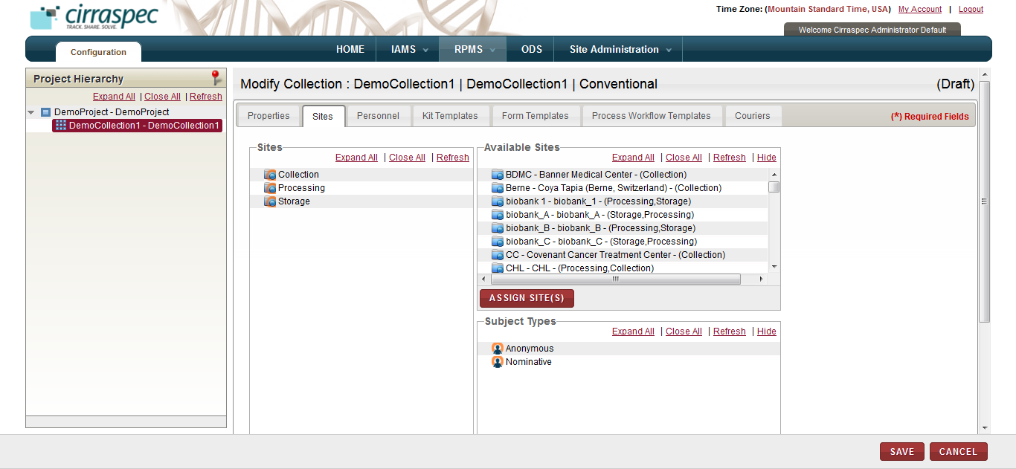

1. Sites assignment page

General tips for all of the collection assignment tabs:

* To assign items:   
  Select the appropriate item on the list on the right and “drag and drop” it to the appropriate item on the left.   
  OR  
  Select the appropriate item on both lists and click **ASSIGN SITE(S)**.
* You can assign multiple items; however, you must select and assign the items one at a time.
* When assigning items using “drag and drop”, the red X indicates that you are trying to assign the item to an invalid level or location.
* You can navigate between tabs with the system automatically saving changes before displaying the next tab. If you click on **SAVE** before completing all of the tabs, you must click **Modify Collection** to return to “create/modify” mode.
* To unassign an item: Select the item on the left that you want to unassign, and click the **UNASSIGN** button.

1. To assign the authorized sites for this collection:
   1. Assign the appropriate collection, processing and storage site locations on the **Available Sites** list on the right to the applicable site types on the left (**Collection, Processing and Storage)**.   
        
      **Note:** The **Available Sites** list displays all sites created and activated in **IAMS > Address Book**.   
      If you don’t see a site location you want to assign, verify that it is activated in the IAMS module.
2. Assign the appropriate subject type on the **Subject Types** list on the right to the applicable collection site location on the left side.
3. To assign the users to the roles for this collection, click the **Personnel** tab.  
   The personnel assignment fields appear.

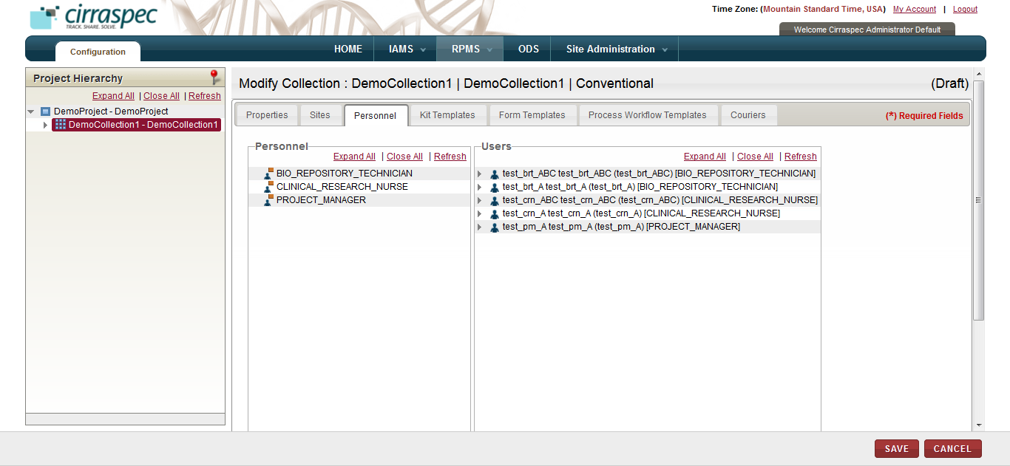

1. Personnel assignment page

* Assign appropriate users on the **Users** list on right to the applicable roles on the left (**Bio Repository Technician** and **Clinical Research Nurse**)**.**

**Note:**

* It is currently not recommended to add **Project Manager** users to collections.
* PHI authorized as well as Non-PHI authorized users, of all user roles, will be shown in the **Personnel** tab for the Site(s) selected for the Collection, and these users can be assigned to the Collection as per the requirement.

**Note:** The **Users** list displays all users assigned to the sites on the **Sites** tab. If you don’t see an item you want to assign, verify that is is assigned to at least one of the sites and is activated in the **IAMS > Address Book** module.

.

1. To assign the kit templates for this collection, click the **Kit Templates** tab.  
   The kit template assignment fields appear.  
     
   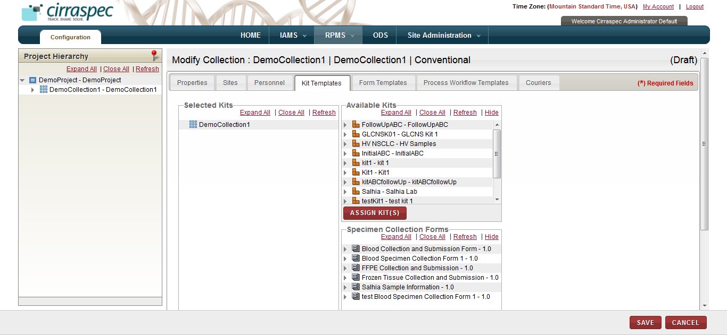
2. Kit Templates assignment page
3. Assign the appropriate kit templates on the **Available Kits** list on the right to the collection on the left.   
     
   **Note:** The **Available Kits** list displays all kits created and activated in **IAMS > Kits Designer** that are available for this project. If you don’t see an item you want to assign, verify that it is activated in the IAMS module.
4. Click the **Expand All** link under **Selected Kits** to expand the hierarchy tree.
5. Assign appropriate forms on the **Specimen Collection Forms** list on the right to the applicable kit component group(s) on the left.   
     
   **Note:** The **Available Specimen Collection Forms** list displays all forms created and activated in **IAMS > Forms Designer** with a Category Type = Specimen Collection Form. If you don’t see an item you want to assign, verify that it is activated in the IAMS module.
6. Assign the default barcode template values for each kit template and each kit component:
7. Select the kit template name on the **Selected Kits** hierarchy tree, and then click **DEFAULT VALUES**.
8. In the **Default Values** pop-up, click **CHANGE.**
9. Input the number of labels needed in **Copies**, select the appropriate value on the **Available Barcode Templates** list and click **SAVE**.
10. Select a kit component on the **Selected Kits** hierarchy tree, and then click **DEFAULT VALUES**.
11. In the **Default Values** pop-up, click **CHANGE.**
12. Input the number of labels needed in **Copies** and select the appropriate value on the **Available Barcode Templates** list.
13. Select the appropriate value on the **Label Codes** list.  
    **Note:** The selected Label Code values must be unique for each kit component.
14. **Quantity** is optional. However, if you input the quantity, the system assigns this quantity as the initial quantity for all samples collected for this kit template component.
15. **Code Scheme** is optional. However, if you complete the code scheme fields, the system assigns this code scheme to all samples collected for this kit template component.
16. Click **SAVE.**Kit templates and kit components that have the default barcode values assigned appear on the **Selected Kits** hierarchy tree with a green check mark.
17. Repeat steps 4 -10 to assign the default barcode template values for each additional kit component.   
    **Note:**

* If you assigned multiple kit templates to this collection, repeat steps 1 – 10 for each additional kit template on the **Selected Kits** hierarchy.

1. To assign consent and clinical forms for this collection, click the **Form Templates** tab.  
   The consent and clinical forms assignment fields appear.  
     
   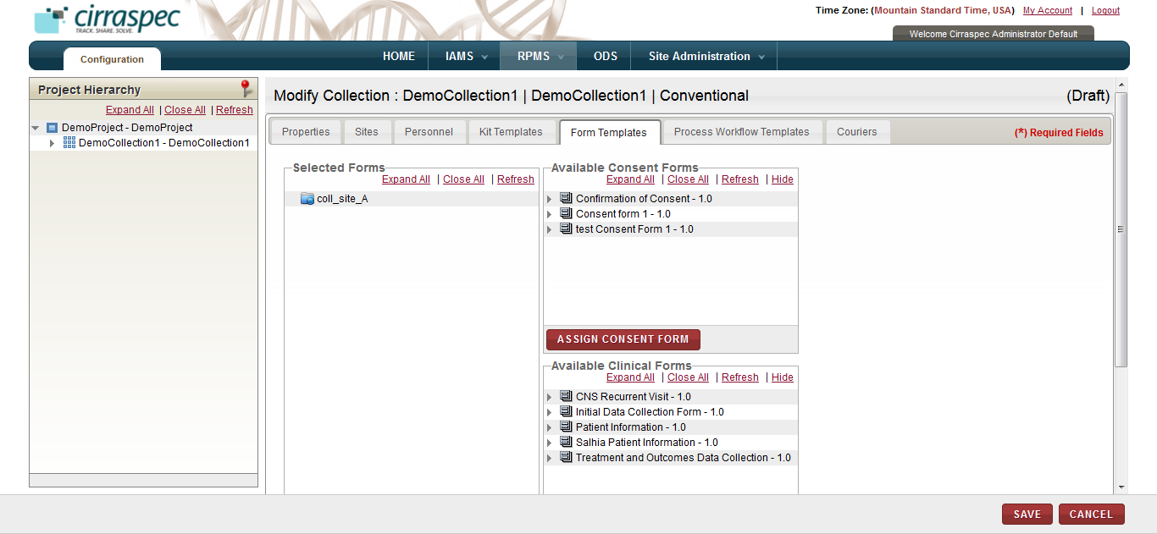
2. Form Templates assignment page
3. Assign the appropriate Consent Form from the **Available Consent Forms** list on the right to the applicable collection site(s) on the left.   
     
   **Note**: The **Available Consent Forms** list displays all forms created and activated in **IAMS > Forms Designer** with a Category Type = Consent Form. If you don’t see an item you want to assign, verify that it is activated in the IAMS module.
4. If applicable, assign the appropriate clinical form(s) from the **Available Clinical Forms** list on the right to the applicable collection site on the left.  
     
   **Note:** The **Available Clinical Forms** list displays all forms created and activated in **IAMS > Forms Designer** with a Category Type = Clinical Form. If you don’t see an item you want to assign, verify that it is activated in the IAMS module.
5. To assign sample process workflow templates and forms for this collection, click the **Process Workflow Templates** tab.  
   The process workflow assignment fields appear.  
     
   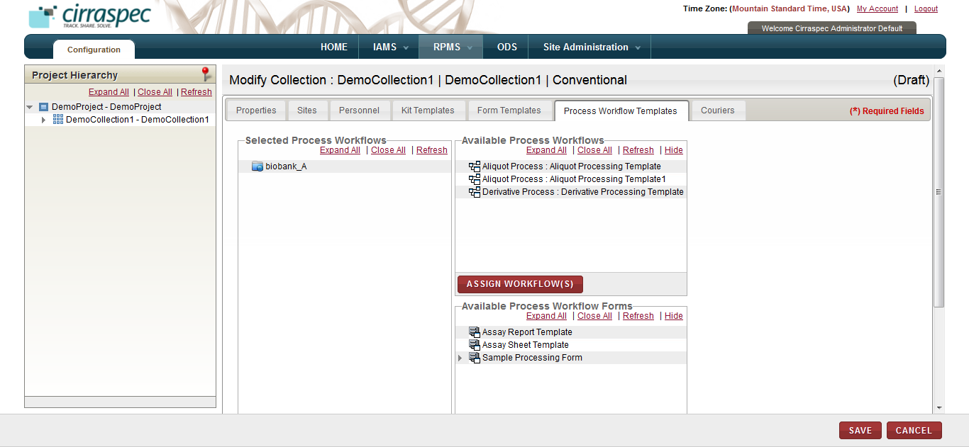
6. Process Workflow assignment page
7. Assign the appropriate process template(s) from the **Available Process Workflows** list on the right to the applicable processing site(s) on the left.   
     
   **Note:** The **Available Process Workflows** list displays all sample processing templates uploaded in **IAMS > Import Data**. If you don’t see an item you want to assign, create and upload the appropriate template(s) in the IAMS module.
8. Click the **Expand All** link under **Available Process Workflow Forms** on the right side.
9. Assign the appropriate Sample Processing Form(s) from the **Available Process Workflow Forms** list on the right to each of the applicable processing template(s) on the left.   
     
   **Note:** The **Available Process Workflow Forms** list displays all forms created and activated in **IAMS > Forms Designer** with a Category Type = Sample Processing Form. If you don’t see an item you want to assign, verify that it is activated in the IAMS module.
10. To assign shipping couriers for this collection, click the **Couriers** tab.  
    The courier assignment fields appear.

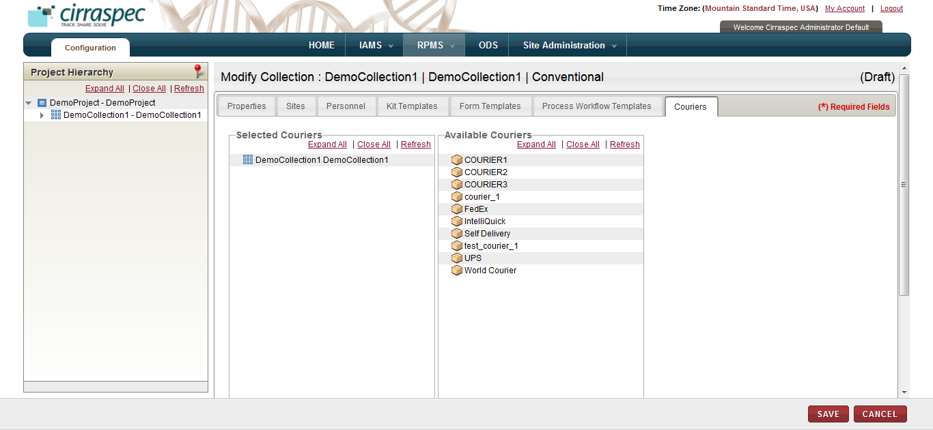

1. Courier assignment page
2. Assign the appropriate courier from the **Available Couriers** list on the right to the applicable collection on the left.   
     
   **Note:** The **Available Couriers** list displays all couriers created and activated in **IAMS > Address Book**. If you don’t see an item you want to assign, verify that it is activated in the IAMS module.
3. Click **SAVE.**  
   Collection information is saved.
4. To create a collection event, click **CREATE COLLECTION EVENT**.  
   The **Create Collection Event** page appears.

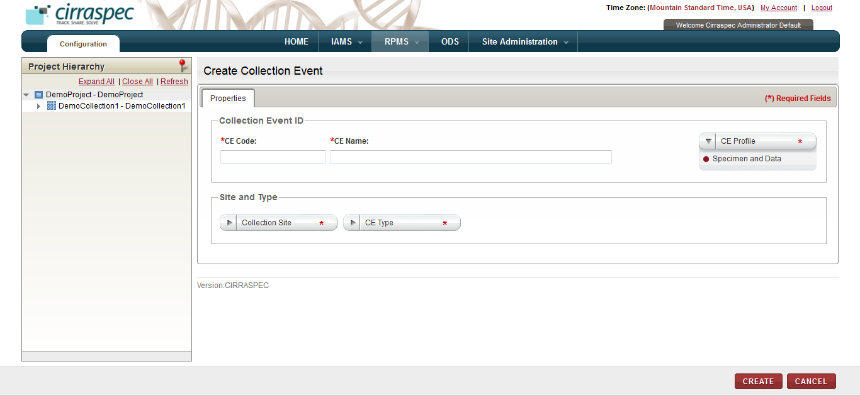

1. Create Collection Event page
2. Enter appropriate information in each field. Following table lists each field and its description.

**Note:** Fields that are marked with the red asterisk (*) are mandatory.

Table : Creating a collection event

|  |  |
| --- | --- |
| **Field** | **Description** |
| **CE Code**\* | Type a code for this collection event. |
| **CE Name**\* | Type a name for this collection event. **Note:** Combination of the code and the name must be unique. |
| **CE Profile\*** | Click the appropriate collection profile for this event. |
| **Collection Site\*** | Click the appropriate collection site for this event. |
| **CE Type\*** | Select the appropriate type for this event. |

1. Click **CREATE**.  
   The collection event is created. The **Project Hierarchy** page appears with the collection event added to the hierarchy tree on the left, and the collection event information fields on the right.

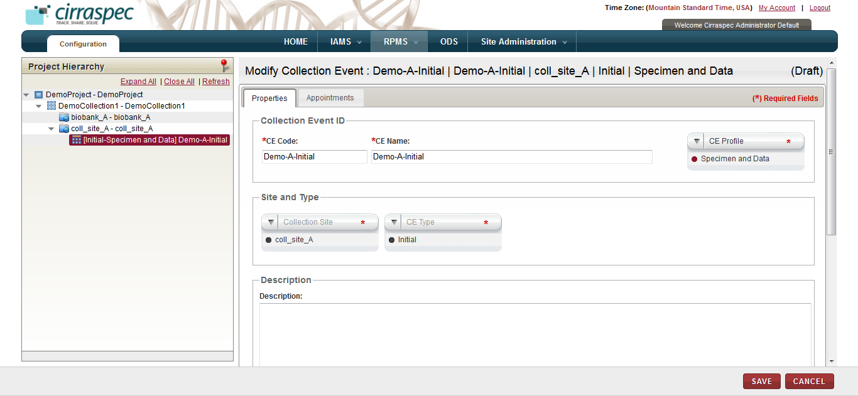

1. Collection Event properties page

General tips for collection events:

* In order to publish this collection, you must create at least one collection event.
* You can create multiple collection events. However, you must create the events one at a time.
* You can create the same event for multiple sites. However, you must create the events one at a time for each site.
* You can only delete a collection event while the Collection has the status as **Draft**. Once the Collection is published, you will not be able to delete any collection events that you added.

1. Type a brief description of this collection event, if applicable.

**Note:** The **Description** field can be expanded by placing the cursor on the bottom right corner of the box and resizing the box.

1. If you selected **Initial** as the **Collection Event Type**, skip this step.

**Note**: One initial collection event is mandatory for each collection site.   
However, if you selected Follow-up, Visit or Final as the Collection Event Type, perform the following:

1. Click the **Appointments** tab.  
   The **Appointments** page appears.

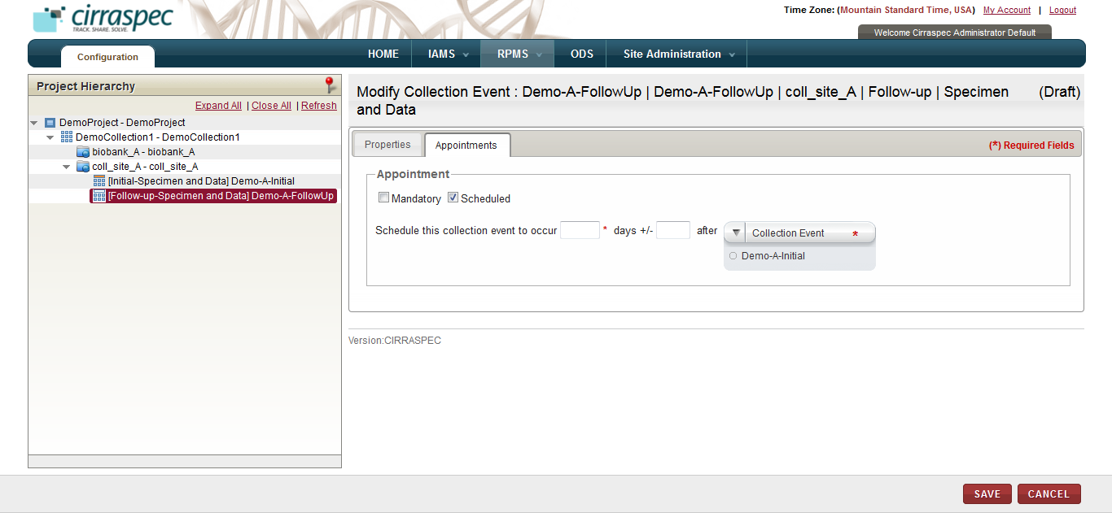

1. Collection Event appointment scheduling page
2. Click the appropriate checkbox:

* **Mandatory**: Click this checkbox if the collection event is mandatory and is not a scheduled event. No appointment scheduling action is required.
* **Scheduled**: Click this checkbox if the event must be scheduled. If checked, fields appear on the page for scheduling the appointment. Enter appropriate information in each field. Following table lists each field and its description.

**Note:** Fields that are marked with the red asterisk (*) are mandatory.

Table : Scheduling a collection event appointment

|  |  |
| --- | --- |
| **Field** | **Description** |
| **Schedule this event to occur**\* | Type the number of days used for the scheduling of this event. |
| **days +/-** | To allow a variance of several days in the scheduling, type the number of days that the scheduling can vary. For example: If you input 10 in the first field and input 2 in this field, this event is scheduled for 8 to 12 days.  **Note:** |
| **after Collection Event\*** | Click the appropriate collection event that should be used for scheduling this event.  For example: If you input 10 in the first field and select **Initial** as the **Collection Event,** this event is scheduled 10 days after the Initial collection event. |

1. Click **SAVE**.  
   The collection event information is saved and the Project Hierarchy is updated.  
     
   **Note:**

* Click the **Expand All** link above the Project Hierarchy to expand the hierarchy tree to show all information.
* If you want to add an additional collection event to this collection, repeat steps 26 – 31.
* If you want to add an additional collection to this project, select the project on the **Project Hierarchy** tree and repeat steps 8 - 25.

1. Click **VALIDATE** to verify if the collection is ready for publishing.  
   The **Validate Collection** page appears.

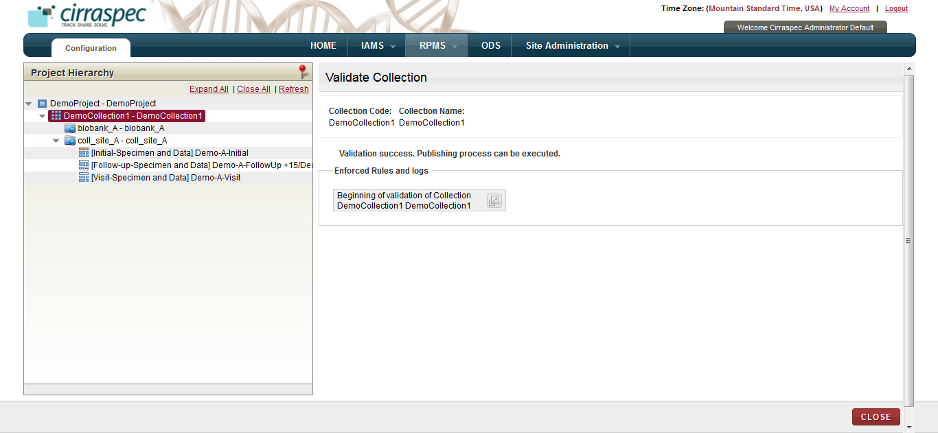

1. Validate Collection page

**Note:** If you receive a publication failed message, do the following:

1. Click the **expand icon**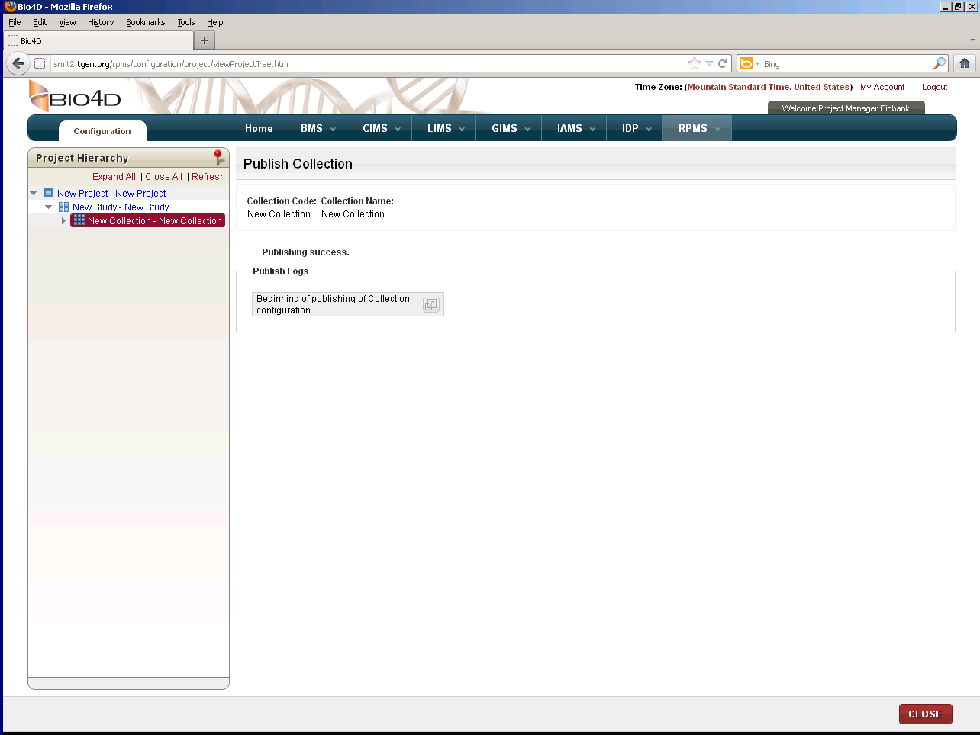.
2. Scroll downand make note of the validation errors, which appear in red.
3. Click **close**.
4. Click **Modify COLLECTION** and make the necessary corrections.
5. Click **VALIDATE**. Repeat the above steps until a successful validation is received.
6. Once the corrections have been made, click **Publish**.   
   The **Publish Collection** page appears.
7. Click **CONFIRM**.

The collection is published and is available for use throughout the applicaiton. All activated users assigned to this collection can access the application.

### Adding a Collection to an Existing Project

To add a collection to an existing project:

1. Log on to the application as the System Administrator.

The CIRRASPEC home page appears.

1. Point to the arrow of the **RPMS** tab, and then click **Configuration**.

The **RPMS Search** page appears.

1. Click **SEARCH**.

TheRPMS search page displays a list of projects and collections.

1. Click the row of the project for which you want to add a collection.

The **Project Hierarchy** page appears.

1. Click **CREATE COLLECTION**.  
   The **Create Collection** page appears.  
     
   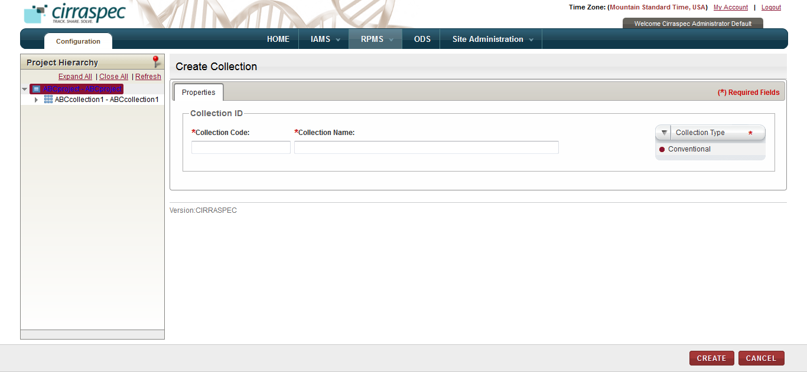
2. Create Collection page
3. Enter appropriate information in each field. Following table lists each field and its description.

**Note:** Fields that are marked with the red asterisk (*) are mandatory.

Table : Creating a collection

|  |  |
| --- | --- |
| **Field** | **Description** |
| **Collection Code**\* | Type a code for this collection. |
| **Collection Name**\* | Type a name for this collection. **Note:** Combination of the code and the name must be unique. |
| **Collection Type\*** | Click the appropriate type for this collection:   * **Conventional**: Select this type for a conventional collection that includes biospecimen collected thru this collection. * **Virtual**: Select this type for a collection that groups already collected biospecimens together from other collections.  **Note:** Since a virtual collection is composed of already collected specimens, collection events are not defined for and do not apply to virtual collections. * **Not Applicable**: Select this type if neither Virtual nor Convention apply to this collection. |

1. Click **CREATE**.  
   The collection is created with the status as **Draft**. The **Project Hierarchy** page appears with the collection added to the hierarchy tree on the left, and the collection information fields on the right.

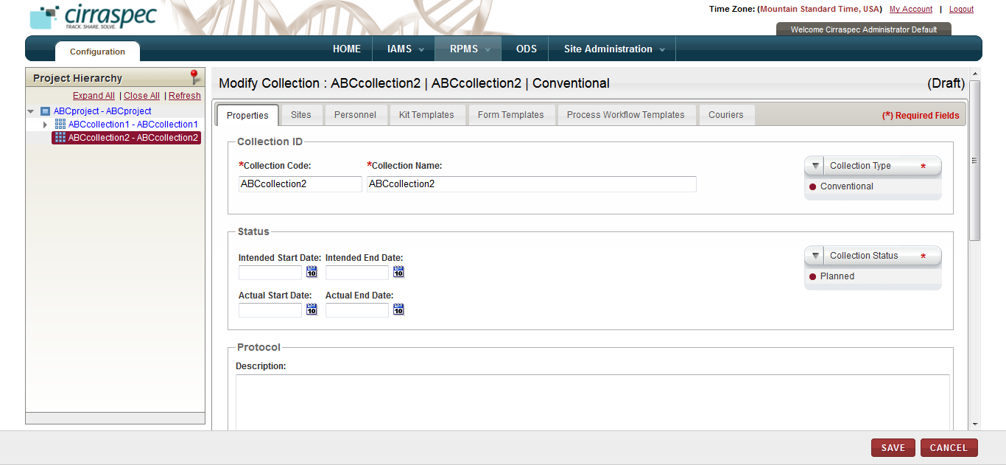

1. Collection properties page
2. Enter appropriate information in each field. Following table lists each field and its description.

**Note:**

* Fields that are marked with the red asterisk (*) are mandatory.
* The **Description** field can be expanded by placing the cursor on the bottom right corner of the box and resizing the box.

Table : Creating a collection

|  |  |
| --- | --- |
| **Field** | **Description** |
| **Intended Start Date** | Click the date icon and then in the pop-up, select the appropriate start date for this collection. |
| **Intended End date** | Click the date icon and then in the pop-up, select the appropriate end date for this collection. |
| **Actual Start Date** | Skip this field. |
| **Actual End date** | Skip this field. |
| **Collection Status \*** | Click the appropriate status for this collection:   * **Planned**: The collection is created but not all its characteristics are completely defined (e.g., some collection events might be missing or some processing steps might not been assigned yet). * **Ongoing**: All collection events have been fully described and acquisition can start. * **On Hold**: Work on the collection has been temporarily stopped due to a specific reason, which should be documented in the **Description** field. * **Closed**: No more specimens can be added to the collection (e.g: all scheduled collection events have occurred). **Note:** You can change the status from **Closed** to **Ongoing** if an unscheduled visit occurs. |
| **Description** | Type a brief description of this collection, if applicable. |
| **Allowed Subject Types** | Click the appropriate subject type(s) that you want to be allowed for enrollment in this collection. |

1. Click the **Sites** tab.

The site assignment fields appear.

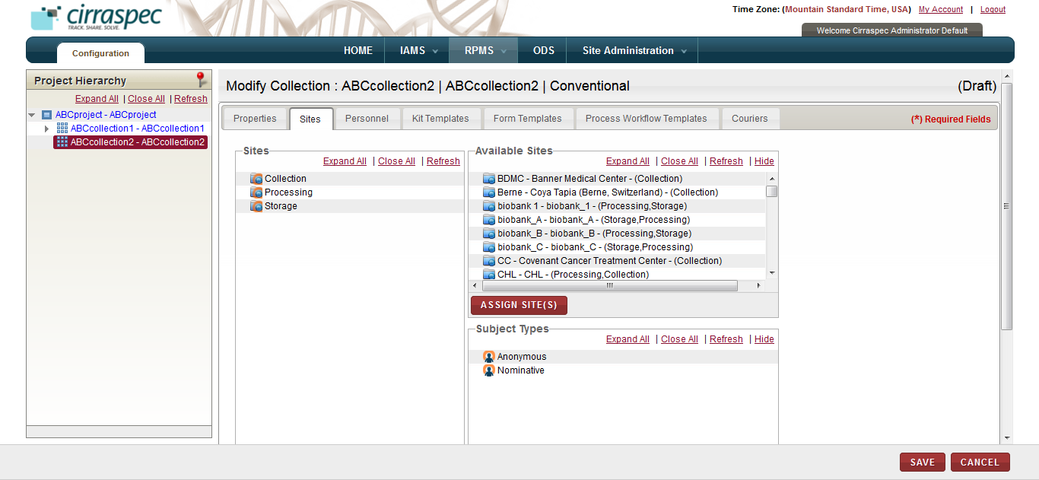

1. Sites assignment page

General tips for the all of the collection assignment tabs:

* To assign items:   
  Select the appropriate item on the list on the right and “drag and drop” it to the appropriate item on the left.   
  OR  
  Select the appropriate item on both lists and click **ASSIGN SITE(S)**.
* You can assign multiple items; however, you must select and assign the items one at a time.
* When assigning items using “drag and drop”, the red X indicates that you are trying to assign the item to an invalid level or location.
* You can navigate between tabs with the system automatically saving changes before displaying the next tab. If you click on **SAVE** before completing all of the tabs, you must click **Modify Collection** to return to “create/modify” mode.
* To unassign an item: Select the item on the left that you want to unassign, and click the **UNASSIGN** button.

1. To assign the authorized sites for this collection:
2. Assign the appropriate collection, processing and storage site locations on the **Available Sites** list on the right to the applicable site types on the left (**Collection, Processing and Storage)**.   
     
   **Note:** The **Available Sites** list displays all sites created and activated in **IAMS > Address Book**.   
   If you don’t see a site location you want to assign, verify that it is activated in the IAMS module.
3. Assign the appropriate subject type on the **Subject Types** list on the right to the applicable collection site location on the left side.
4. To assign the users to the roles for this collection, click the **Personnel** tab.  
   The personnel assignment fields appear.

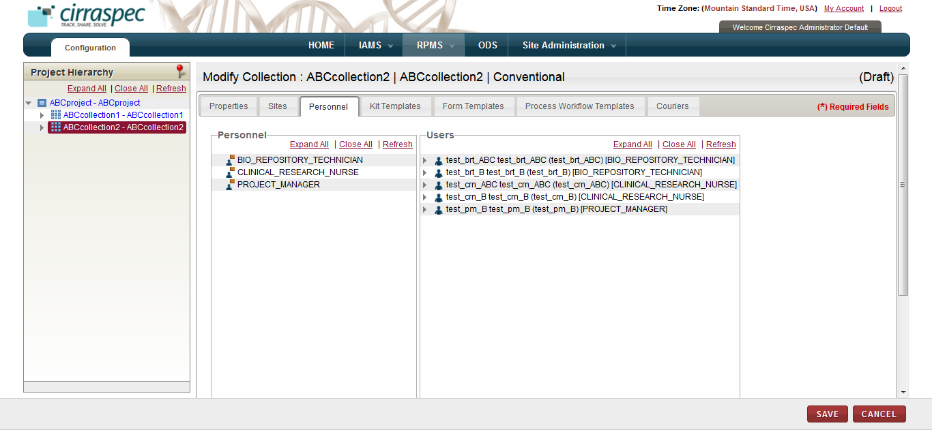

1. Personnel assignment page  
   1. Assign appropriate users on the **Users** list on right to the applicable roles on the left (**Bio Repository Technician** and **Clinical Research Nurse**).

**Note:**

* It is currently not recommended to add **Project Manager** users to collections.
* PHI authorized as well as Non-PHI authorized users, of all user roles, will be shown in the **Personnel** tab for the Site(s) selected for the Collection, and these users can be assigned to the Collection as per the requirement.

**Note:** The **Users** list displays all users created and activated in **IAMS > Address Book** that are authorized for the specified roles. If you don’t see an item you want to assign, verify that it is assigned and activated in the IAMS module.

1. To assign the kit templates for this collection, click the **Kit Templates** tab.  
   The kit template assignment fields appear.  
     
   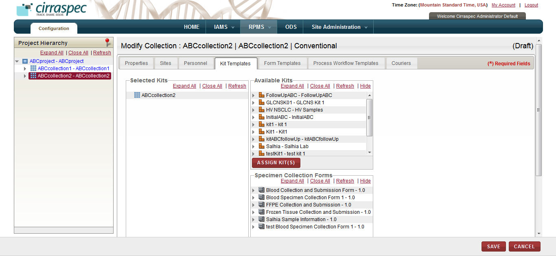
2. Kit Templates assignment page  
   1. Assign the appropriate kit templates on the **Available Kits** list on the right to the collection on the left.   
        
      **Note:** The **Available Kits** list displays all kits created and activated in **IAMS > Kits Designer** that are available for this project. If you don’t see an item you want to assign, verify that it is activated in the IAMS module.
   2. Click the **Expand All** link under **Selected Kits** to expand the hierarchy tree.
   3. Assign appropriate forms on the **Specimen Collection Forms** list on the right to the applicable kit component group(s) on the left.   
        
      **Note:** The **Available Specimen Collection Forms** list displays all forms created and activated in **IAMS > Forms Designer** with a Category Type = Specimen Collection Form. If you don’t see an item you want to assign, verify that it is activated in the IAMS module.
   4. Assign the default barcode template values for each kit template and each kit component:
3. Select the kit template name on the **Selected Kits** hierarchy tree, and then click **DEFAULT VALUES**.
4. In the **Default Values** pop-up, click **CHANGE.**
5. Input the number of labels needed in **Copies**, select the appropriate value on the **Available Barcode Templates** list and click **SAVE**.
6. Select a kit component on the **Selected Kits** hierarchy tree, and then click **DEFAULT VALUES**.
7. In the **Default Values** pop-up, click **CHANGE.**
8. Input the number of labels needed in **Copies** and select the appropriate value on the **Available Barcode Templates** list.
9. Select the appropriate value on the **Label Codes** list.  
   **Note:** The selected Label Code values must be unique for each kit component.
10. **Quantity** is optional. However, if you input the quantity, the system assigns this quantity as the initial quantity for all samples collected for this kit template component.
11. **Code Scheme** is optional. However, if you complete the code schemem fields, the system assigns this code scheme to all samples collected for this kit template component.
12. Click **SAVE.**Kit templates and kit components that have the default barcode values assigned appear on the **Selected Kits** hierarchy tree with a green check mark.
13. Repeat steps 4 -10 to assign the default barcode template values for each additional kit component.   
    **Note:**

* If you assigned multiple kit templates to this collection, repeat steps 1 – 10 for each additional kit template on the **Selected Kits** hierarchy.

1. To assign consent and clinical forms for this collection, click the **Form Templates** tab.  
   The consent and clinical forms assignment fields appear.  
     
   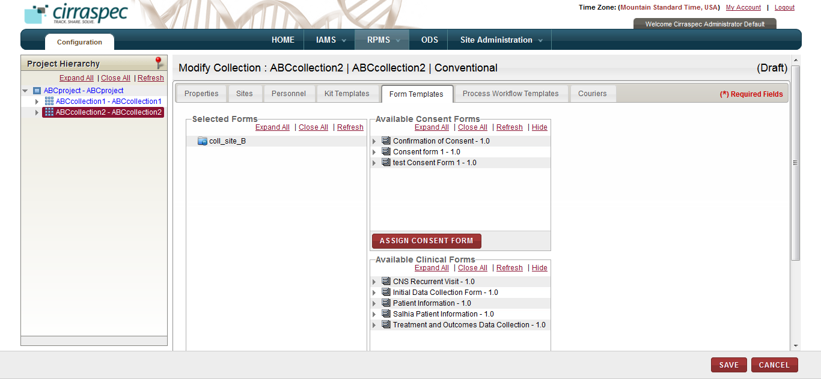
2. Form Templates assignment page
3. Assign the appropriate Consent Form from the **Available Consent Forms** list on the right to the applicable collection site(s) on the left.   
     
   **Note**: The **Available Consent Forms** list displays all forms created and activated in **IAMS > Forms Designer** with a Category Type = Consent Form. If you don’t see an item you want to assign, verify that it is activated in the IAMS module.
4. If applicable, assign the appropriate clinical form(s) from the **Available Clinical Forms** list on the right to the applicable collection site on the left.  
     
   **Note:** The **Available Clinical Forms** list displays all forms created and activated in **IAMS > Forms Designer** with a Category Type = Clinical Form. If you don’t see an item you want to assign, verify that it is activated in the IAMS module.
5. To assign sample process workflow templates and forms for this collection, click the **Process Workflow Templates** tab.  
   The process workflow assignment fields appear.  
     
   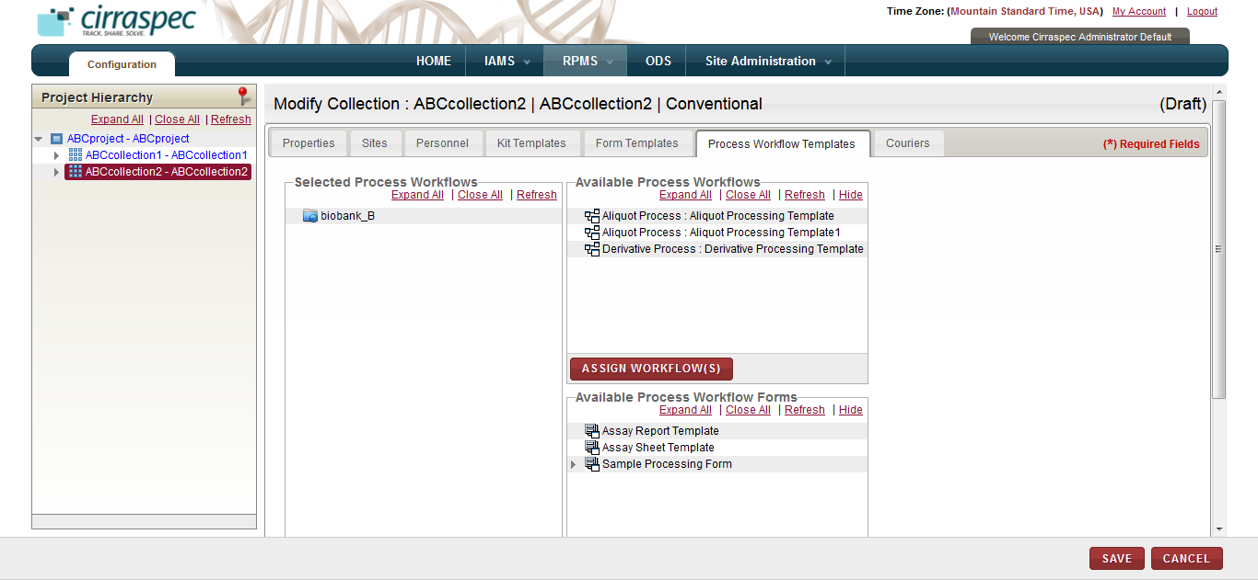
6. Process Workflow assignment page
7. Assign the appropriate process template(s) from the **Available Process Workflows** list on the right to the applicable processing site(s) on the left.   
     
   **Note:** The **Available Process Workflows** list displays all sample processing templates uploaded in **IAMS > Import Data**. If you don’t see an item you want to assign, create and upload the appropriate template(s) in the IAMS module.
8. Click the **Expand All** link under **Available Process Workflow Forms** on the right side.
9. Assign the appropriate Sample Processing Form(s) from the **Available Process Workflow Forms** list on the right to each of the applicable processing template(s) on the left.   
     
   **Note:** The **Available Process Workflow Forms** list displays all forms created and activated in **IAMS > Forms Designer** with a Category Type = Sample Processing Form. If you don’t see an item you want to assign, verify that it is activated in the IAMS module.
10. To assign shipping couriers for this collection, click the **Couriers** tab.  
    The courier assignment fields appear.

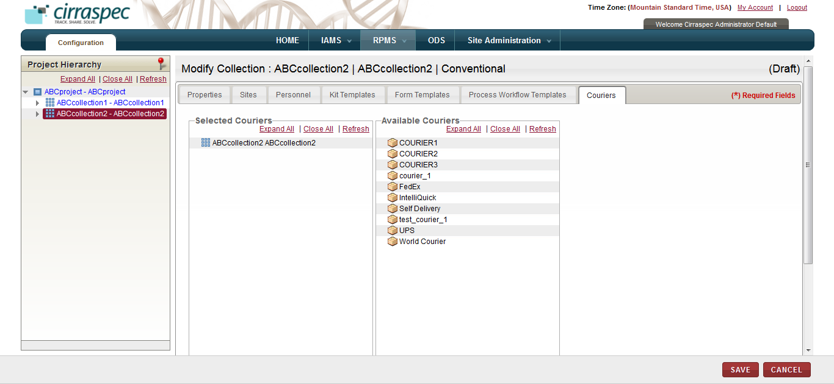

1. Courier assignment page
2. Assign the appropriate courier from the **Available Couriers** list on the right to the applicable collection on the left.   
     
   **Note:** The **Available Couriers** list displays all couriers created and activated in **IAMS > Address Book**. If you don’t see an item you want to assign, verify that it is activated in the IAMS module.
3. Click **SAVE.**  
   Collection information is saved.
4. To create a collection event, click **CREATE COLLECTION EVENT**.  
   The **Create Collection Event** page appears.   
     
   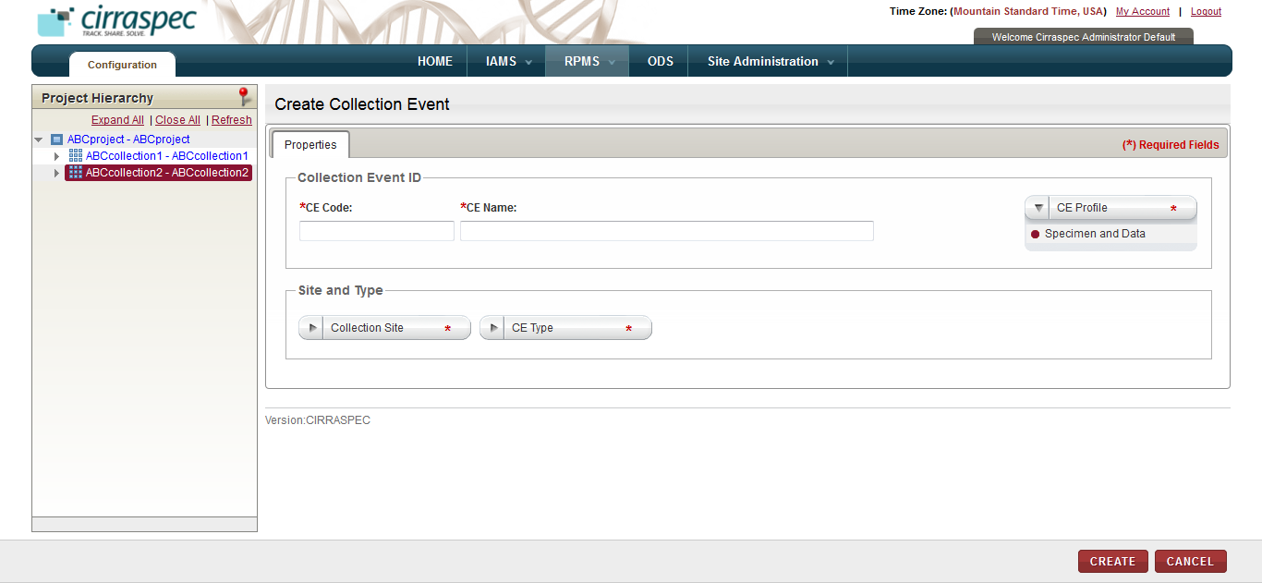
5. Create Collection Event page
6. Enter appropriate information in each field. Following table lists each field and its description.

**Note:** Fields that are marked with the red asterisk (*) are mandatory.

Table : Creating a collection event

|  |  |
| --- | --- |
| **Field** | **Description** |
| **CE Code**\* | Type a code for this collection event. |
| **CE Name**\* | Type a name for this collection event. **Note:** Combination of the code and the name must be unique. |
| **CE Profile\*** | Click the appropriate collection profile for this event. |
| **Collection Site\*** | Click the appropriate collection site for this event. |
| **CE Type\*** | Select the appropriate type for this event. |

1. Click **CREATE**.  
   The collection event is created. The **Project Hierarchy** page appears with the collection event added to the hierarchy tree on the left, and the collection event information fields on the right.

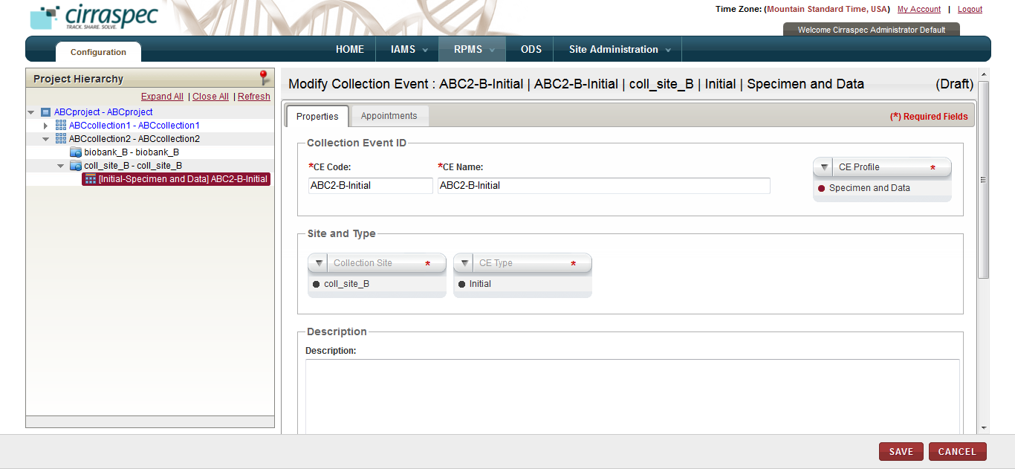

1. Collection Event properties page

General tips for collection events:

* In order to publish this collection, you must create at least one collection event.
* You can create multiple collection events. However, you must create the events one at a time.
* You can create the same event for multiple sites. However, you must create the events one at a time for each site.

1. Type a brief description of this collection event, if applicable.

**Note:** The **Description** field can be expanded by placing the cursor on the bottom right corner of the box and resizing the box.

1. If you selected **Initial** as the **Collection Event Type**, skip this step.

**Note**: One initial collection event is mandatory for each collection site.   
However, if you selected Follow-up, Visit or Final as the **Collection Event Type,** perform the following:

1. Click the **Appointments** tab.  
   The **Appointments** page appears.

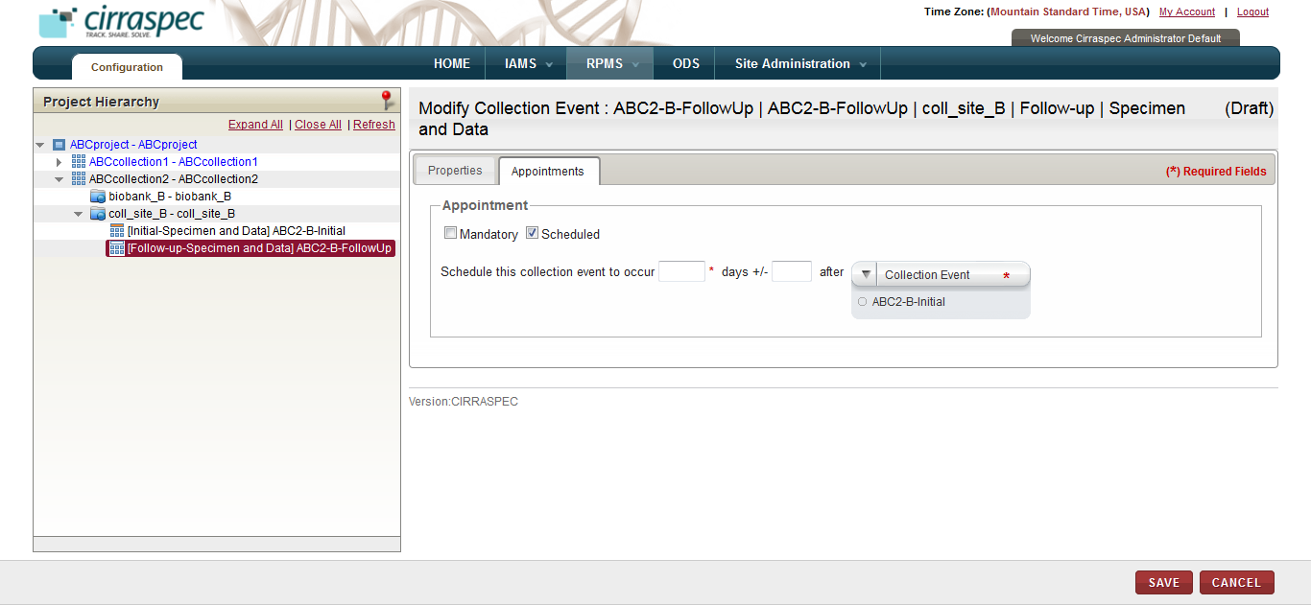

1. Collection Event appointment scheduling page
2. Click the appropriate checkbox:

* **Mandatory**: Click this checkbox if the collection event is mandatory and is not a scheduled event. No appointment scheduling action is required.
* **Scheduled**: Click this checkbox if the event must be scheduled. If checked, fields appear on the page for scheduling the appointment. Enter appropriate information in each field. Following table lists each field and its description.

**Note:** Fields that are marked with the red asterisk (*) are mandatory.

Table : Scheduling a collection event appointment

|  |  |
| --- | --- |
| **Field** | **Description** |
| **Schedule this event to occur**\* | Type the number of days used for the scheduling of this event. |
| **days +/-** | To allow a variance of several days in the scheduling, type the number of days that the scheduling can vary. For example: If you input 10 in the first field and input 2 in this field, this event is scheduled for 8 to 12 days.  **Note:** |
| **after Collection Event\*** | Click the appropriate collection event that should be used for scheduling this event.  For example: If you input 10 in the first field and select **Initial** as the **Collection Event,** this event is scheduled 10 days after the Initial collection event. |

1. Click **SAVE**.  
   The collection event information is saved and the **Project Hierarchy** is updated.  
     
   **Note:**

* Click the **Expand All** link above the Project Hierarchy to expand the hierarchy tree to show all information.
* If you want to add an additional collection event to this collection, repeat steps 17 – 22.
* If you want to add an additional collection to this project, select the project on the **Project Hierarchy** tree and repeat steps 5 - 22.

1. Click **VALIDATE** to verify if the collection is ready for publishing.  
   The **Validate Collection** page appears.

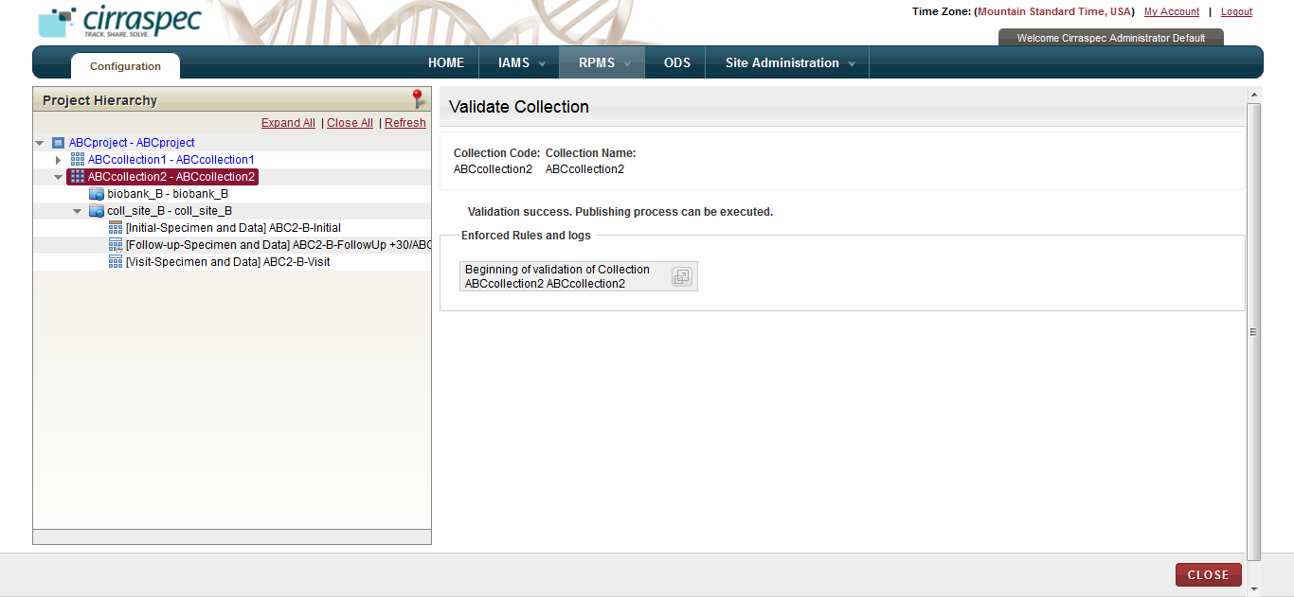

1. Validate Collection page

**Note:** If you receive a publication failed message, do the following:

1. Click the **expand icon.**
2. Scroll downand make note of the validation errors, which appear in red.
3. Click **close**.
4. Click **Modify COLLECTION** and make the necessary corrections.
5. Click **VALIDATE**. Repeat the above steps untila successful validation is received.
6. Once the corrections have been made, click **Publish**.   
   The **Publish Collection** page appears.
7. Click **CONFIRM**.

The collection is published and is available for use throughout the applicaiton. All activated users assigned to this collection can access the application.

### Adding a Collection Event to an Existing Collection

To add a collection event to an existing collection:

1. Log on to the application as the System Administrator.

The CIRRASPEC home page appears.

1. Point to the arrow of the **RPMS** tab, and then click **Configuration**.

The **RPMS Search** page appears.

1. Click **SEARCH**.

TheRPMS search page displays a list of projects and collections.

1. Note the **Publication Status** of the collection for which you want to add a collection event, and click the row of the collection.

The **Project Hierarchy** page appears.

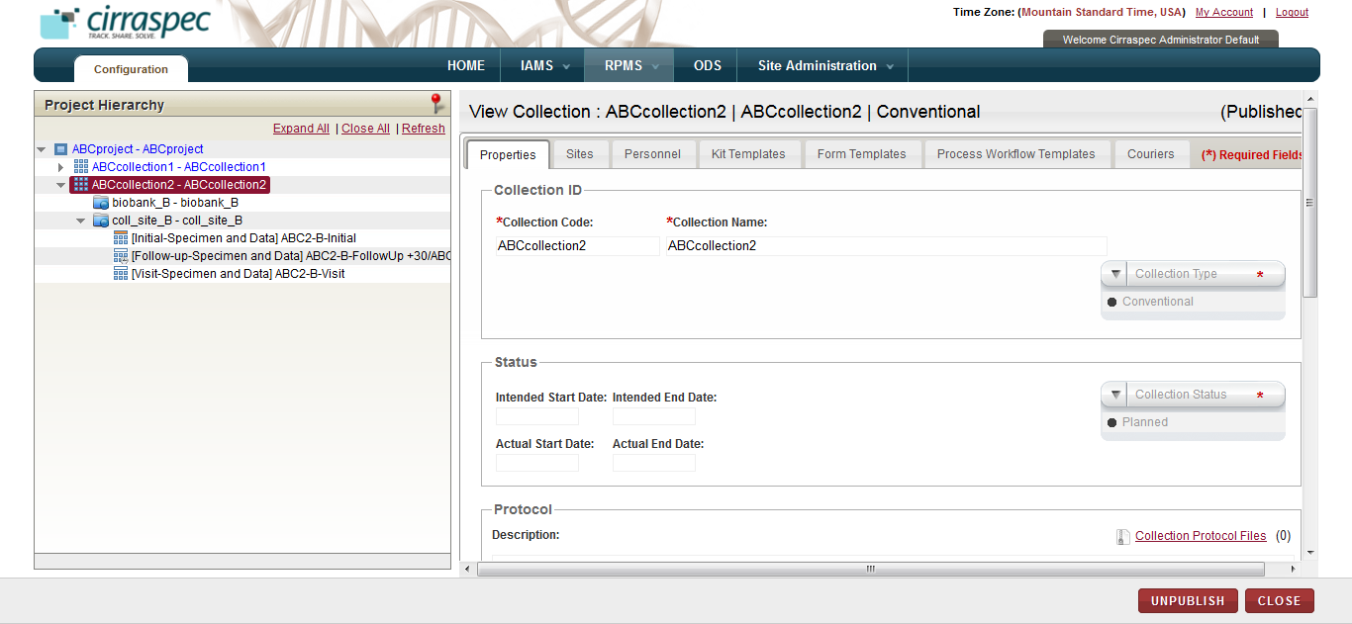

1. Project Hierarchy page
2. If the **Publication Status** noted in step 4 was **Published**, click **UNPUBLISH**. Then, click **CREATE COLLECTION EVENT**.  
   OR

If the Publication Status noted in step 4 was **Unpublished** or **Draft**, click **CREATE COLLECTION EVENT**.  
The **Create Collection Event** page appears.

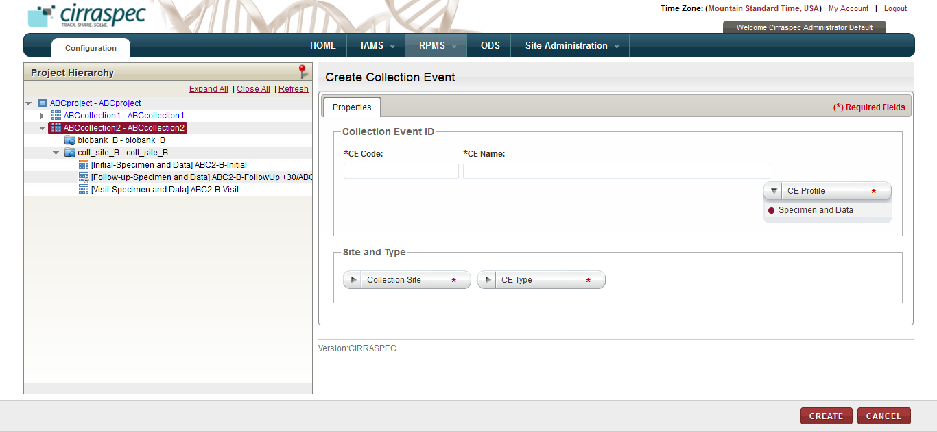

1. Create Collection Event page
2. Enter appropriate information in each field. Following table lists each field and its description.

**Note:** Fields that are marked with the red asterisk (*) are mandatory.

Table : Creating a collection event

|  |  |
| --- | --- |
| **Field** | **Description** |
| **CE Code**\* | Type a code for this collection event. |
| **CE Name**\* | Type a name for this collection event. **Note:** Combination of the code and the name must be unique. |
| **CE Profile\*** | Click the appropriate collection profile for this event. |
| **Collection Site\*** | Click the appropriate collection site for this event. |
| **CE Type\*** | Select the appropriate type for this event. |

1. Click **CREATE**.  
   The collection event is created. The **Project Hierarchy** page appears with the collection event added to the hierarchy tree on the left, and the collection event information fields on the right.

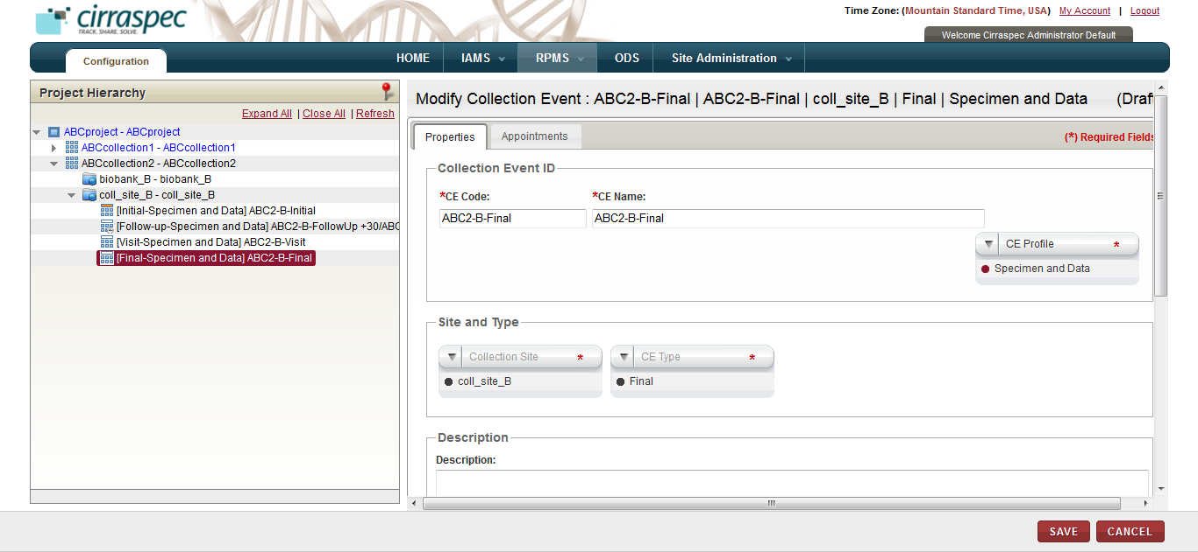

1. Collection Event properties page

General tips for collection events:

* In order to publish this collection, you must create at least one collection event.
* You can create multiple collection events. However, you must create the events one at a time.
* You can create the same event for multiple sites. However, you must create the events one at a time for each site.

1. Type a brief description of this collection event, if applicable.

**Note:** The **Description** field can be expanded by placing the cursor on the bottom right corner of the box and resizing the box.

1. If you selected **Initial** as the **Collection Event Type**, skip this step.   
   **Note**: One initial collection event is mandatory for each collection site.   
   However, if you selected Follow-up, Visit or Final as the **Collection Event Type,** perform the following:
2. Click the **Appointments** tab.  
   The **Appointments** page appears.

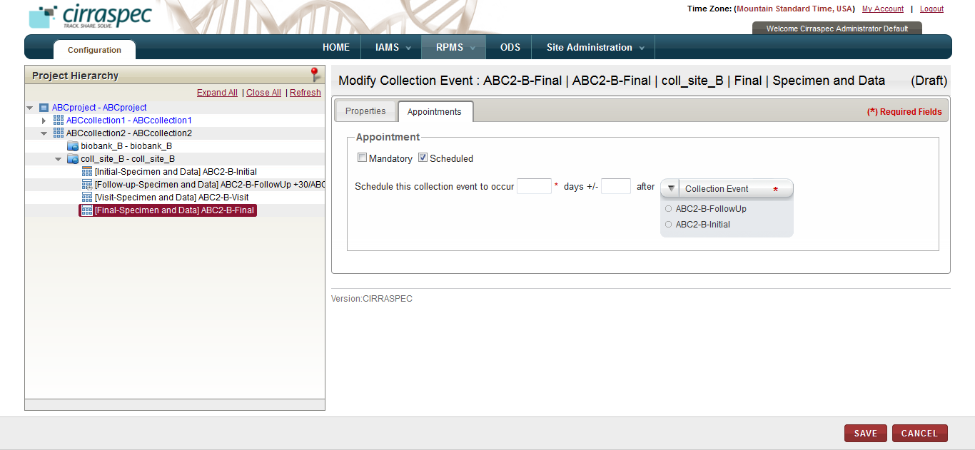

1. Collection Event appointment scheduling page
2. Click the appropriate checkbox:

* **Mandatory**: Click this checkbox if the collection event is mandatory and is not a scheduled event. No appointment scheduling action is required.
* **Scheduled**: Click this checkbox if the event must be scheduled. If checked, fields appear on the page for scheduling the appointment. Enter appropriate information in each field. Following table lists each field and its description.   
  **Note:** Fields that are marked with the red asterisk (*) are mandatory.

**Table 56: Scheduling a collection event appointment**

|  |  |
| --- | --- |
| **Field** | **Description** |
| **Schedule this event to occur**\* | Type the number of days used for the scheduling of this event. |
| **days +/-** | To allow a variance of several days in the scheduling, type the number of days that the scheduling can vary. For example: If you input 10 in the first field and input 2 in this field, this event is scheduled for 8 to 12 days. |
| **after Collection Event\*** | Click the appropriate collection event that should be used for scheduling this event.  For example: If you input 10 in the first field and select **Initial** as the **Collection Event,** this event is scheduled 10 days after the Initial collection event. |

1. Click **SAVE**.  
   The collection event information is saved and the **Project Hierarchy** is updated.  
     
   **Note:**

* Click the **Expand All** link above the Project Hierarchy to expand the hierarchy tree to show all information.
* If you want to add an additional collection event to this collection, repeat steps 5 – 10.
* If you want to add an additional collection to this project, select the project on the **Project Hierarchy** tree and repeat steps mentioned in the section **Adding a Collection to an Existing Project**.

1. Click **VALIDATE** to verify if the collection is ready for publishing.  
   The **Validate Collection** page appears.

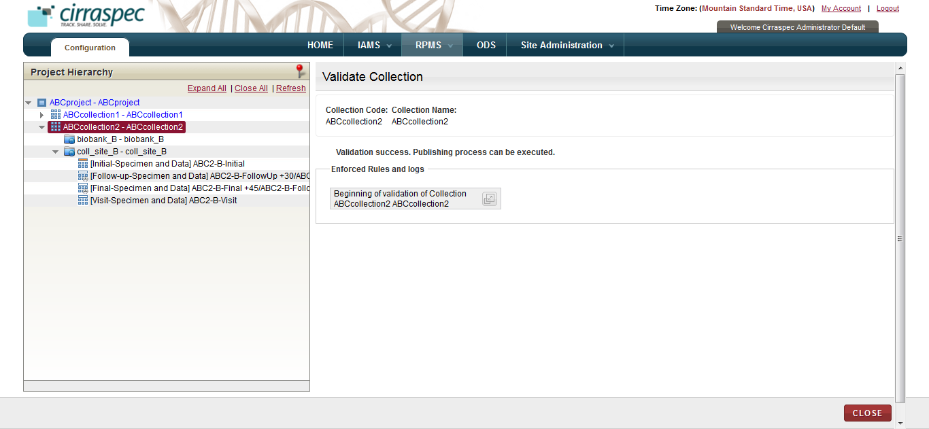

1. Validate Collection page

**Note:** If you receive a publication failed message, do the following:

1. Click the **expand icon.**
2. Scroll downand make note of the validation errors, which appear in red.
3. Click **close**.
4. Click **Modify COLLECTION** and make the necessary corrections.
5. Click **VALIDATE**. Repeat the above steps untila successful validation is received.
6. Once the corrections have been made, click **Publish**.   
   The **Publish Collection** page appears.
7. Click **CONFIRM**.

The collection is published and is available for use throughout the applicaiton. All activated users assigned to this collection can access the application.

### Modifying the Project Details

To modify the details of an existing project:

1. Log on to the application as the System Administrator.

The CIRRASPEC home page appears.

1. Point to the arrow of the **RPMS** tab, and then click **Configuration**.

The **RPMS Search** page appears.

1. Click **SEARCH**.

TheRPMS search page displays a list of projects and collections.

1. Click the row of the project that you want to modify.

The **View Project** page appears.

1. Click **MODIFY PROJECT**.  
   The **Modify Project** page appears.   
     
   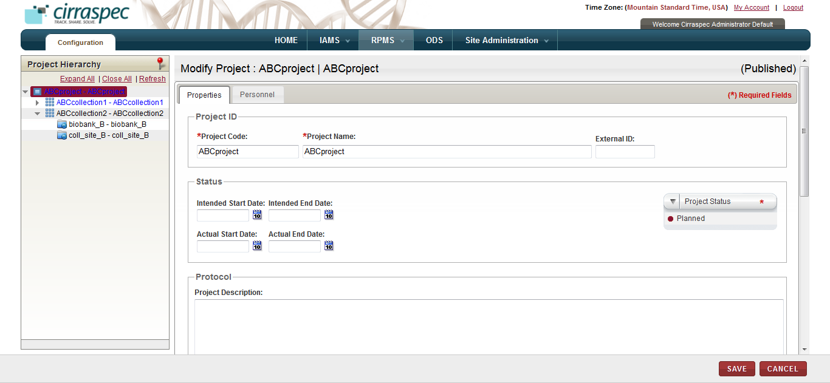
2. Modify Project page
3. Enter appropriate information in each field. Following table lists each field and its description.

**Note:**

* Fields that are marked with the red asterisk (*) are mandatory.
* The **Project Description** and **Project Characteristics** fields can be expanded by placing the cursor on the bottom right corner of the box and resizing the box.

Table : Modifying a project

|  |  |
| --- | --- |
| **Field** | **Description** |
| **Project Code**\* | Type a new code for this project, if applicable. |
| **Project Name**\* | Type a new name for this project, if applicable. **Note:** Combination of the code and the name must be unique. |
| **External ID** | Type an external identifier, if applicable. |
| **Intended Start Date** | If applicable, click the date icon and then in the pop-up, select the appropriate start date for this project. |
| **Intended End date** | If applicable, click the date icon and then in the pop-up, select the appropriate end date for this project. |
| **Actual Start Date** | If applicable, click the calendar icon and then in the pop-up, select the appropriate date when the project actually started. |
| **Actual End date** | If applicable, click the date icon and then in the pop-up, select the appropriate date for when the project actually ended. |
| **Project Status \*** | Click the appropriate status for this project:   * **Planned**: No kit has been created yet in the system and collections have not started yet. * **Ongoing**: The first collection associated with this project has started. Preconditions for the availability of this status are: * All mandatory fields in the collection form have been filled. * At least one collection has been assigned to the project. * All mandatory fields of an assigned collection have been filled. * At least one assigned collection has got the approval of all required committees * **On Hold**: Work on all collections associated with this project has been temporarily stopped due to a specific reason, which should be documented in the **Description** field. * **Closed**: The work on all collections associated with this project has been completed. |
| **Project Description** | Type a brief description of this project, if applicable. |
| **Project Characteristics** | Type a summary of the project charactereistics, if applicable. |

1. Click **SAVE**.

Project information is saved.

### Modifying the Collection Details

**Note:** You cannot modify a collection with **Published** as the **Publication Status**.

To modify the collection details:

1. Log on to the application as the System Administrator.

The CIRRASPEC home page appears.

1. Point to the arrow of the **RPMS** tab, and then click **Configuration**.

The **RPMS Search** page appears.

1. Click **SEARCH**.

TheRPMS search page displays a list of projects and collections.

1. Note the **Publication Status** of the collection that you want to modify and click the row of the collection.

The **View Collection** page appears.

1. If the **Publication Status** noted in step 4 was **Published**, click **UNPUBLISH**. Click **CLOSE** and then, click **MODIFY COLLECTION**.  
   OR

If the Publication Status noted in step 4 was **Unpublished or Draft**, click **MODIFY COLLECTION**.  
The **Modify Collection** page appears.

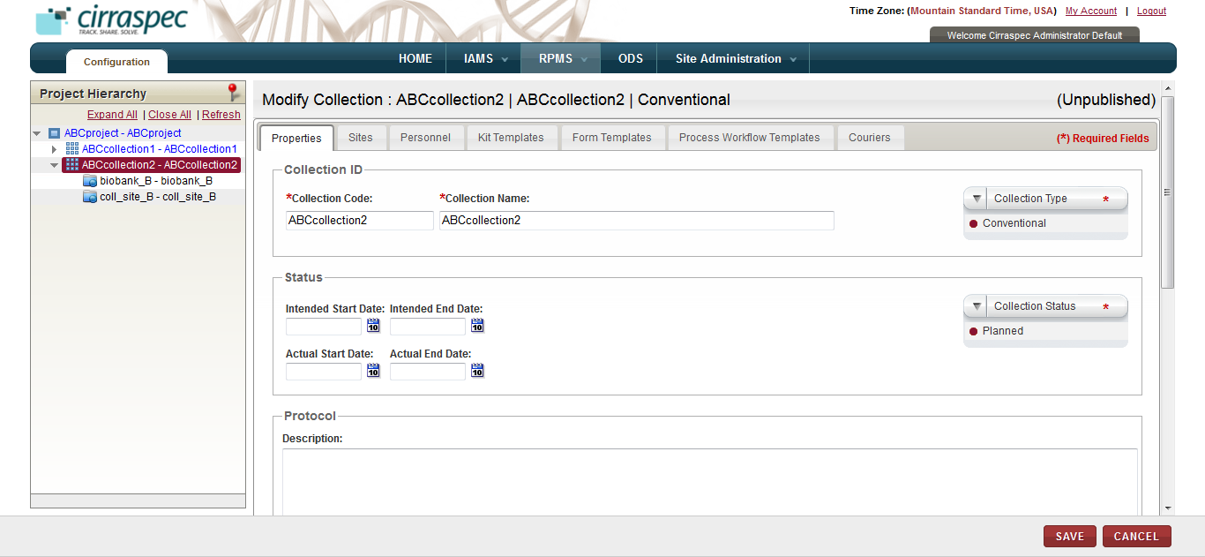

1. Collection properties page
2. Enter appropriate information in each field. Following table lists each field and its description.

**Note:**

* Fields that are marked with the red asterisk (*) are mandatory.
* The **Description** field can be expanded by placing the cursor on the bottom right corner of the box and resizing the box.

Table : Modifying a collection

|  |  |
| --- | --- |
| **Field** | **Description** |
| **Collection Code**\* | Type a new code for this collection, if applicable. |
| **Collection Name**\* | Type a new name for this collection, if applicable. **Note:** Combination of the code and the name must be unique. |
| **Collection Type\*** | Click the appropriate type for this collection:   * **Conventional**: Select this type for a conventional collection that includes biospecimen collected thru this collection. * **Virtual**: Select this type for a collection that groups already collected biospecimens together from other collections.  **Note:** Since a virtual collection is composed of already collected specimens, collection events are not defined for and do not apply to virtual collections. * **Not Applicable**: Select this type if neither Virtual nor Convention apply to this collection. |
| **Intended Start Date** | If applicable, click the date icon and then in the pop-up, select the appropriate start date for this collection. |
| **Intended End date** | If applicable, click the date icon and then in the pop-up, select the appropriate end date for this collection. |
| **Actual Start Date** | If applicable, click the calendar icon and then in the pop-up, select the appropriate date when the project actually started. |
| **Actual End date** | If applicable, click the date icon and then in the pop-up, select the appropriate date for when the project actually ended. |
| **Collection Status \*** | Click the appropriate status for this collection:   * **Planned**: The collection is created but not all its characteristics are completely defined (e.g., some collection events might be missing or some processing steps might not been assigned yet). * **Ongoing**: All collection events have been fully described and acquisition can start. * **On Hold**: Work on the collection has been temporarily stopped due to a specific reason, which should be documented in the **Description** field. * **Closed**: No more specimens can be added to the collection (e.g., all scheduled collection events have occurred). **Note:** You can change the status from **Closed** to **Ongoing** if an unscheduled visit occurs. |
| **Description** | Type a brief description of this collection, if applicable. |
| **Allowed Subject Types** | Click the appropriate subject type(s) that you want to be allowed for enrollment in this collection. |

1. Click the **Sites** tab.The site assignment fields appear.  
     
   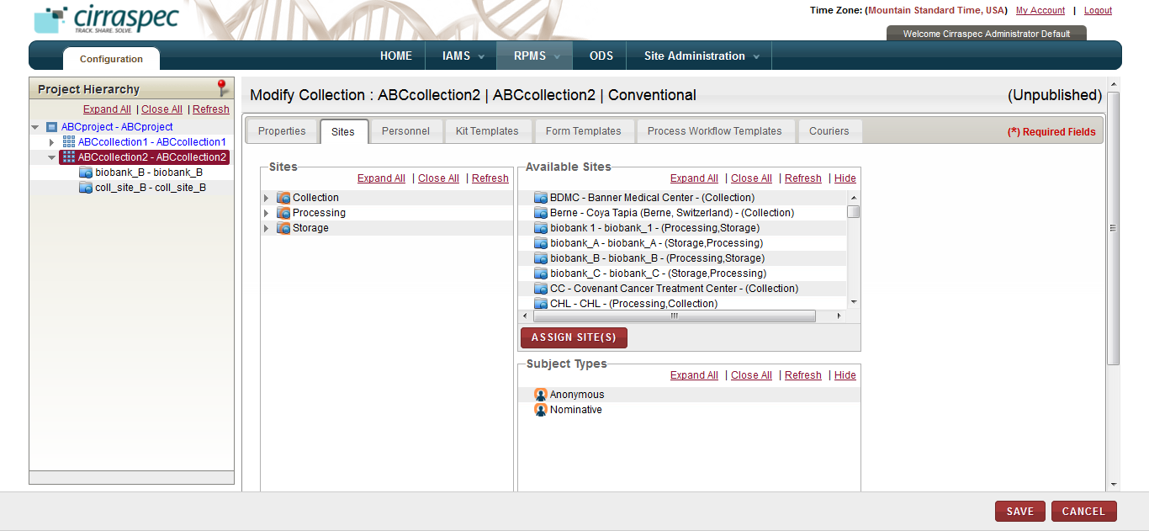
2. Sites assignment page

General tips for the all of the collection assignment tabs:

* To assign items:   
  Select the appropriate item on the list on the right and “drag and drop” it to the appropriate item on the left.   
  OR  
  Select the appropriate item on both lists and click **ASSIGN SITE(S)**.
* You can assign multiple items; however, you must select and assign the items one at a time.
* When assigning items using “drag and drop”, the red X indicates that you are trying to assign the item to an invalid level or location.
* You can navigate between tabs with the system automatically saving changes before displaying the next tab. If you click on **SAVE** before completing all of the tabs, you must click **Modify Collection** to return to “create/modify” mode.
* To unassign an item: Select the item on the left that you want to unassign, and click the **UNASSIGN** button.

1. To make changes to the authorized sites for this collection, assign or unassign the collection, processing and storage site locations listed under **Available Sites** on the right to the applicable site types (**Collection, Processing and Storage)** on the left.   
     
   **Note:** The **Available Sites** list displays all sites created and activated in **IAMS > Address Book**.   
   If you don’t see a site location you want to assign, verify that it is activated in the IAMS module.
2. To make changes to the authorized subject type for this collection, assign or unassign a subject type on the **Subject Types** list to the applicable collection site location on the left side.
3. To make changes to the users assigned to the roles for this collection, click the **Personnel** tab.  
   The personnel fields appear.

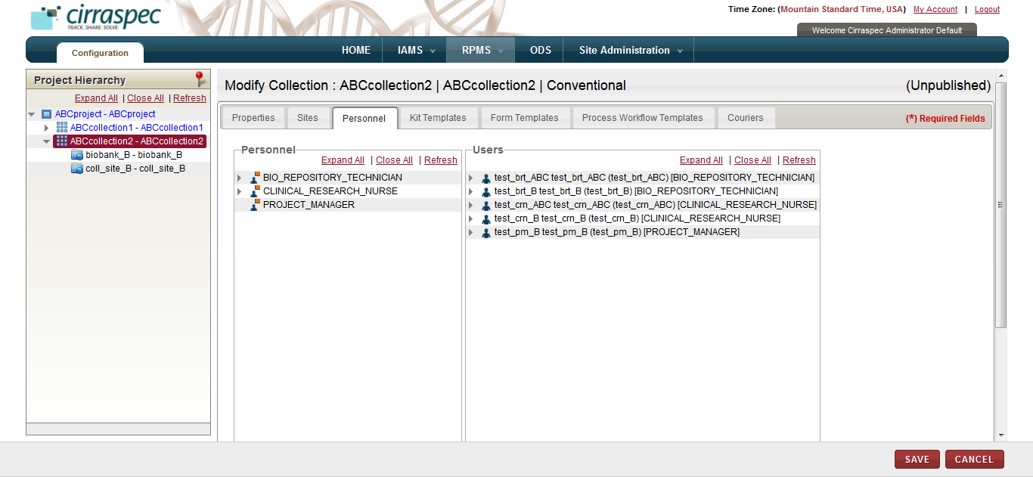

1. Personnel assignment page
2. Assign or unassign the appropriate users on the **Users** list on right to the applicable roles on the left (**Bio Repository Technician** and **Clinical Research Nurse**).

**Note**:

* It is currently not recommended to add **Project Manager** users to collections.
* PHI authorized as well as Non-PHI authorized users, of all user roles, will be shown in the **Personnel** tab for the Site(s) selected for the Collection, and these users can be assigned to the Collection as per the requirement.  
    
  **Note:** The **Users** list displays all users created and activated in **IAMS > Address Book** that are authorized for the specified roles. If you don’t see an item you want to assign, verify that it is assigned and activated in the IAMS module.

1. To make changes to the kit templates assigned for this collection, click the **Kit Templates** tab.  
   The kit template assignment fields appear.  
     
   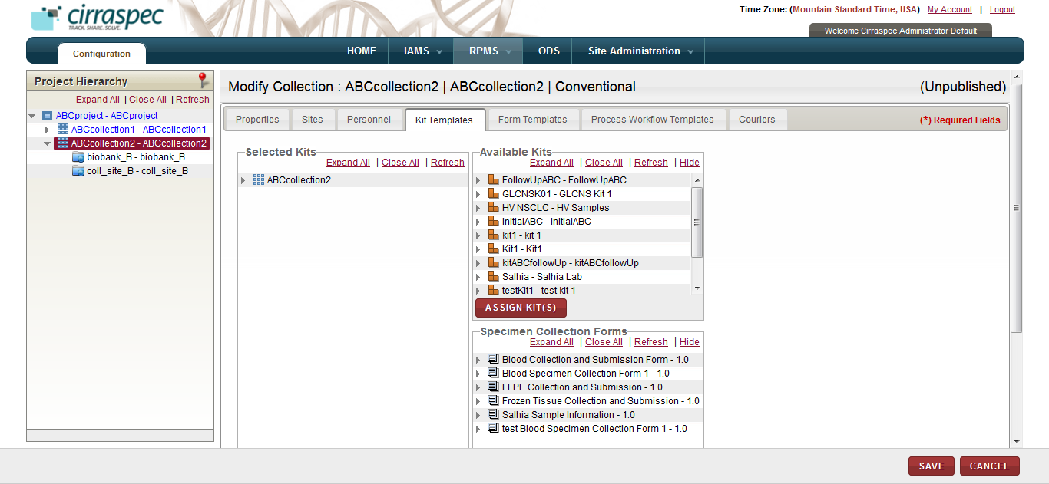
2. Kit Templates assignment page
3. Assign or unassign the appropriate kit templates on the **Available Kits** list on the right to the collection on the left.   
     
   **Note:** The **Available Kits** list displays all kits created and activated in **IAMS > Kits Designer** that are available for this project. If you don’t see an item you want to assign, verify that it is activated in the IAMS module.
4. Click the **Expand All** link under **Selected Kits** to expand the hierarchy tree.
5. Assign or unassign the appropriate forms on the **Specimen Collection Forms** list on the right to the applicable kit component item(s) on the left.   
     
   **Note:** The **Available Specimen Collection Forms** list displays all forms created and activated in **IAMS > Forms Designer** with a Category Type = Specimen Collection Form. If you don’t see an item you want to assign, verify that it is activated in the IAMS module.
6. Assign or unassign the default barcode template values for each kit template and each kit component:
7. Select the kit template name on the **Selected Kits** hierarchy tree, and then click **DEFAULT VALUES**.
8. In the **Default Values** pop-up, click **CHANGE.**
9. Input the number of labels needed in **Copies**, select the appropriate value on the **Available Barcode Templates** list and click **SAVE**.
10. Select a kit component on the **Selected Kits** hierarchy tree, and then click **DEFAULT VALUES**.
11. In the **Default Values** pop-up, click **CHANGE.**
12. Input the number of labels needed in **Copies** and select the appropriate value on the **Available Barcode Templates** list.
13. Select the appropriate value on the **Label Codes** list.  
    **Note:** The selected Label Code values must be unique for each kit component.
14. **Quantity** is optional. However, if you input the quantity, the system assigns this quantity as the initial quantity for all samples collected for this kit template component.
15. **Code Scheme** is optional. However, if you complete the code schemem fields, the system assigns this code scheme to all samples collected for this kit template component.
16. Click **SAVE.**Kit templates and kit components that have the default barcode values assigned appear on the **Selected Kits** hierarchy tree with a green check mark.
17. Repeat steps 4 -10 to assign the default barcode template values for each additional kit component.   
     **Note:**

* If you assigned multiple kit templates to this collection, repeat steps 1 – 10 for each additional kit template on the **Selected Kits** hierarchy.

1. To make changes to the consent and clinical forms assigned for this collection, click the **Form Templates** tab.  
   The consent and clinical forms assignment fields appear.  
     
   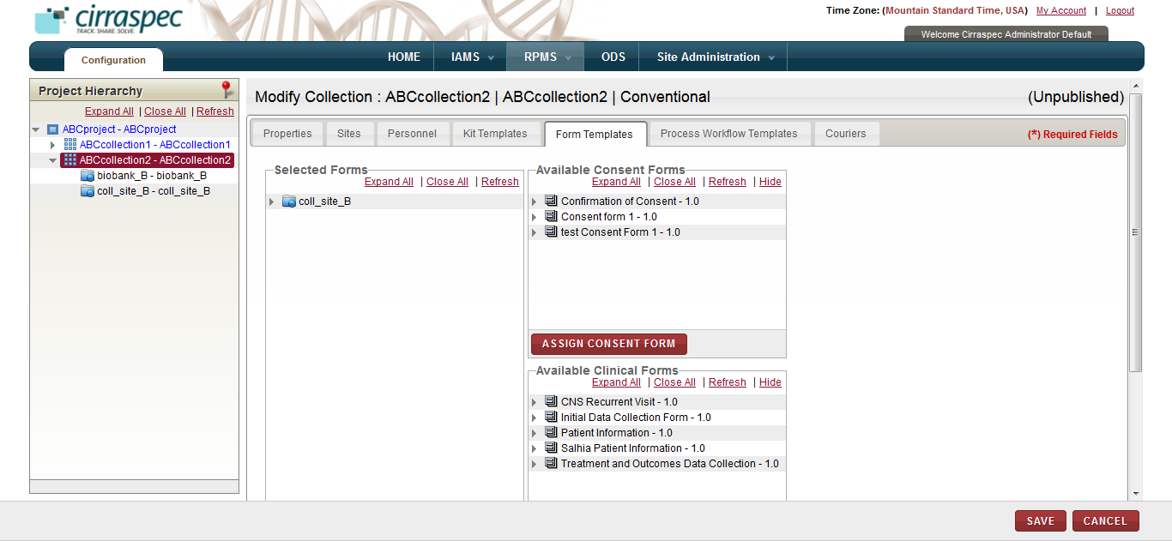
2. Form Templates assignment page
3. Assign or unassign the appropriate Consent Form from the **Available Consent Forms** list on the right to the applicable collection site(s) on the left.   
     
   **Note**: The **Available Consent Forms** list displays all forms created and activated in **IAMS > Forms Designer** with a Category Type = Consent Form. If you don’t see an item you want to assign, verify that it is activated in the IAMS module.
4. If applicable, assign or unassign the appropriate clinical form(s) from the **Available Clinical Forms** list on the right to the applicable collection site on the left.  
     
   **Note:** The **Available Clinical Forms** list displays all forms created and activated in **IAMS > Forms Designer** with a Category Type = Clinical Form. If you don’t see an item you want to assign, verify that it is activated in the IAMS module.
5. To make changes to the sample process workflow templates and forms assigned for this collection, click the **Process Workflow Templates** tab.  
   The process workflow assignment fields appear.  
     
   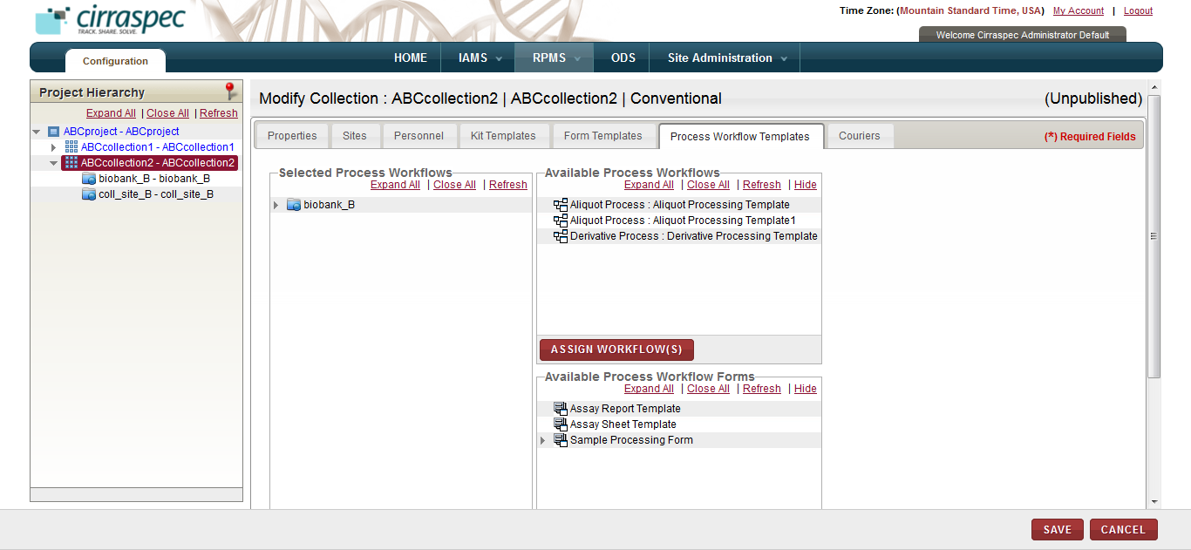
6. Process Workflow assignment page
7. Assign or unassign the appropriate process template(s) from the **Available Process Workflows** list on the right to the applicable processing site(s) on the left.   
     
   **Note:** The **Available Process Workflows** list displays all sample processing templates uploaded in **IAMS > Import Data**. If you don’t see an item you want to assign, create and upload the appropriate template(s) in the IAMS module.
8. Click the **Expand All** link under **Available Process Workflow Forms** on the right side.
9. Assign or unassign the appropriate Sample Processing Form(s) from the **Available Process Workflow Forms** list on the right to each of the applicable processing template(s) on the left.   
     
   **Note:** The **Available Process Workflow Forms** list displays all forms created and activated in **IAMS > Forms Designer** with a Category Type = Sample Processing Form. If you don’t see an item you want to assign, verify that it is activated in the IAMS module.
10. To make changes to the shipping courier(s) assigned for this collection, click the Couriers tab.  
    The courier assignment fields appear.

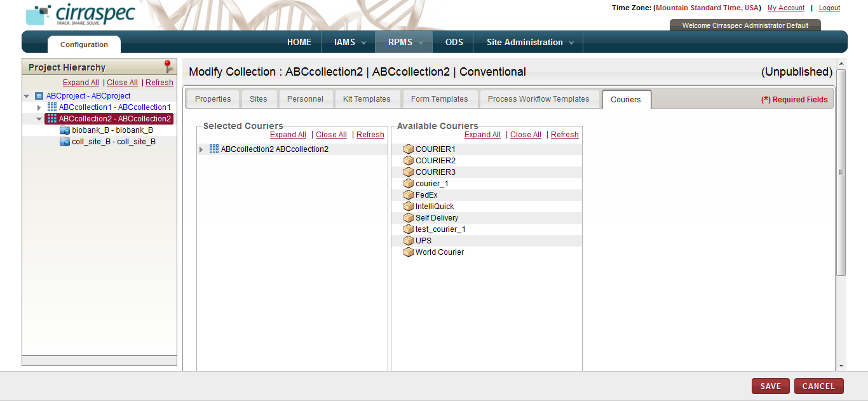

1. Courier assignment page
2. Assign or uanassign the appropriate courier from the **Available Couriers** list on the right to the applicable collection on the left.   
     
   **Note:** The **Available Couriers** list displays all couriers created and activated in **IAMS > Address Book**. If you don’t see an item you want to assign, verify that it is activated in the IAMS module.
3. Click **SAVE.**  
   Collection information is saved.
4. Click **VALIDATE** to verify if the collection is ready for publishing.  
   The **Validate Collection** page appears.

**Note:** If you receive a publication failed message, do the following:

1. Click the **expand icon.**
2. Scroll downand make note of the validation errors, which appear in red.
3. Click **close**.
4. Click **Modify COLLECTION** and make the necessary corrections.
5. Click **VALIDATE**. Repeat the above steps untila successful validation is received.
6. Once the corrections have been made, click **Publish**.   
   The **Publish Collection** page appears.
7. Click **CONFIRM**.

The collection is published and is available for use throughout the applicaiton. All activated users assigned to this collection can access the application.

### Deleting a Collection

**Note:**

* You cannot delete a collection with **Published** as the **Publication Status.**
* You cannot delete a collection if collection events appear under the collection on the project hierarchy. You must first delete any collection events. For information regarding deleting a collection, see**Deleting a Collection Event****.**

To delete a collection:

1. Log on to the application as the System Administrator.

The CIRRASPEC home page appears.

1. Point to the arrow of the **RPMS** tab, and then click **Configuration**.

The **RPMS Search** page appears.

1. Click **SEARCH**.

TheRPMS search page displays a list of projects and collections.

1. Note the **Publication Status** of the collection that you want to delete and click the row of the collection.

The **View Collection** page appears.

1. If the **Publication Status** noted in step 4 was **Published**, click **UNPUBLISH**. Then, click **DELETE COLLECTION**.  
   OR

If the Publication Status noted in step 4 was **Unpublished or Draft**, click **DELETE COLLECTION**.  
A confirmation message appears.

1. Click **YES**.   
   The collection is removed from the Project Hierarchy tree.

### Modifying the Collection Event Details

**Note:** You cannot modify a collection event for a collection with **Published** as the **Publication Status**.

To modify the collection event details:

1. Log on to the application as the System Administrator.

The CIRRASPEC home page appears.

1. Point to the arrow of the **RPMS** tab, and then click **Configuration**.

The **RPMS Search** page appears.

1. Click **SEARCH**.

TheRPMS search page displays a list of projects and collections.

1. Note the **Publication Status** of the collection for which you want to modify a collection event and click the row of the collection.

The **View Collection** page appears.

1. If the **Publication Status** noted in step 4 was **Published**, click **UNPUBLISH**. Then, click **CLOSE**.
2. Click the collection event on the Project Hierarchy tree that you want to modify. Then click **MODIFY COLLECTION EVENT.**The **Modify Collection Event** page appears.  
     
   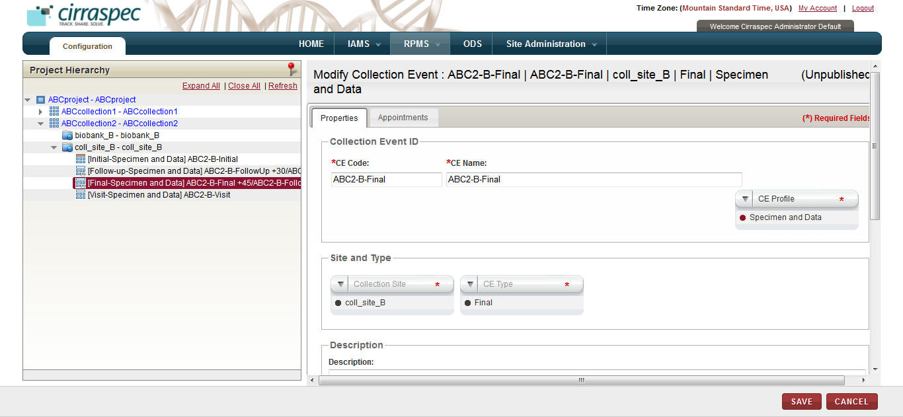
3. Collection Event properties page
4. Enter appropriate information in each field. Following table lists each field and its description.

**Note:** Fields that are marked with the red asterisk (*) are mandatory.

Table : Modifying a collection event

|  |  |
| --- | --- |
| **Field** | **Description** |
| **CE Code**\* | Type a new code for this collection event, if applicable. |
| **CE Name**\* | Type a new name for this collection event, if applicable. **Note:** Combination of the code and the name must be unique. |
| **CE Profile\*** | To change the profile for this event, click the appropriate collection profile. |
| **Description** | Type a brief description of this collection event, if applicable. **Note:** The **Description** field can be expanded by placing the cursor on the bottom right corner of the box and resizing the box |

1. To change the scheduling of this event, click the **Appointments** tab.  
   The **Appointments** page appears.
2. Click the appropriate checkbox:

* **Mandatory**: Click this checkbox if the collection event is mandatory and is not a scheduled event. No appointment scheduling action is required.
* **Scheduled**: Click this checkbox if the event must be scheduled. If checked, fields appear on the page for scheduling the appointment. Enter appropriate information in each field. Following table lists each field and its description.

**Note:** Fields that are marked with the red asterisk (*) are mandatory.

Table : Scheduling a collection event appointment

|  |  |
| --- | --- |
| **Field** | **Description** |
| **Schedule this event to occur**\* | Type the number of days used for the scheduling of this event. |
| **days +/-** | To allow a variance of several days in the scheduling, type the number of days that the scheduling can vary. For example: If you input 10 in the first field and input 2 in this field, this event is scheduled for 8 to 12 days.  **Note:** |
| **after Collection Event\*** | Click the appropriate collection event that should be used for scheduling this event.  For example: If you input 10 in the first field and select **Initial** as the **Collection Event,** this event is scheduled 10 days after the Initial collection event. |

1. Click **SAVE**.  
   The collection event information is saved.
2. Click **VALIDATE** to verify if the collection is ready for publishing.  
   The **Validate Collection** page appears.

**Note:** If you receive a publication failed message, do the following:

1. Click the **expand icon.**
2. Scroll downand make note of the validation errors, which appear in red.
3. Click **close**.
4. Click **Modify COLLECTION** and make the necessary corrections.
5. Click **VALIDATE**. Repeat the above steps untila successful validation is received.
6. Once the corrections have been made, click **Publish**.   
   The **Publish Collection** page appears.
7. Click **CONFIRM**.

The collection is published and is available for use throughout the application. All activated users assigned to this collection can access the application.

### Deleting a Collection Event

**Note:** You can only delete a collection event for a collection with **Draft** as the **Publication Status.**

To delete a collection event:

1. Log on to the application as the System Administrator.

The CIRRASPEC home page appears.

1. Point to the arrow of the **RPMS** tab, and then click **Configuration**.

The **RPMS Search** page appears.

1. Click **SEARCH**.

TheRPMS search page displays a list of projects and collections.

1. Click the row of the collection for which you want to delete a collection event.

The **View Collection** page appears.

1. Click the collection event on the Project Hierarchy tree that you want to delete.
2. Click **DELETE COLLECTION EVENT**.   
   A confirmation message appears.
3. Click **YES**.   
   The collection event is removed from the Project Hierarchy tree.

# Search by Date Ranges, Change Search Results display, Manage Events and Upload Files

## Understanding the Date Range Search Options

You can search for information using the date range options in the search pane of the following modules in IAMS:

* Forms Designer
* Kits Designer
* Question Designer

To understand the date range options:

1. Log on to the application using your login credentials.

The home page appears.

1. Point to the arrow of the **IAMS** tab, and then click the module for which you want to access the search pane.

The search pane for the module that you selected appears on the left side of the page.

1. To specify the date range, click the date icon  for the **Date Range** box.

A list of date range options appears.

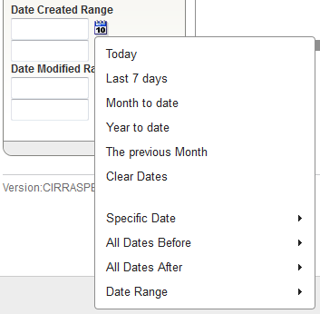

1. Date Range options
2. Click appropriate daterange option. Following table lists each range option and its description.

Table : Date range options

| **Option** | **Description** |
| --- | --- |
| **Today** | To search for information for the current day, click this option. |
| **Last 7 days** | To search for information for the last seven days, click this option. |
| **Month to date** | To search for information from the start date of the current month to the current date, click this option. |
| **Year to date** | To search for information from the start date of the current year to the current date, click this option. |
| **The previous Month** | To search for information for the previous month, click this option. |
| **Clear Dates** | To clear the information in the **Date Range** box, click this option. |
| **Specific Date** | To search for information for a specific date:   1. Click this option.   The **Specific Date** calendar appears.  **Note:**   * The calendar displays the current month and year. To update the month, click the arrow icons next to the month name. * To update the year, in the year list, click the appropriate year.  1. Click the appropriate date.   The date appears in the **Date Range** box. |
| **All Dates Before** | To search for information on all dates before a specific date:   1. Click this option.   The **All Dates Before** calendar appears.  **Note:**   * The calendar displays the current month and year. To update the month, click the arrow icons next to the month name. * To update the year, in the year list, click the appropriate year.  1. Click the appropriate date.   The date appears in the **Date Range** box. |
| **All Dates After** | To search for information from a specific date to the current date:   1. Click this option.   The **All Dates After** calendar appears.  **Note:**   * The calendar displays the current month and year. To update the month, click the arrow icons next to the month name. * To update the year, in the year list, click the appropriate year.  1. Click the appropriate date.   The date appears in the **Date Range** box. |
| **Date Range** | To search for information within a specific date range:   1. Click this option.   The **Start date** and **End date** calendars appear.  **Note:**   * The calendars display the current month and year. To update the month, click the arrow icons next to the month name. * To update the year, in the year list, click the appropriate year.  1. In the **Start date** calendar, click the start date of the date range. 2. In the **End date** calendar, click the end date of the date range. 3. Click **Done**.   The dates appear in the **Date Range** box. |

### 

## 

## Changing the Search Results Display

### Changing the Number of Records Per Page

You can specify the number of records that are displayed on each page of the search results.

To specify the number of records displayed on a page:

1. Log on to the application using your login credentials.

The home page appears.

1. Point to the arrow of the **IAMS** tab, and then click the module for which you want to search a specific number of records per page.
2. Click **SEARCH**.   
   A list of items within the module that you selected appears.
3. Enter appropriate number of records you want to display in the **Display** **Records per page**

Box.  
The specified number of records are displayed on the search results page.

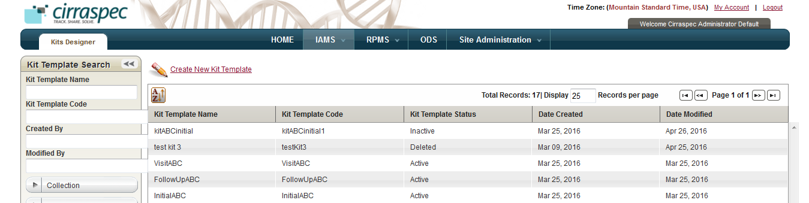

1. Changing the number of records per page

### Changing the Display Columns

You can change the search results display columns.

To change the display columns:

1. Log on to the application using your login credentials.

The home page appears.

1. Point to the arrow of the **IAMS** tab, and then click the module for which you want to sort results.
2. Click **SEARCH**.   
   A list of items within the module that you selected appears.
3. Click the **Sort Table** icon .

The sort window appears and displays the Column Visibility check boxes.

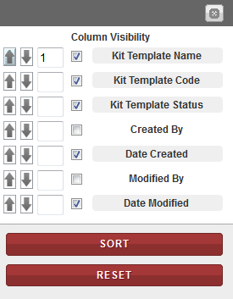

1. Sort window: Column Visibility checkboxes
2. If you want to hide a column in the search results, de-select the checkbox for that column.   
   Click **SORT**.

The search results appear without the specified column.   
  
If you want to display a column in the search results, select the checkbox for that column.

Click **SORT**.  
The search results appear with the specified column.   
**Note:** To clear all the selections, click **RESET**.

### Sorting Search Results

You can sort your search results in ascending and descending order based on one column or based on multiple columns.

To sort the search results based on one item:

1. Log on to the application using your login credentials.

The home page appears.

1. Point to the arrow of the **IAMS** tab, and then click the module for which you want to sort results.
2. Click **SEARCH**.   
   A list of items within the module that you selected appears.
3. Click the column header name by which you want to sort.   
   The search results are sorted according to the column that you selected.   
     
   

To sort the search results based on multiple items:

1. Log on to the application using your login credentials.

The home page appears.

1. Point to the arrow of the **IAMS** tab, and then click the module for which you want to sort results.
2. Click **SEARCH**.   
   A list of items within the module that you selected appears.
3. Click the **Sort Table** icon .

The sort window appears and displays the sort options.



1. Sort window
2. If you want to sort the search results in ascending order, click the **Sort Ascending** icon  next to the appropriate item column.

If you want to sort the search results in descending order, click the **Sort Descending** icon  next to the appropriate item column.

1. To set the sorting priority for the columna, type the appropriate number in the textbox next to the columns as per your priorities.

For example, in the following figure, you sort the search results in descending order, first by Kit Template Name in ascending order and then by Kit Template Code, Date Created and Date Modified:

* **Kit Template Name** to **1** in ascending order
* **Kit Template Code** to **2**
* **Date Created** to **3**
* **Date Modified** to **4**

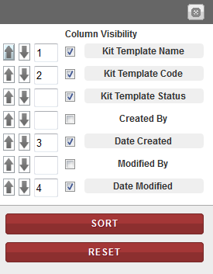

1. Sort order example
2. Click **SORT**.

The search results are sorted according to the sort order you specified.

**Note:** To clear all selections, click **RESET**.

## Managing Events

The Manage Events functionality allows you to view the existing events that are associated with items, such as kits. You can also create new events using this functionality.

### Viewing an Event

To view an existing event:

1. Log in to the application using your log in credentials.

The home page appears.

1. Point to the arrow of the **BMS** tab, and then click the module (Kits Inventory, Kits Shipment, Shipment, Worklists) for which you want to access the search pane.

The search pane for the module that you selected appears on the left side of the page.

1. Click **SEARCH**.

A list of items within the module that you selected appears.

1. Click on the row of the item for which you want to view an event.

**Manage Events** link

A page that displays the details of the item appears.

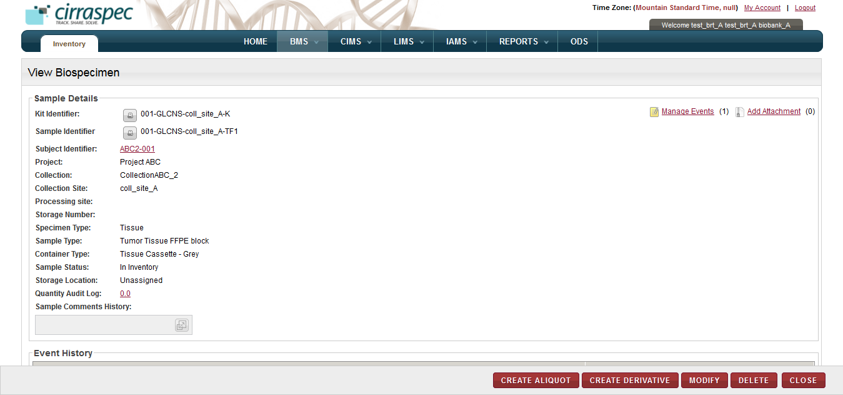

1. Manage Events link
2. Click the **Manage Events** link. Or Click the **yellow icon** as link for manage events on each row.  
   The **Manage Events** window appears. The **Event/Action List** area displays the existing events.

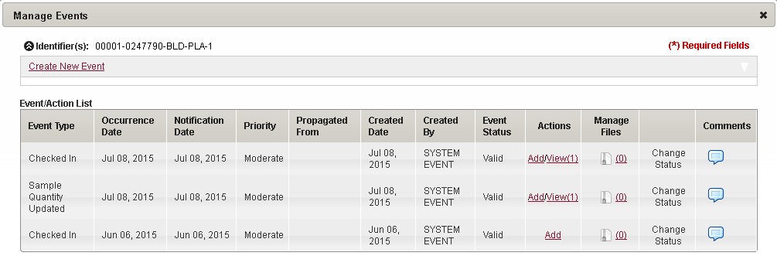

1. Manage Events window

### Creating an Event

To create an event:

1. In the **Manage Events** window, click the **Create New Event** link.

The **Create New Event** area appears.

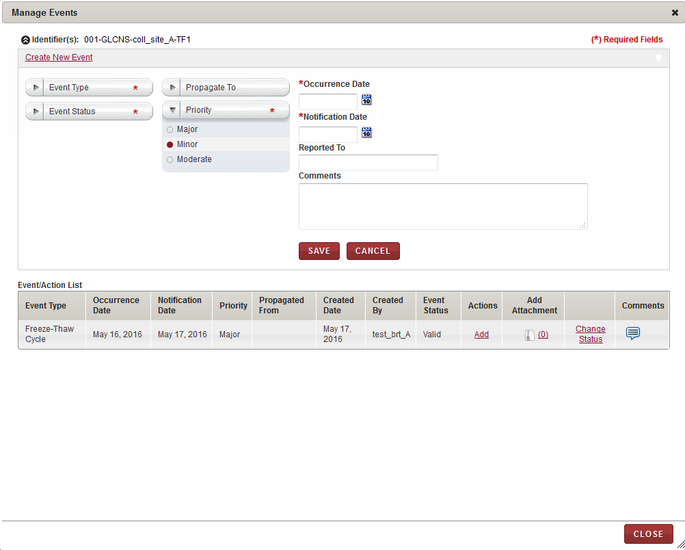

1. Create New Event area

1. Enter appropriate information in each field. Following table lists each field and its description.   
   **Note:** Fields that are marked with the red asterisk (*) are mandatory.

Table : Creating an event

| **Field** | **Description** |
| --- | --- |
| **Event Type\*** | Click the appropriate event type for this event. |
| **Event Status**\* | Click the appropriate status for this event. |
| **Propagate To** | Click the appropriate shipment cascading option to identify what items associated with the initial item should also have the event attached. Example: All items associated with the shipment, or biospecimens associated with the shipment. |
| **Priority** | Click the appropriate priority for this event. |
| **Occurrence Date**\* | Click the date icon Search calendar, and then click the date when the event occurred. |
| **Notification Date**\* | Click the date icon Search calendar, and then click the date when you were notified of the event. |
| **Reported To** | Type the person or organization to which the event was reported. |
| **Comments** | Type the appropriate comments for this event. |

1. Click **SAVE**.

The event is created. This event appears in the **Event/Action List** area.

### Changing the Status of an Event

To change the status of an event:

* In the **Manage Events** window, click the **Change Status** link.  
  The event status shown in the pop-up is modified from **Valid** to **Invalid** (or vice versa).

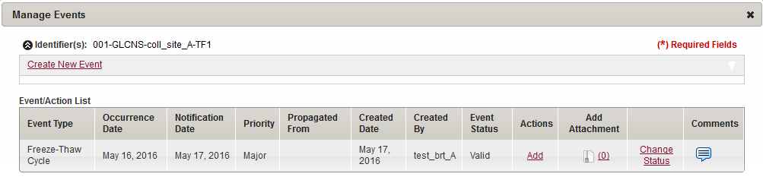

1. Change Status link

Allows you to change the event status

### Viewing or Adding Comments to an Event

To view comments associated with an event:

* In the **Manage Events** window, click the **Comments** icon in the Comments column.  
  The **Comments** window appears with previous comments displayed in **Comments History** area.

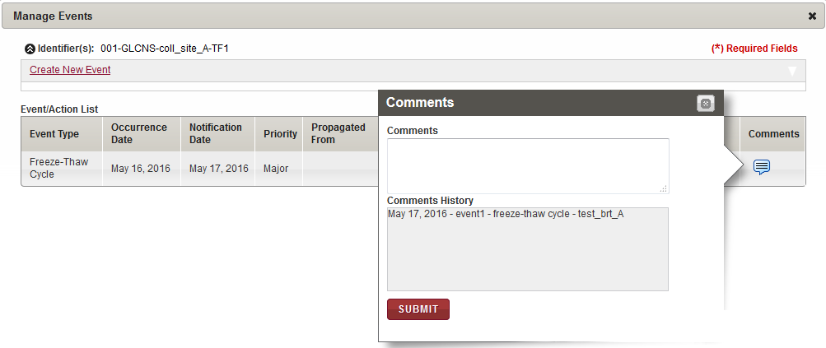

1. Comments window

To add comments associated with an event:

* In the **Comments** window, type your comments in **Comments**, and then click **SUBMIT**.  
  Your comments are added to the **Comments History** and the **Comments** window closes.

### Adding an Action for an Event

To add an action for an event in the **Event/Action List** area:

1. In the of the **Actions** column, click the **Add** link of the event for which you want to add an action.

The **Action** area appears.

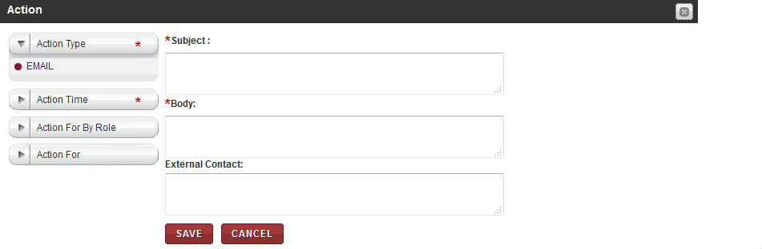

1. Action area
2. Enter appropriate information in each field. Following table lists each field and its description.

**Note:** Fields that are marked with the red asterisk (*) are mandatory.

Table : Adding an action for an event

| **Field** | **Description** |
| --- | --- |
| **Action Type**\* | Click the appropriate type of action.  **Note:** The default action is **EMAIL**. |
| **Action Time**\* | Click the time when you want to perform the action. |
| **Action For By Role** | If you want to specify to which CIRRASPEC user role(s) the action pertains, click on the field and select one or more roles. All users with the specified role(s) will receive the e-mail. |
| **Action For** | If you want to specify the CIRRASPEC user(s) to whom the action pertains, click on the field and select one or more users. The specified users will receive the e-mail. |
| **Subject**\* | Type a subject for the e-mail. |
| **Body**\* | Type the appropriate text for the e-mail message. |
| **External Contact** | If you want to specify an external contact to which the action pertains, type one or more external e-mail addresses. The specified external users will receive the e-mail. **Note:**  For multiple e-mail addresses, you must separate the e-mail addresses with a comma.  You must complete one of the following fields: **Action For By Role** or **Action For** or **External Contact** for the EMAIL action. |

1. Click **SAVE**.

The action is added to the **Actions** column for that event.

### Viewing the Actions Associated with an Event

To view the actions associated with an event in the **Event/Action List** area:

* In the **Actions** column, click the **View** link of the event for which you want to view an action.

Allows you to collapse the action row

Allows you to view the actions

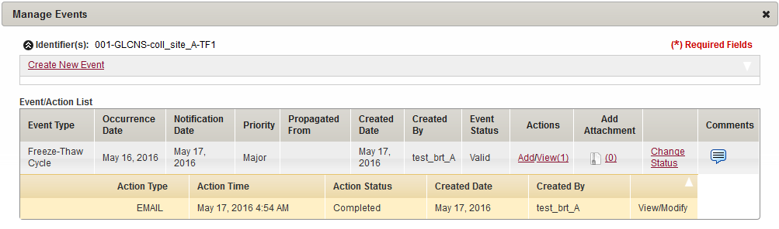

Action row

1. Action row

The action row appears below the event and displays the action details.   
**Note:** To collapse the action row, in the upper-right corner of the action row header, click the arrow icon.

## Common File Upload

The Common File Upload functionality allows you to upload, download and delete files that are attached to items, such as kits and shipments.

### Uploading a File

To upload a file, do the following:

1. Log in to the system using your log in credentials

The home page appears.

1. Point to the arrow of the **BMS** tab, and then click the module for which you want to access the search pane

The search pane for the module that you selected appears on the left side of the page.

1. Click **SEARCH**.

A list of items within the module that you selected appears.

1. Click the appropriate item.

**Add Attachment** link

A page that displays the details of the item appears.



1. Add Attachment link
2. Click the **Add Attachment** link.  
   The **MANAGE ATTACHMENTS** window appears

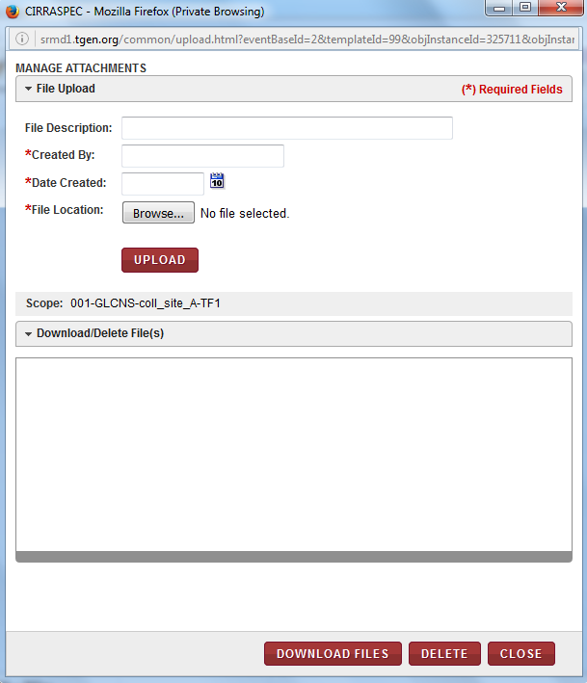

1. Manage Attachments window
2. In the **File Upload** area, enter appropriate information in each field. Following table lists each field and its description.

**Note:** Fields that are marked with the red asterisk (*) are madatory.

Table : Uploading a file

| **Field** | **Description** |
| --- | --- |
| **File Description** | Type a description for the file that you want to upload. |
| **Created By**\* | Type the name of the person who created this file. |
| **Date Created**\* | Click the date icon Search calendar, and then click the date on which the file was created. |
| **File Location**\* | To select the file that you want to upload:   1. Click **Browse.**  The browse files window appears. 2. Select the filethat you want to upload in the window, and click **Open**.   The browse window closes and the file name appears below the **File Location** box.  **Note:**   * You can select multiple files, one at a time, by repeating this browse step. * You can remove a selected file by clicking on the in the upper right corner of the selected file box. |

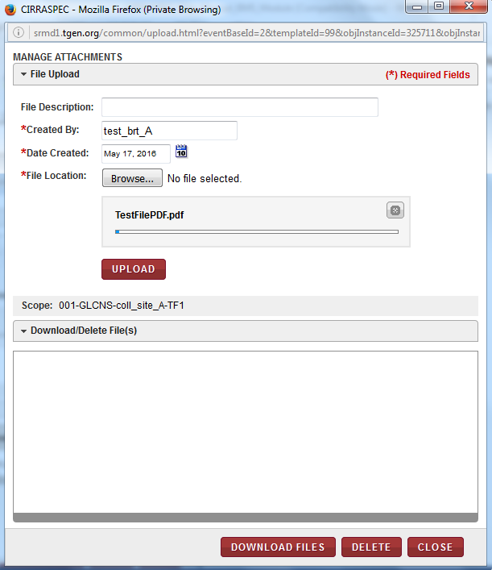

1. Manage Attachments Upload window with selected file
2. Click **UPLOAD**.  
   The file is uploaded and appears in the **Download/Delete File(s)** area.

### Downloading a File

To download a file in the **MANAGE ATTACHMENTS** window:

1. In the **Download/Delete File(s)** area, select the checkbox of the file that you want to download.

**Note:** To download all the files, select the checkbox on the header of the **Download/Delete File(s)** area.

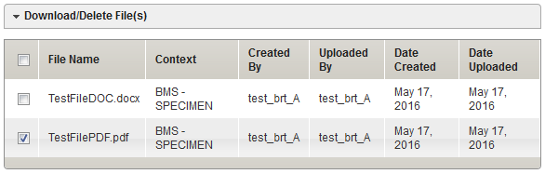

1. Download/Delete File(s) area
2. Click **DOWNLOAD FILES**.  
   The **Opening download** window appears. **Note:** You might not have the permission to download all the files in the **Download/Delete File(s)** area. If you do not have the permission to download a particular file, an error message appears.

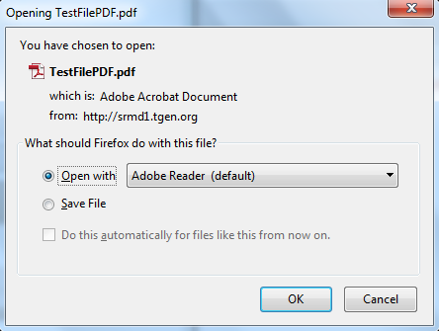

1. Download window
2. Click the applicable field to either open the file or to save it to your machine.  
   The following table provides a description of the download fields:

Table : Download fields

| **Field** | **Description** |
| --- | --- |
| **Open with** | Click this field if you just want to open and view the file. |
| **Save File** | Click this field to save the file to your machine. |

### Deleting a File

To delete a file in the **MANAGE ATTACHMENTS** window:

1. In the **Download/Delete File(s)** area, select the checkbox of the file that you want to delete.

**Note:** To delete all the files, select the checkbox on the header of the **Download/Delete File(s)** area.

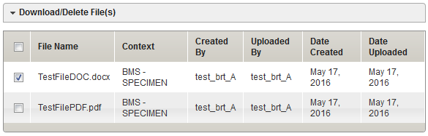

1. Download/Delete File(s) area
2. Click **DELETE**.

A confirmation window appears.   
**Note:** You might not have the permission to delete all the files in the **Download/Delete File(s)** area. If you do not have the permission to delete a particular file, an error message appears.

1. Click **OK**.

The file is deleted from the **Download/Delete File(s)** area.